Directions: Read Section 16.3 in your textbook. Then, answer the questions below.
Part One: Vocabulary
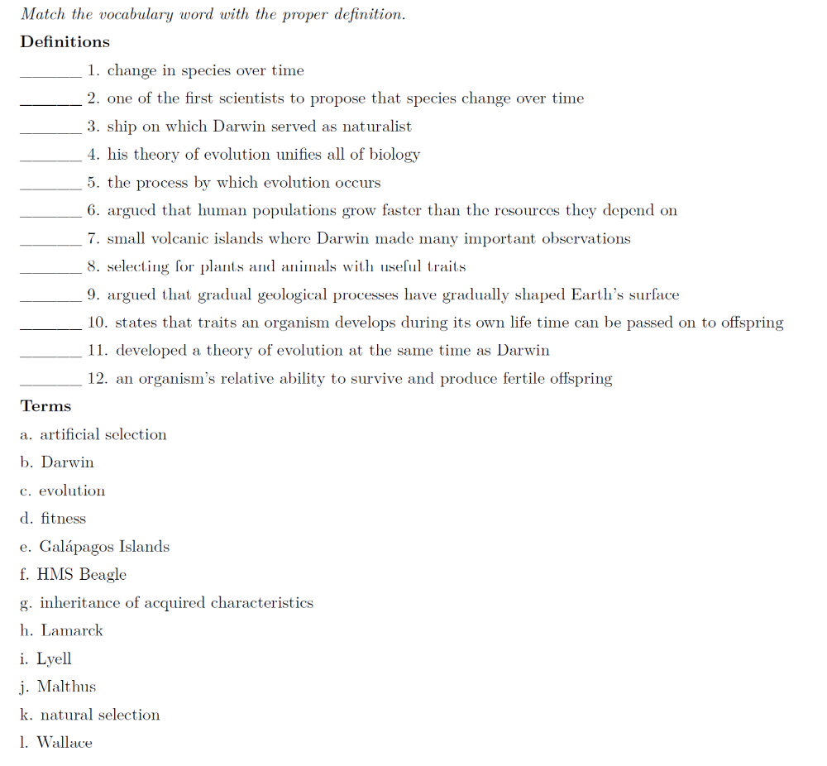

Part Two: Darwin’s Theory of Evolution by Natural Selection
Define the following terms that are essential in explaining the mechanism of Natural Selection.
- Variation –

- Competition –

- Struggle for Survivial –

- Adaptation -

- Environment –

- Selecting Agent -

Use the following terms above to explain Natural Selection in the following scenario.
THE pesticide malathion, which is being used to combat the spread of the Mediterranean fruit fly in California, has been widely applied without incident in New Jersey and across the country, according to state and Federal officials. Malathion has a broad range of applications. In New Jersey, Mr. Fringer said, it has been used to protect many varieties of fruit and vegetables in all sections of the state, including home gardens. It is also used to control mosquitoes and roaches and to protect pets from fleas and ticks. New Jersey farmers have used malathion for insect control around livestock and poultry, but some insects, mainly flies that infest dairy barns, have developed a resistance to it and have reduced its effectiveness.
Explain the resistance of fruit flies that infest dairy barns (and orange groves in California) to malathion using Darwin’s theory of evolution by natural selection.

What two pieces of information did Darwin not have knowledge of that would further support, scientifically, his theory of evolution by natural selection?
Part 3: Evolution of Galapagos Finches
Directions: Use the graphic below to answer the questions that follow.

