Name: ______________________________________________________ Unit 7: Evolution
RG 16.1/16.2
Directions: Complete the following questions after reading the text (pgs 450-459)
- Define the term evolution. How is the noun evolution different from the verb, evolve?
The noun Evolution means the process by which organisms change over time. The verb, evolve, means to change over time.

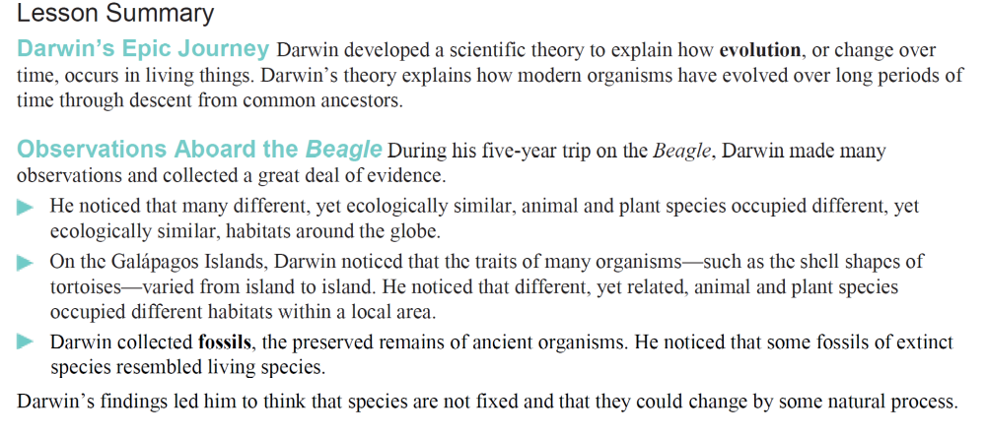
Use the diagrams of the tortoises to answer questions 2 and 3.

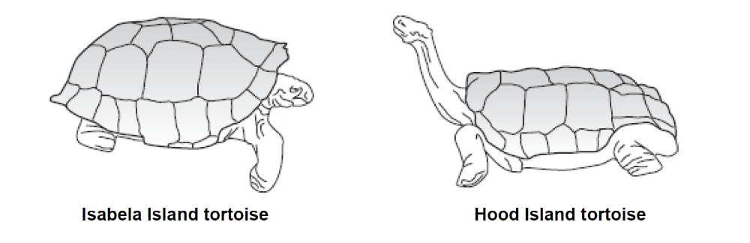

2. What important information about the Galápagos Islands tortoises did Darwin learn?
3. Given its body structure, which tortoise above would require a habitat where food is easy to reach?

4. Why might Darwin come to think that the finches of the Galápagos Islands might be related to the finches of South America, despite how different the birds were in appearance?

5. Darwin observed that the birds he would eventually discover were finches had differently shaped beaks. What might this suggest about the eating habits of the birds? Explain.

6. What did the similarities between fossil animals and modern animals, like the glyptodont and armadillo, suggest to Darwin?
Common Ancestor!!

7. Complete the table about the scientists who contributed to Darwin’s development of the Theory of Evolution.
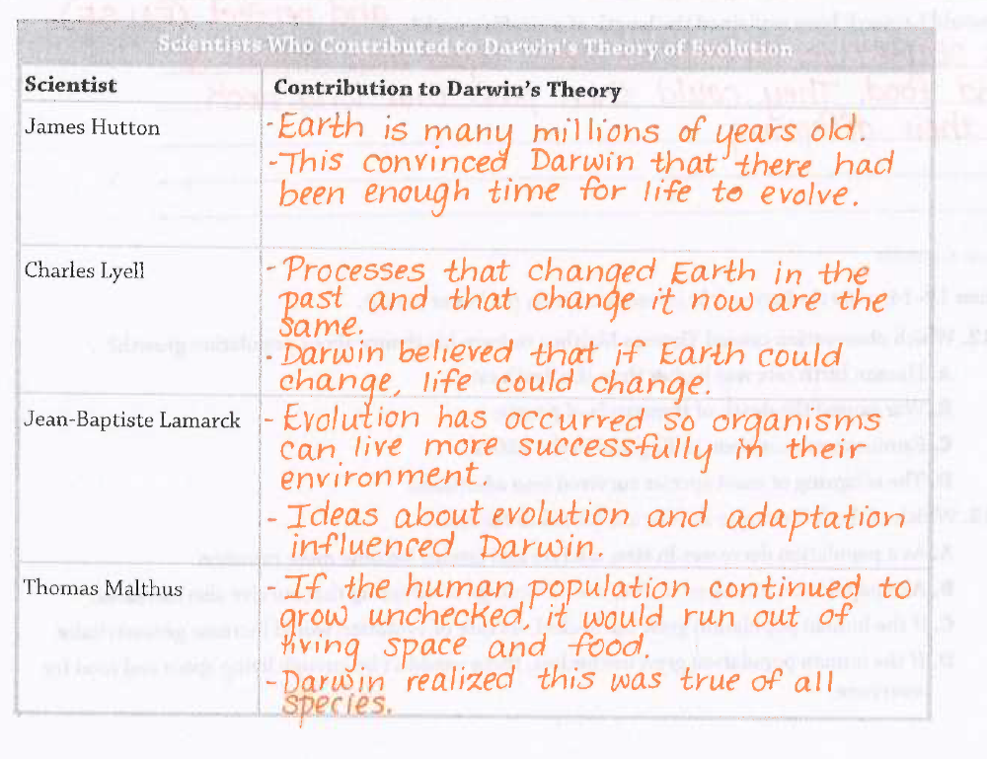

8. What is artificial selection? How is artificial selection different from natural selection?
In artificial selection, humans select the traits they find useful. It is different from natural selection, because in natural selection it is the environment that will select for the useful traits (adaptations).

9. How do humans affect artificial selection?

Humans are the selecting agent. They determine which trait(s) will be successful and passed on to the next generation.

10. What is another name for artificial selection?
Selective Breeding
11. Describe how you could use artificial selection to breed pigeons with large beaks.
Humans would breed two pigeons that had large beaks together. They would hope that the offspring would also have large beaks. Over several generations, humans would only breed pigeons with large beaks. Eventually the trait for small beaks would be bred out of the population. The drawback to artificial selection is that it takes time and the results are not guaranteed (as recessive traits could show up).

