Name: ______________________________________________________ Unit 7: Evolution
RG 16.1/16.2
Directions: Complete the following questions after reading the text (pgs 450-459)
- Define the term evolution. How is the noun evolution different from the verb, evolve?

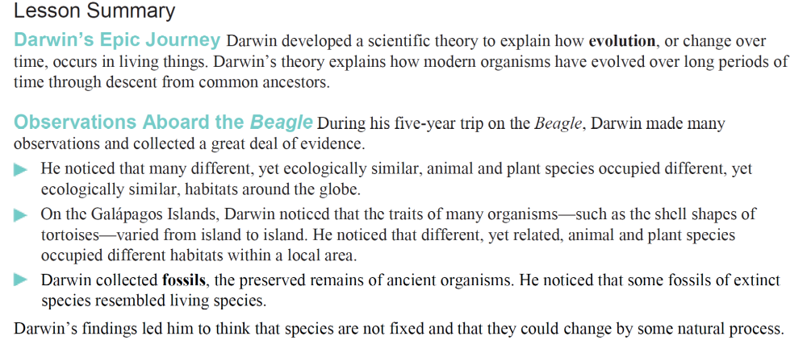
Use the diagrams of the tortoises to answer questions 2 and 3.

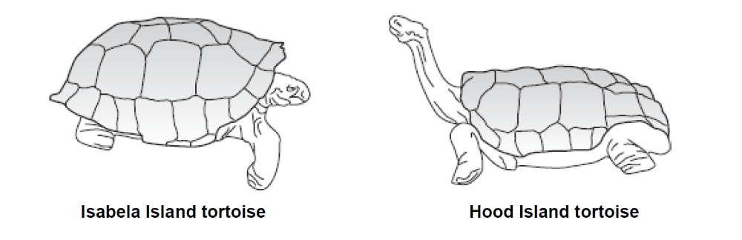

2. What important information about the Galápagos Islands tortoises did Darwin learn?

3. Given its body structure, which tortoise above would require a habitat where food is easy to reach?

4. Why might Darwin come to think that the finches of the Galápagos Islands might be related to the finches of South America, despite how different the birds were in appearance?

5. Darwin observed that the birds he would eventually discover were finches had differently shaped beaks. What might this suggest about the eating habits of the birds? Explain.

6. What did the similarities between fossil animals and modern animals, like the glyptodont and armadillo, suggest to Darwin?

(Continue to the next page)
7. Complete the table about the scientists who contributed to Darwin’s development of the Theory of Evolution.
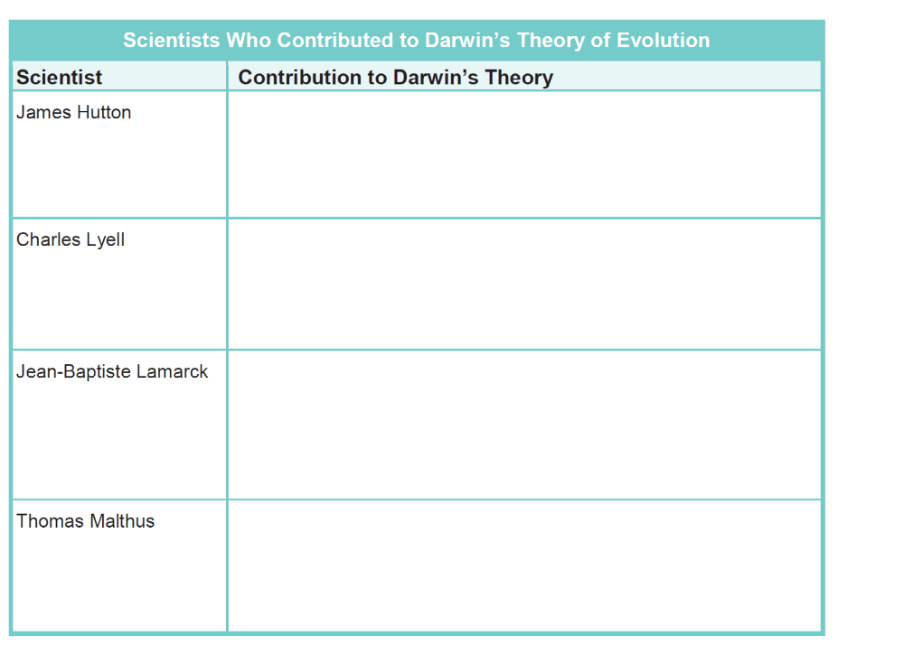

8. What is artificial selection? How is artificial selection different from natural selection?

9. How do humans affect artificial selection?

10. What is another name for artificial selection?

11. Describe how you could use artificial selection to breed pigeons with large beaks.

