Patient #1 – Jeff Jones

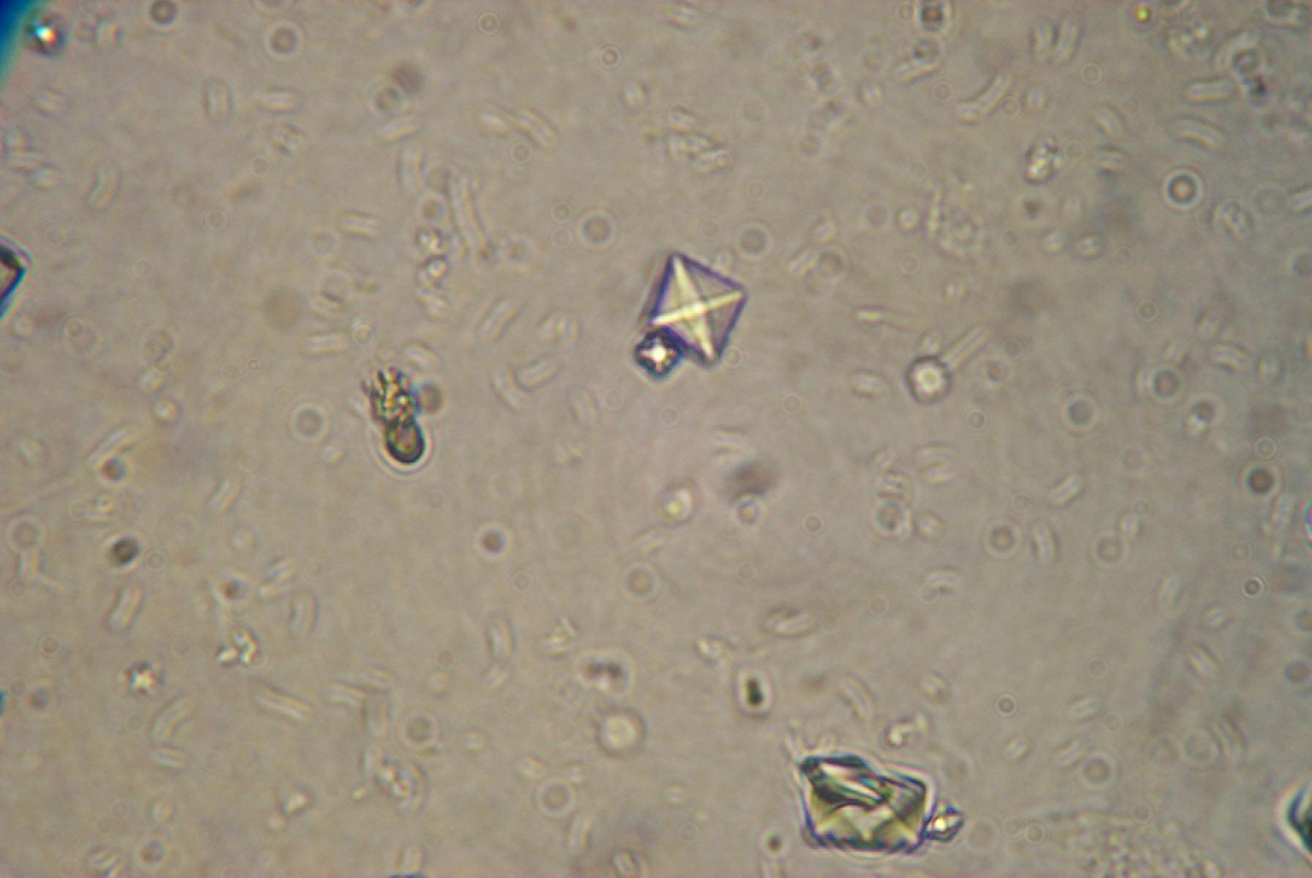

Patient #2 - Mr. Thompson

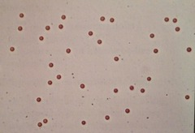

Patient #3 – Ms. Smith

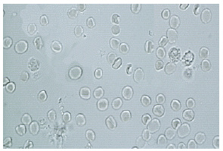

Patient #4

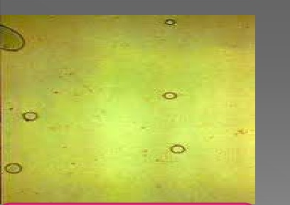

** Note presence of air bubbles in sample

