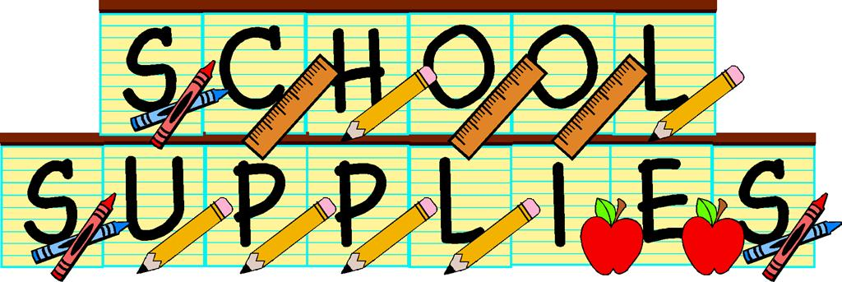

FOURTH GRADE SUPPLIES NEEDED FOR SCHOOL

Dear Fourth Grader,
We are looking forward to meeting you in September and working with you during the upcoming school year. The following supply list is provided so that you can take advantage of “back-to-school” sales during the summer and you can be prepared and ready to jump into fourth grade. Please keep in mind while shopping the sales, throughout the school year your son/daughter may need these supplies maintained and replenished as necessary.

All students should have (for the classroom):
2 red pens
12 sharpened pencils
2 LOW ODOR black dry erase markers and eraser or old sock
Crayons (24)
Colored pencils
3 highlighters, assorted colors please
1 pair sharp scissors
12” ruler (centimeters & inches)
2 Wide glue sticks
1 pkg. Wide-Lined notebook paper
Pencil box (approx. 8”x6” only)
2 composition notebooks
Headphones/ Earbuds labeled with student name in plastic bag
Ultra-fine black Sharpie
1- 3 subject notebook
6- 2 pocket folders with clips – Red, Green, Blue, Yellow, Purple, Black
2 large boxes of tissues
3- 3 packs of post- it notes (3x3)
Art:
1 Fine point black sharpie marker
1 glue stick (.21 oz or larger)
1 art smock (oversized T-shirt or apron, labeled with student’s name)
Last name A-M: roll of paper towels N-Z: sandwich or gallon sized Ziploc Bags



