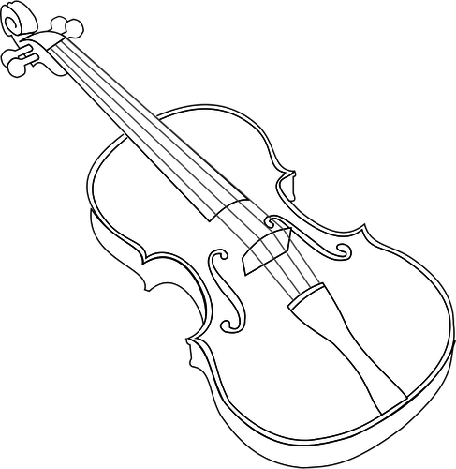
Central Dauphin Middle School
2023-2024 Orchestra Handbook
I am delighted to welcome you to the Central Dauphin Middle School Orchestra. I am looking forward to a fantastic year. It is my pleasure to begin my 19th year at CDMS and my 28th year of teaching at Central Dauphin School District. It is my desire to see string students grow to become better musicians while having an enjoyable learning experience while expanding thinking and critical response skills. I believe that we have a great group of young musicians in our orchestra and I can’t wait to work with you all. We can have a fantastic year in orchestra making music.
If you have any questions or concerns throughout the year, please don’t hesitate to ask. I would also love to be a resource if you are looking for a new instrument. Please let me help. Email is the best way to reach me since my schedule changes daily. If you would like me to give you a call, just let me know what times may be best to call and I will. My email is asmith@cdschools.org. You may also call the office and leave a message for me.
-Anita Smith
Please read the following information carefully and complete the google form (listed at the end of the handbook) stating that you have received and read this. Please mark important concert dates on your family calendar.

Class Schedule
Orchestra meets two times per each 6 day cycle during Enrichment Period. Lessons are scheduled once every 6 days and will be assigned on a rotating schedule where students are excused from ½ a period of a class.

Orchestra Attendance
- Orchestra Rehearsal:
  - Orchestra is a graded class and you are required to attend all regularly scheduled rehearsals. This class period should not be used to make up work in other classes.
  - If a student is present at school, but does not attend band during the scheduled class period, that is an unexcused absence and is considered skipping class. For a first offense, this will result in a zero for class participation that day. If the student continues to skip rehearsal, the student will receive zero participation points and an office discipline referral will be submitted for each offense. Consequences will follow the building policy.

- Concerts and After-school Activities:
  - Students are required to participate in all orchestra performances and activities as scheduled.
  - Prior to a performance, we may have after-school rehearsals if deemed necessary. Advance notice will be given for these rehearsals
    - Late buses will be available for after school practices ending at 4:30
    - Parents/Guardians may need to provide transportation to and from evening activities
  - Please contact Mrs, Smith immediately about any scheduling conflicts! An unavoidable absence must be approved before the event. An unexcused absence will result in a lowered grade.

Lessons
Our school music program offers instrumental lessons for all students scheduled for orchestra. These lessons count as part of your orchestra class grade.
All students will receive a lesson schedule that will be used as their pass for lessons. Copies of the lesson schedule will also be posted on Canvas and in the music hallway. This pass should be politely presented to the classroom teacher at the beginning of class, and the student will sign out of the classroom. All lessons are ½ a class period and rotate between 4 class periods so that students do not miss the same class often. Students are responsible for all class work they miss during the lesson time.

Students can make up missed lessons for full credit. If a student misses a lesson for any reason, they can see Mrs. Smith first thing in the morning before homeroom in the music hallway/cafeteria area. Availability for a make-up lesson will depend on teacher and student schedule availability. If a student has advanced notice of a lesson conflict (for example: they know a test or quiz is scheduled the same period as their lesson), they can see Mrs. Smith in the morning before homeroom to ask to reschedule. Make-up lessons should be kept to a minimum and used only if needed.

Lesson Material
Students will need to bring their Essential Elements for Strings lesson book(s) with them to lessons. Depending on the level of the student, they may need book 1, 2, or 3. If a student does not have this book or is ready for the next book, it is the student’s responsibility to secure the book. Please check with me before you buy the book to make sure we have the correct level. In the case of more advanced students, other repertoire may be selected for lesson materials. Students must have their own personal copy of the method book.

Grading
Orchestra is a graded subject in the middle schools. You will receive an orchestra grade every marking period. The following components will determine a student’s grade in orchestra:
1. Class Participation in Orchestra Class (30% of grade)
- 4 points will be possible for each rehearsal
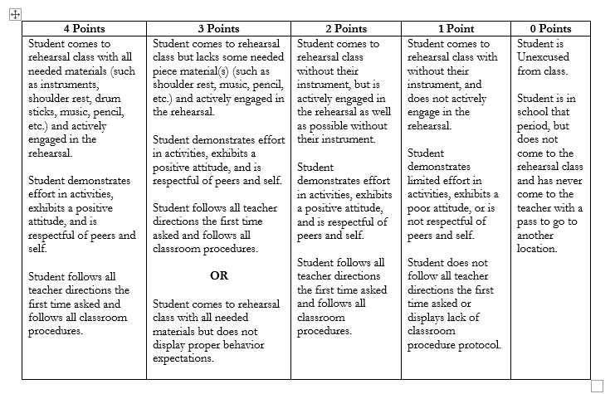
2. Lessons (40% of grade) - Labeled as ‘Classwork’ in the gradebook
- Each lesson is worth 20 points
  - 14 points for preparedness
  - 6 points for evidence of practice
    - 3 possible points for practice at home
    - 3 points for practice sheet
If a student does not attend a scheduled lesson, it is entered in the gradebook as 0 until a make-up lesson is attended. You will have one excused absence for lessons each marking period.
3. Assessments (30% of the grade)
- Playing Tests (scales, lessons music, etc.) - Playing tests must be completed within 2 cycles of the date announced.
- Other Assessments (performance tasks, written tests, listening reflections)
- Assessments may be assigned in canvas and posted on the weekly agenda.

Individual Practice Time
Being a part of an orchestra involves much teamwork and a commitment from all members. The success of our orchestra depends on each player contributing to the best of their ability. Students are expected to practice at home and to be prepared with their lesson and orchestra material. Weekly lesson assignments/practice sheets will be distributed each week. Should a student miss their lesson, they should check with Mrs. Smith and receive their assignment sheet and turn in the past week’s sheet. Parents should sign each sheet weekly. Parents, please encourage your child to practice and continue to support them by helping them find a quiet place to practice. Middle school is a time for great growth musically and we are excited to hear the progress. Your help and guidance of your child's practice routine at home is necessary for continued success. Let's make a terrific orchestra at CD Middle together.

Discontinuing Orchestra
If it is necessary for a student to drop orchestra, the CDMS Music Ensemble Drop/Add form must be completed by a parent and the music director. Due to the performance schedule and the fact that the group relies on all of its members, students are only allowed to drop at two specific times during the school year. The first is at the beginning of the school year during the first three weeks of school, and the second is after the winter concert through at the end of the 3rd marking period. Drop forms submitted at the end of the 2nd marking period will not take effect until the beginning of the 3rd marking period. Students experiencing severe academic difficulties may be permitted to drop at other times based on evaluation by the principal, music director, guidance counselor, and the student’s team. Submission of this request does not guarantee that the student will be given permission to drop the course. However, I highly encourage all students to give orchestra a try. When a student is undecided at the beginning of the year on what to do with orchestra, I find that those who stay with the group are happy they did so.
If a student drops orchestra all music department property must be returned prior to his or her release from the program. This includes instruments and music which must be returned in the condition in which they were issued.

School Instruments & Instrument Care
The Central Dauphin School District has a limited number of musical instruments to loan to students. There is an extremely limited supply of violins and violas and students are highly encouraged to obtain their own instrument. If you receive a school instrument it is on a temporary basis and cannot be guaranteed that the instrument will be available the following year or in the High School. If a personal or school instrument is not acquired by the end of September, students will be dropped from orchestra. Please talk to Mrs. Smith if you would like help or suggestions of where to look for quality and affordable instruments.
All attempts will be made to issue cello and bass players a school instrument when needed. Especially in the case of cello players, if they have their own instrument, they can use that instrument for home practice and concerts and will not need to bring their own instrument to school on a regular basis and can use the school cello at school. If a student does not have a cello at home, they must see that the school instrument is transported safely to school each week. When possible, bass players are issued a bass to play at school and one to keep at home to practice.
School-owned instruments and equipment become the responsibility of the student to whom they are assigned. Any damage (other than normal wear and tear) or loss of property will need to be repaired or replaced at the student’s expense.

Please be careful with your instrument, and always place it out of harm’s way. Never play around with or play on anyone else’s instrument. Also, never try to repair an instrument yourself. If you have a damaged instrument, bring it to Mrs. Smith for further evaluation.

Concert Etiquette
- Arrive 20-30 minutes before a scheduled performance time.
- Maintain a professional stage presence while performing.
- Listen to other groups as they perform and be respectful and supportive of them.
- Wear proper concert attire
- Stay for the entire performance. You are expected to stay and support the other performers.

Concert Attire
- All music ensemble students are required to purchase a CDMS Music Department polo shirt to wear at all CDMS music performances (unless otherwise specified).
- Girls – CDMS polo shirt, black dress pants or skirt (appropriate length), black shoes
- Guys – CDMS polo shirt, black dress pants, black shoes

2023-2024 Concert Dates
Please mark your calendars!!!
Winter Concert: 6th grade – Monday, December 18 7:00 PM
7/8th grade – Tuesday, December 12 7:00 PM

CD MEGA Strings Festival: 7th/8th grade- Monday, March 25 6:00 PM
Spring Concert: 6th grade – Monday, May 20 7:00 PM
7/8th grade – Tuesday, May 14 7:00 PM

Expectations in Orchestra
RAMS Expectations in Orchestra
- Respectful
  - RESPECT those in authority and your fellow classmates.
  - COOPERATE with others in the orchestra and the music program. The better we work together and get along, the more success we will see.
- Accountable
  - FOLLOW all middle school orchestra and middle school procedures.
  - PRACTICE regularly. Our ensemble will only be as good as the members in it. Orchestra is a team sport, and we need everyone to participate to the best of their ability.
- Make good choices
  - BE RESPONSIBLE by attending all lessons, rehearsals, and concerts. Please make sure you keep track of your calendar dates, lesson schedule and rehearsal schedule.
- Safe
  - SHOW proper care and respect for your instrument and the instruments of others. You do not want to have to repair your instrument or the instrument of someone else.
Parents and Students together please complete the acknowledgment form saying that you have read and understand this handbook by Friday, September 22, 2023 It can be found here.--Please fill out this google form.

