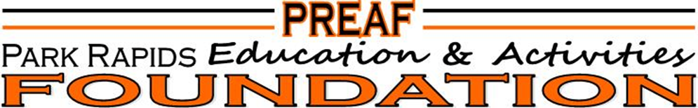

PREAF…What does it stand for?
PREAF is an acronym that stands for Park Rapids Education & Activities Foundation. The Foundation was established in 2000, and throughout the last 24 years, the Foundation has allocated over $824,000 to the educational, fine arts, and athletic programs in the Park Rapids Area Schools. Decisions are made by a Board of Directors, (a group of volunteer community leaders with a strong commitment to educational excellence). Allocation priorities include: art, music, and drama activities; educational and academic activities and equipment; and athletic programs. Grant requests are considered by members of the Allocation Committee within a defined set of guidelines on a case-by-case basis.

PREAF…Why does it exist?
The mission of the PREAF is to ensure the funding for strong and healthy educational, fine arts, and athletic programs of the Park Rapids Area Schools; as well as to provide a contribution structure for these and other school programs. The goals of the PREAF are to establish an annual Park Rapids Area Schools fundraising effort, to create a sustaining Park Rapids Area School District Endowment, to allow for a tax-exempt vehicle for contributions, gifts, grants, trusts, or other fundraising efforts for the school, and to minimize door-to-door fundraising for the Park Rapids Area School District.

PREAF…How does it benefit me?
All allocations are directly funded by individuals, associations, and corporation membership contributions…that is why participation is extremely crucial to our students and the Park Rapids Area Schools. In addition to your membership contribution, there are membership benefits that the PREAF provides for YOU! The PREAF provides a variety of levels of membership that will benefit you and your family’s needs…season passes to athletic and fine arts performances, Panther Prowl gift certificates, advertising space in game programs…it’s all waiting for YOU! Sustaining memberships are also available.

PREAF…Please sign me up!
Membership forms can be found on the school website www.parkrapids.k12.mn.us under the Community tab (select Education & Activities Foundation), and at all Park Rapids school offices. Memberships can be mailed directly to PREAF at PO Box 211, Park Rapids, MN 56470. Please contact Steph Carlson at 252-1597 or Lisa Koppelman 237-4545 for additional information/questions or email preafoundation@gmail.com or send us a message on our PREAF Facebook page.

