Try making a glass xylophone.
Learn all about sound waves. Try this simple project using materials you have at home that demonstrates how sound travels through water and air.

What You Need:
- 3-8 tall glasses (they should all be the same shape and size)
- Pitcher of water
- Spoon or other object to use as a mallet (metal or wood)
- An adult helper
- Water Color Paint and Paintbrush (optional)

What You Do:
- First, line up the empty glasses, then tap each with your spoon and listen to the sounds they make. Do they all sound the same?
- Fill the first glass almost to the top with water from the pitcher.
- Fill the second glass about an inch or so less full than the first glass.
- Repeat step 2, filling each glass slightly less full than the previous glass so that the final glass has only 1-2 inches of water. You can change the difference in the amount of water between each glass slightly depending on how many glasses you’re using; just make sure that the water level in each glass creates steps going down.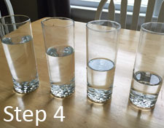
- Use the spoon to tap gently on the side of the first (fullest) glass and listen closely to the sound it makes. Repeat with each glass and notice the difference in sounds from each one.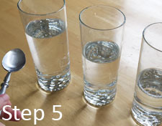

What Happened:
By filling the glasses with different levels of water, you were able to hear how sound travels through a container of water. The sound from the glass with the most water sounded quite a bit different from the one with the least water, and the glasses in between should have created sounds that were gradually higher or lower than the sounds from the first and last glasses. Sound waves can travel through water and when the amount of water in a container changes, the sound you hear changes as well. Do you know why? When you tapped each glass, the sound you heard started out as a vibration of the glass and was quickly transferred to vibrating through the water inside the glass as well. The glass with more water had more matter for the sound to travel through, causing the vibrations to become larger and produce a sound with a lower pitch. To compare, think about a stringed instrument such as a ukelele or guitar: the thicker strings have more mass and create a lower sound than the thinner strings! The glass with the least amount of water had shorter vibrations and created a sound with a higher pitch.
To take this a step further, you can fine-tune the amount of water in each glass to get even steps in sounds made by each one until you can play a simple song (try “Twinkle-Twinkle Little Star” or “Mary Had a Little Lamb” or “Hot Cross Buns”) by tapping on different glasses to play the tune.

