Professional Growth Plan (PGP) Guide
For Information from the Louisiana Department of Education related to PGPs visit:
http://www.louisianabelieves.com/resources/library/compass
Writing and Implementing Professional Growth Plans (from the Louisiana Department of Education)
What is the Purpose of a PGP?
Professional Growth Plans (PGPs) provide an opportunity for educators to set specific goals and create action plans that will help them improve their professional practice and help their students meet more rigorous standards.
What Makes a Strong PGP?
A strong PGP is aligned to the standards of professional practice upon which the educator will be evaluated and targets specific needs and strengths within those standards that reflect that employee’s greatest opportunities for growth. A strong PGP should include a set of action steps, resources needed, and target dates of completion to ensure that the plan results in concrete actions and measurable outcomes for the educator.
Developing a Strong Professional Growth Plan
Educators can use their evaluations from previous years to guide the creation of their PGP.
Use the Areas of Growth targeted in the observations and/or evaluations to develop an action plan designed to strengthen one of those areas.
Review school-wide data with an evaluator to discuss opportunities for professional growth that will be provided to the entire faculty. Determine how each educator can best utilize these resources to improve professional practice and help their students achieve growth.
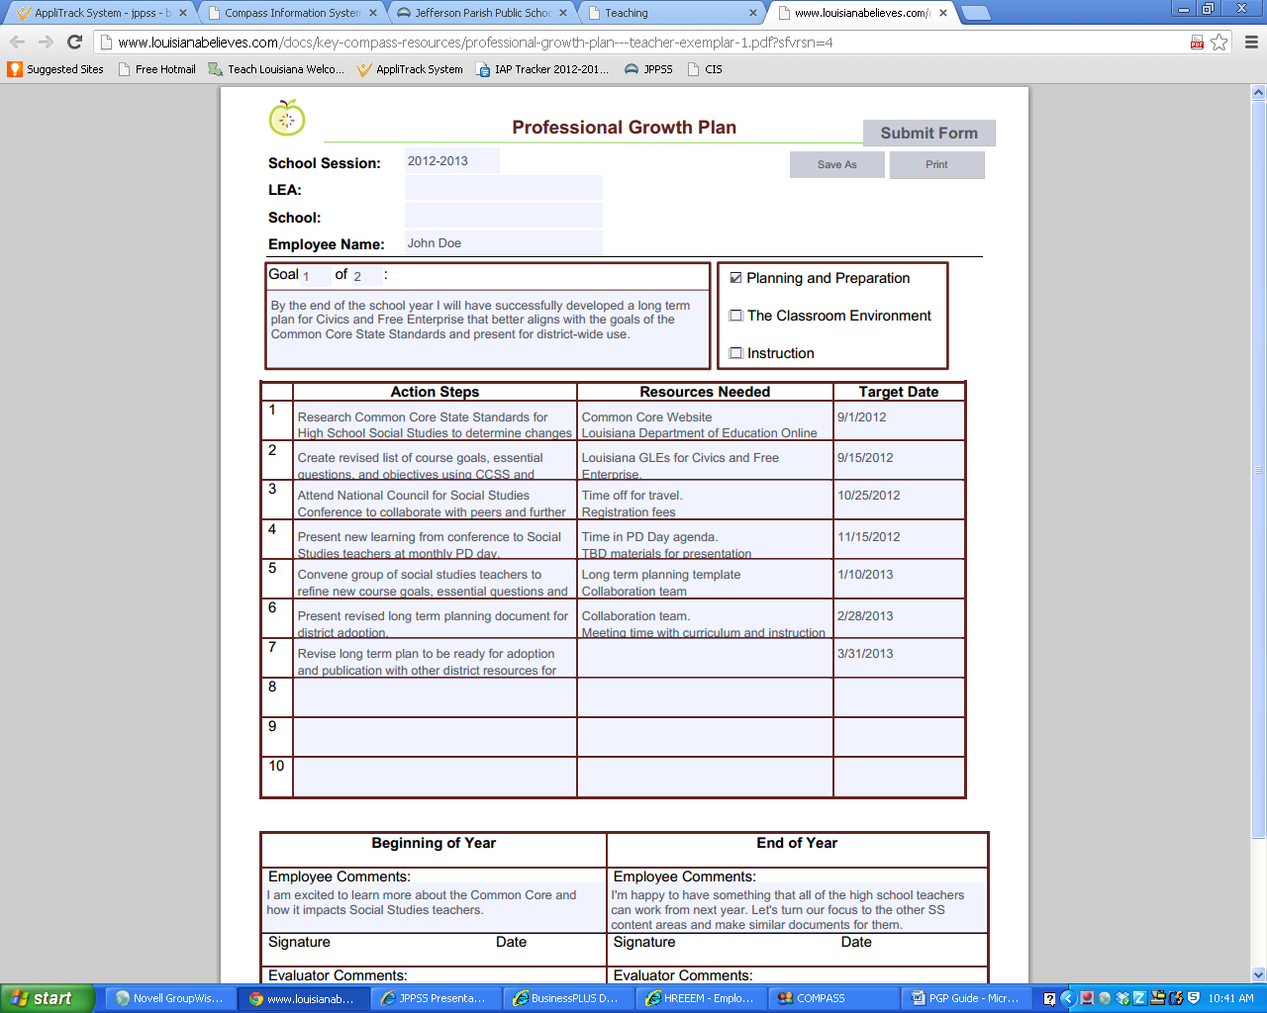
EXAMPLE:

Teachers’ PGPs should align with the growth plan established by school leaders so as to maximize opportunities for support and professional development that will be available at the school site. School Improvement Plans and Principal/Assistant Principal PGPs can be used to guide the development of PGP goals for educators.
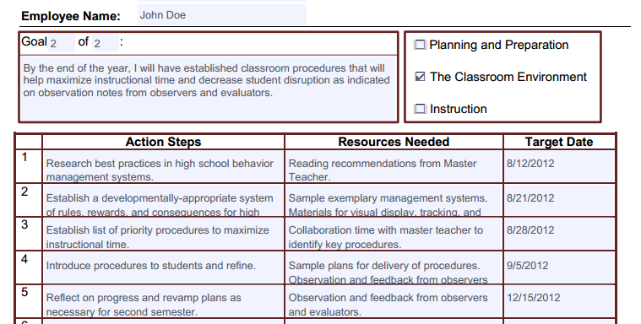
EXAMPLE:

Entering PGPs into CIS
Follow the steps below to enter your PGPs into CIS:
- In the top row of tabs, click “PGP.”
- In the second row of tabs, click “Set” and then click “Add” to the right of the screen.
- Fill out the Goal and Action Steps for this Goal box with the appropriate information.
- Make sure to check all boxes that apply in the Align Goal to Domain section.
- Once you have completed your PGP, click “submit.”
- Repeat the steps above to add another Goal.
*Note: Evaluators are not required to acknowledge employee PGPs.*

