SER IEP Forms Progress Reports 

How to Begin the Progress Report Process—
Log into the SER Production Site at https://serp.doe.louisiana.gov/ser
Enter SER User ID number and Password
Enter Student’s Name
Click on Search
Confirm Correct Student (dob etc.,)

Open up the student’s current IEP for which you are reporting progress. (You do not amend the IEP to use the SER IEP Forms Progress Reports.)
Click on the drop down menu beside 1.Transition Services. If Progress Reports is displayed, click on Progress Reports. Select the Goal to Edit Progress and proceed.
If Progress Report forms have not been added proceed to the following step.
In the upper right hand corner of the IEP display click on the blue “add/delete IEP forms to IEP”. Note: If Progress Report Forms have already been added, skip to page 9.
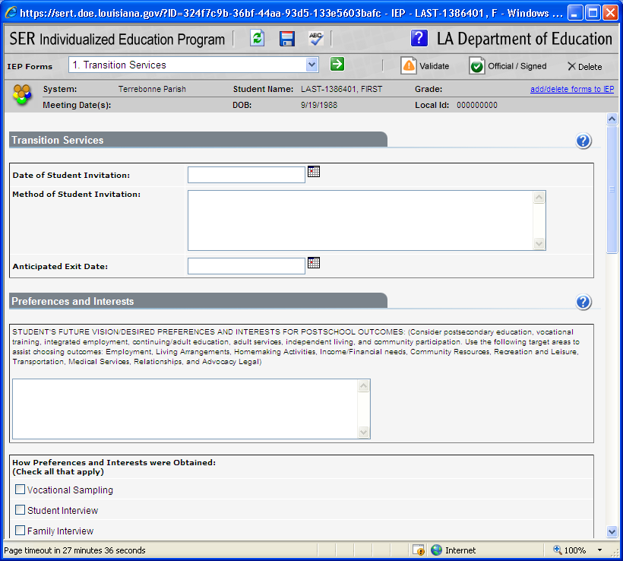

Check the box next to Progress Reports. Click on “Save.”
Once the Progress Report form has been added and saved on the IEP, this step will not have to be repeated for this IEP. (Do not add Progress Reports until the IEP has been made official and sent to SER.)
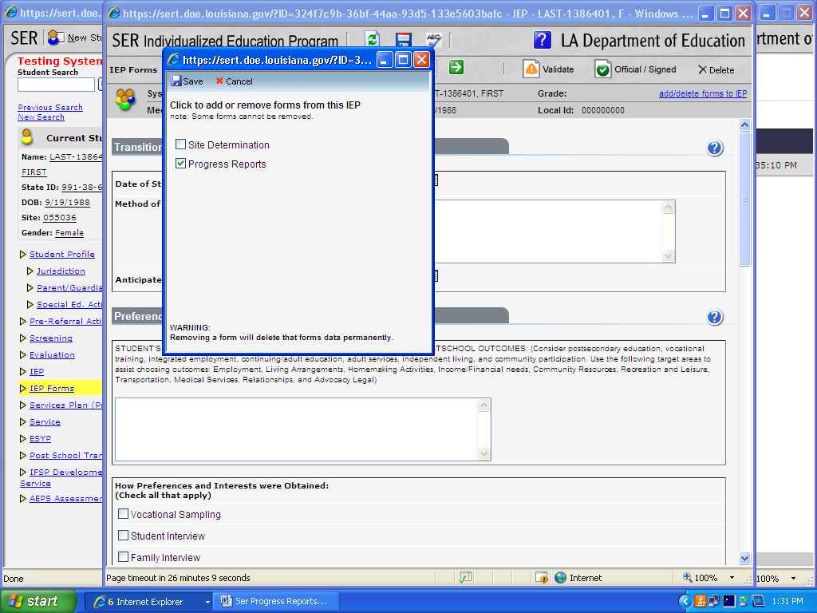

The SER IEP Form you have opened will be displayed. Click on the drop down box of IEP forms (Transition, GSI, Instruction…) and locate “Progress Reports.”
Click on “Progress Reports.”
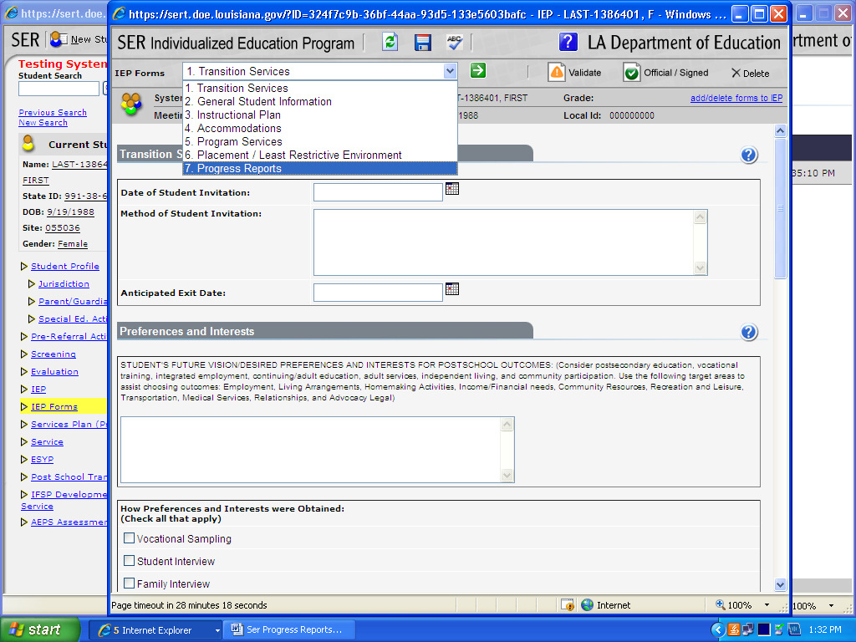

Enter Baseline Data if this is the first reporting period for the Goal.
Baseline data is basic information (where the student is performing as identified in the academic achievement and functional performance section on the instruction plan) gathered before instruction begins. Baseline Data is used later to provide a comparison to assess instructional impact and progress monitoring.
*Baseline Data is not applicable for Gifted/Talented IEPs.
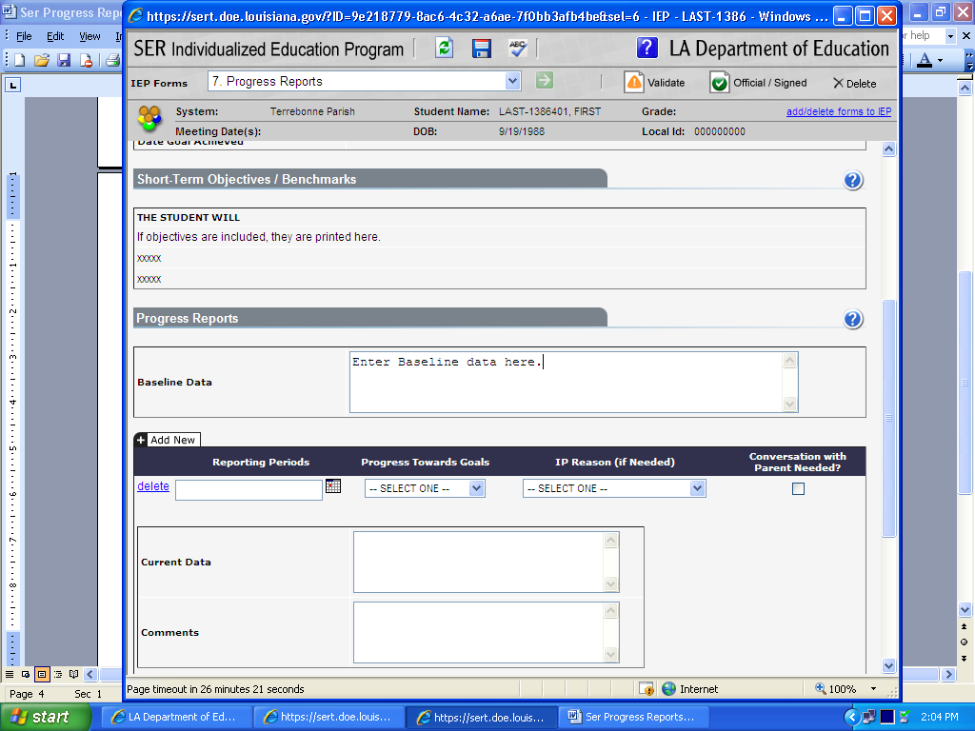

Data you cannot change i.e. not available for edit that is pulled from the Instructional Plan and automatically displayed on the Progress Report Form for informational purposes—Educational Need Area, Goal, Content Area (if applicable), Method of Measurement, Additional Methods of Measurement (if applicable), Date Goal Achieved (if applicable), and Short-Term Objectives/Benchmarks (if applicable.)
A Progress Report is generated for each Goal with or without Short-term objectives on the Instructional Plan in the IEP.
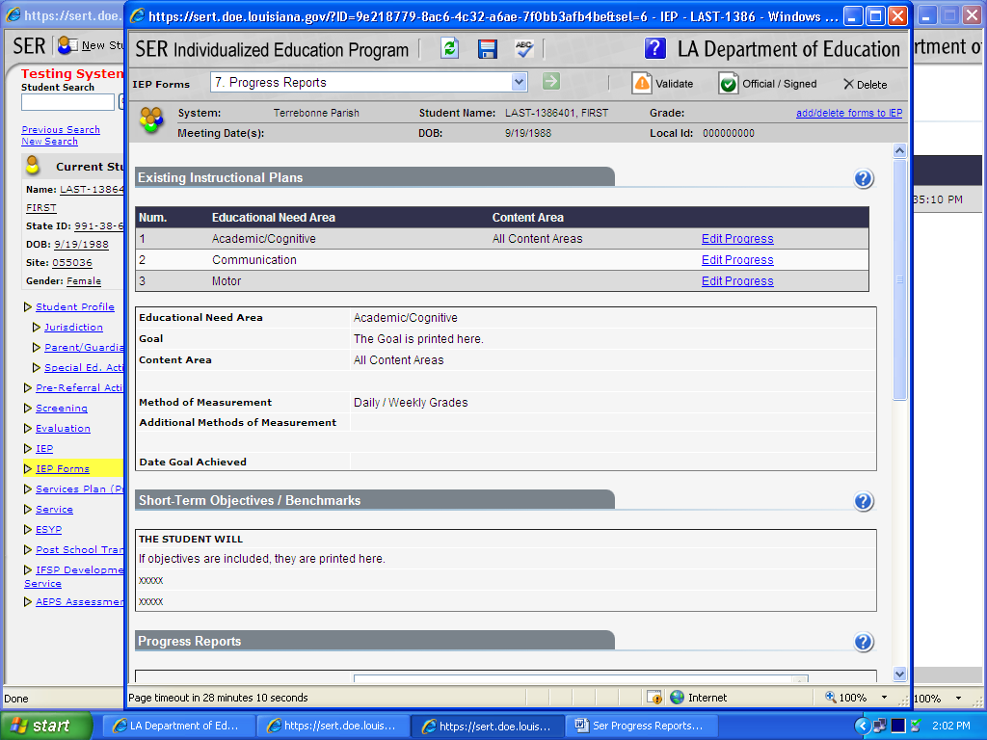

Select date for Reporting Period (date of the end of the 9 week period).
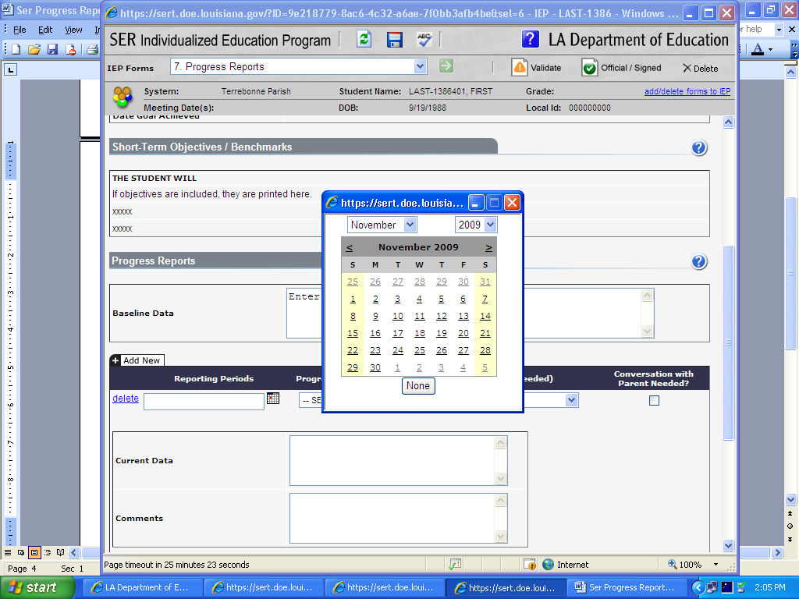

Indicate Progress Towards Goal using drop down choices.
NA=Not Addressed
IP= Insufficient Progress—Skill/behavior is not on target toward achieving goal
SP=Sufficient Progress—Skill/behavior is on target toward achieving goal
A=Achieved—Skill/behavior is demonstrated consistently over time
G=Generalized—Skill/Behavior is generalized and transferable
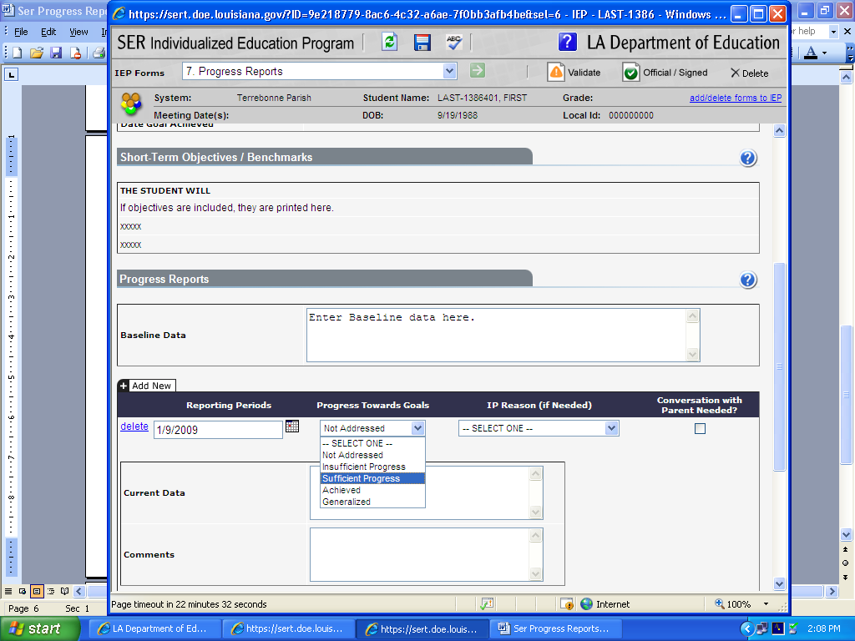

If insufficient progress reason is needed, select from drop down box.
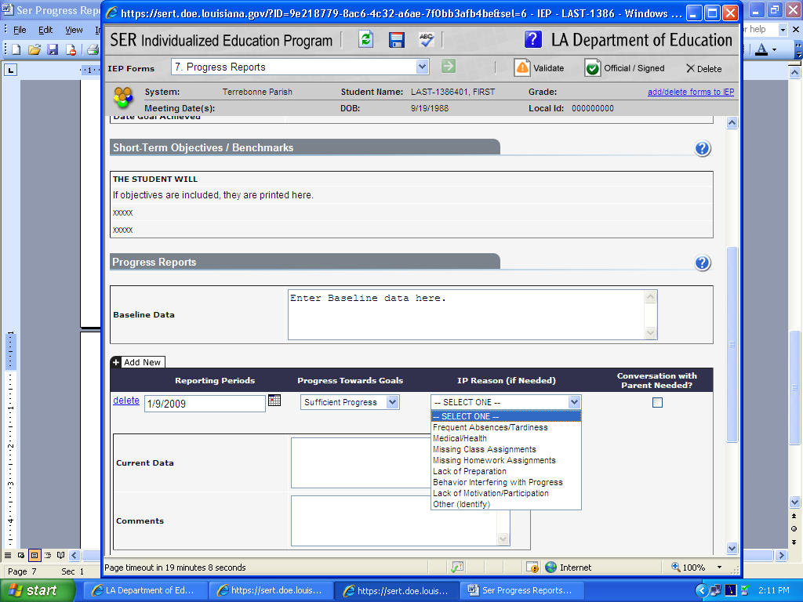

Indicate if conversation with parent needed by checking box. If a conversation with the parent is needed it is the teacher’s/service provider’s responsibility to follow up on contacting the parent. 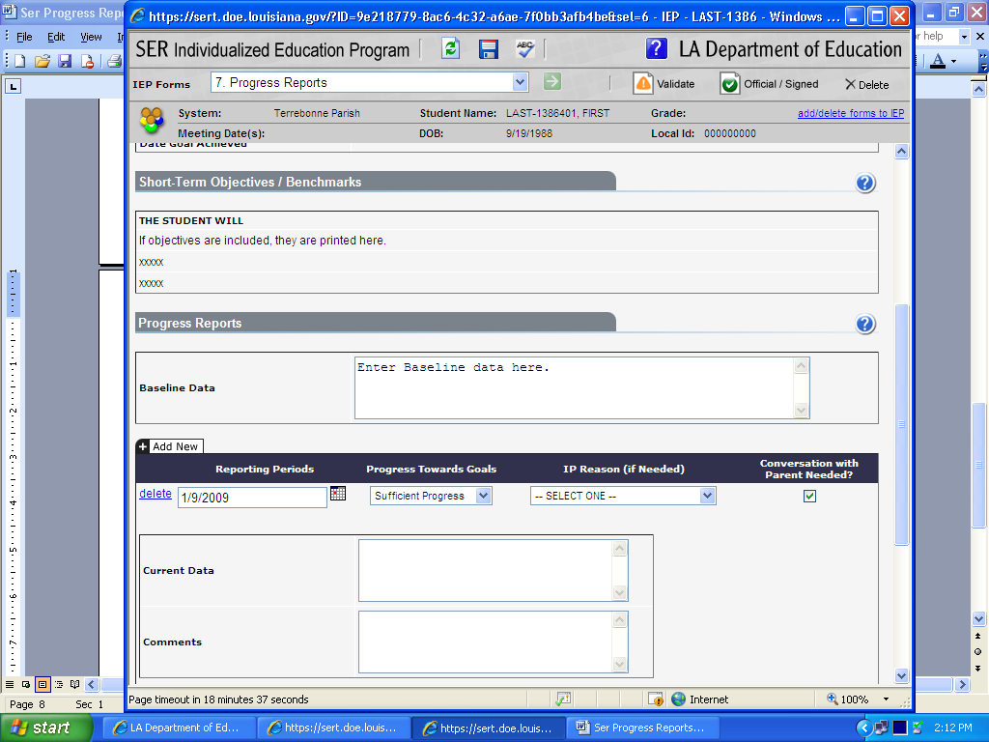

Enter current data. Current data shows how much progress the student has made since the baseline data was gathered and is reflected in the choice the teacher/service provider indicated in Progress towards Goals. DO NOT LEAVE BLANK. If all text space is used, SER will create an addendum page.
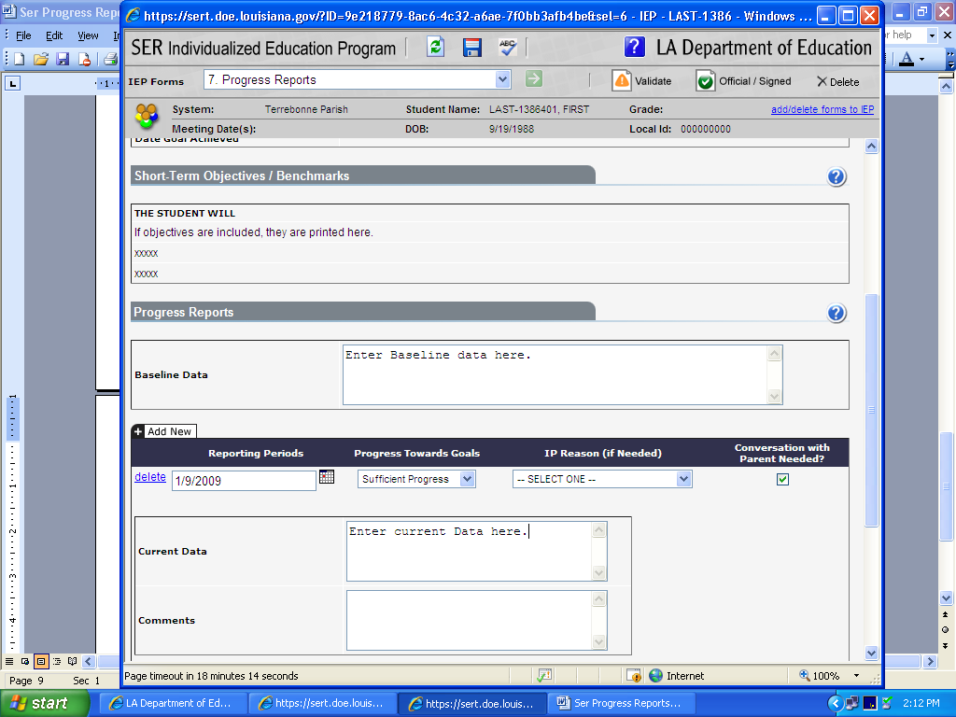

Enter any needed comments. DO NOT LEAVE BLANK. If all text space is used, SER will create an addendum page. 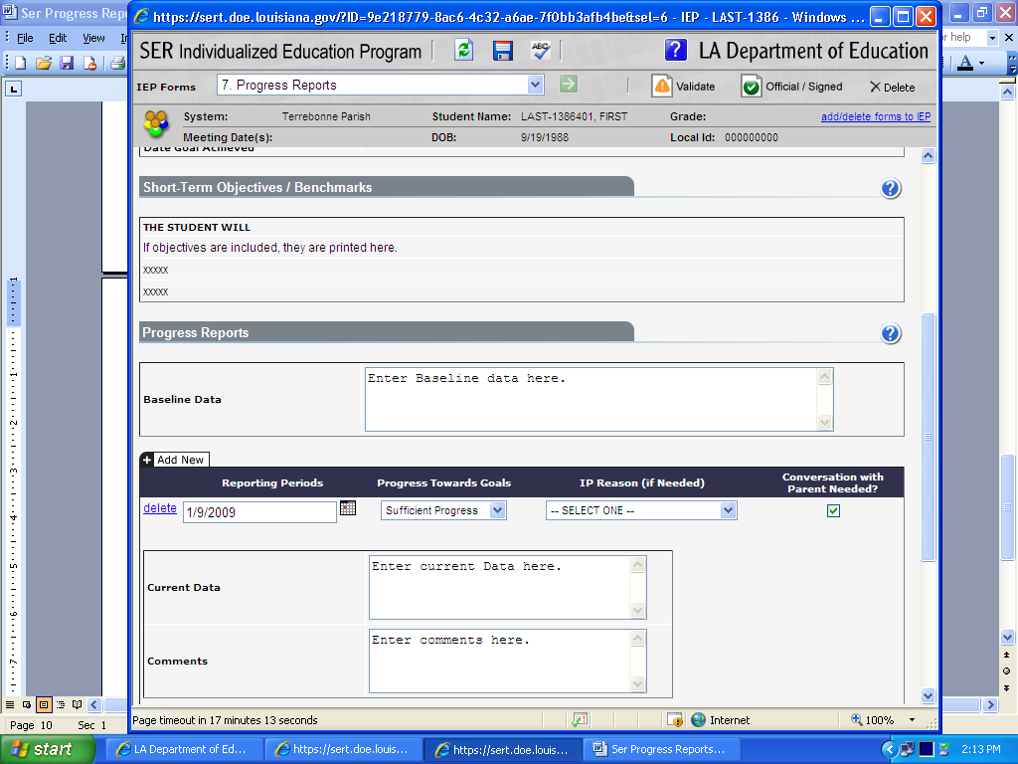

Enter Teacher’s name. Any teacher/service provider responsible for implementing a goal on the instruction plan may add information on the progress report. Caution, do not delete any information another teacher/service provider has entered. After printing the progress report, the teacher/service provider must sign his/her name on the signature line.
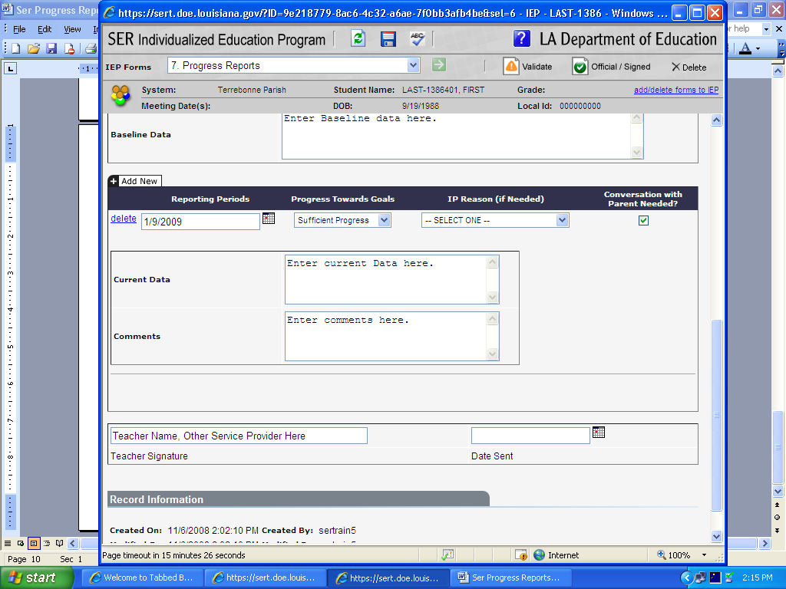

Enter Date sent to Parent. Progress Reports must be sent to the parent at the same time as Report Cards. (Date Sent must be entered to SAVE the Progress Report.)
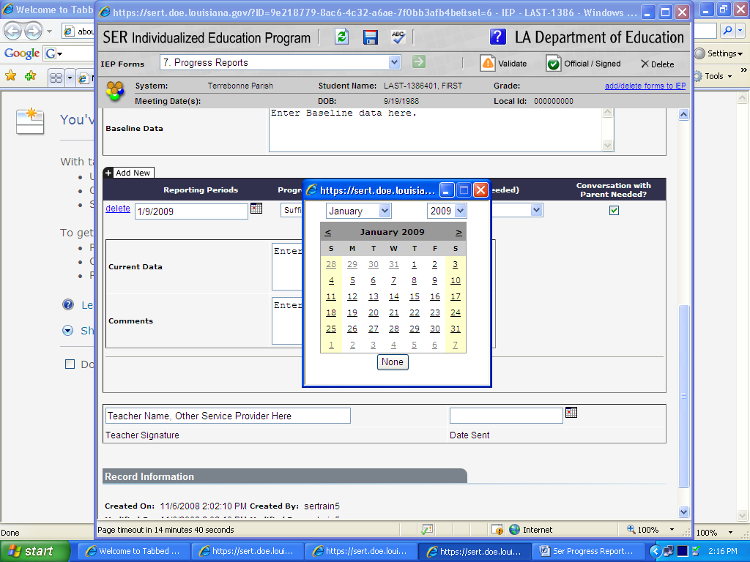

A progress report is generated for each goal with or without short-term objectives on the Instructional Plan in the IEP. The “Edit Progress” link next to an Instructional Plan Goal switches between the progress reports and displays the information from the Instructional Plan. Click on “Edit Progress” for the progress form to be displayed for each Educational Need Area.
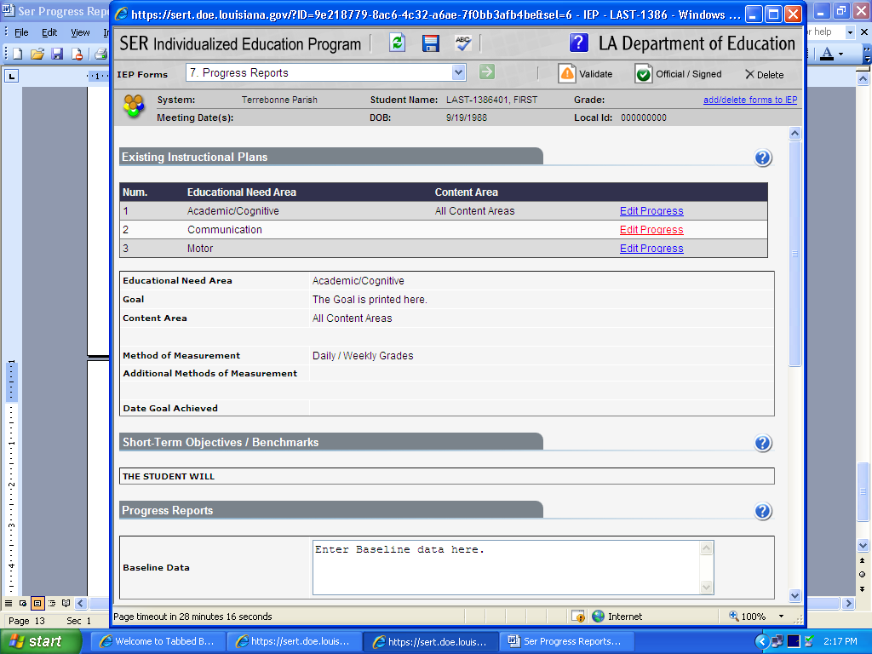

Enter baseline data and follow other steps as indicated in previous directions.
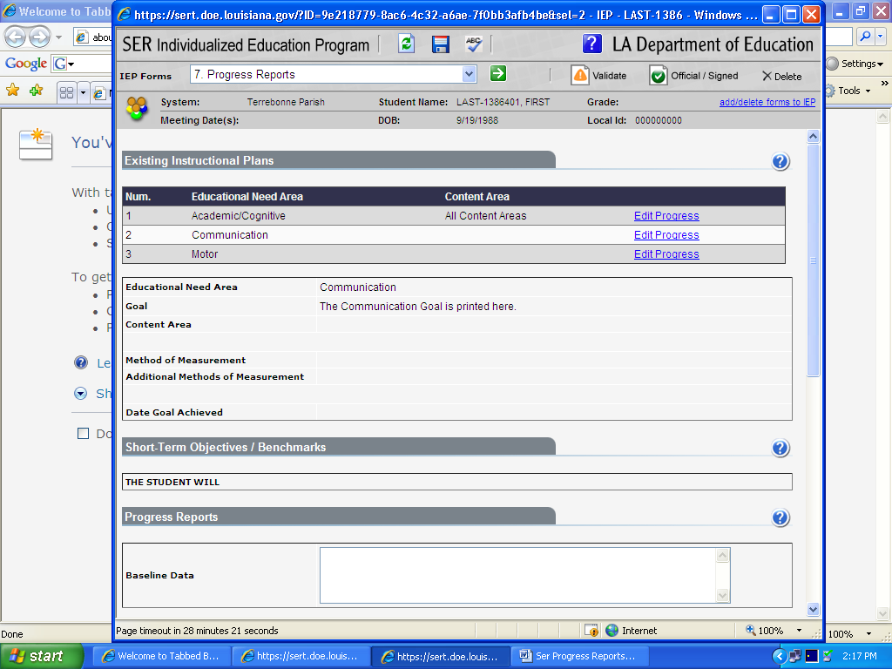

For each reporting period, click on the “ADD NEW” tab. Do not delete the previous dates/comments etc. to enter the “next” progress information. Enter Progress Information for each Goal. You do not re-enter Baseline data. Enter progress information. Remember SER Progress Reports are cumulative with the IEP. They will show each progress reporting period for that IEP when you print.
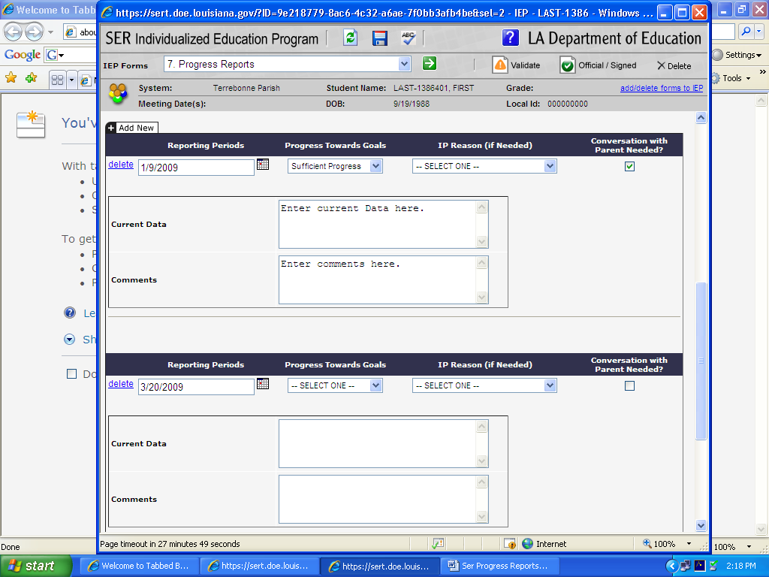

Throughout each step of adding information to the Progress Report, click on “save”.

Each nine-weeks, the teacher/service provider with IEP authority will send progress reports home to the parent along with the student’s report card. If the teacher and service provider are addressing the same goal together, each may put their initials with the information they enter in data gathered and comments. Be careful not to inadvertently erase another person’s information entered. The teacher with IEP authority will file a copy of all pages of the progress report in the student’s IEP folder. The Service Provider will file a copy in their records.

How to Print Progress Reports:

- To print the Progress Reports, you must click on the print link (beside the word edit) on the row that corresponds to the student’s record. (You will need to close out the IEP for the view/print link to show.)
- Check the box so only the last 4 of the State ID number is printed!!!!!
- Check the box next to Progress Reports.
- It may take a minute for the Progress Report to appear in PDF.
- Click on the Printer button to Print.
- Indicate pages to be printed.
- If current data or comments are continued, be sure to also print your Progress Report page (and addendum, if needed) at each 9 week period.

Example of IEP Progress Report for the First Reporting Period (9 weeks) of the IEP:

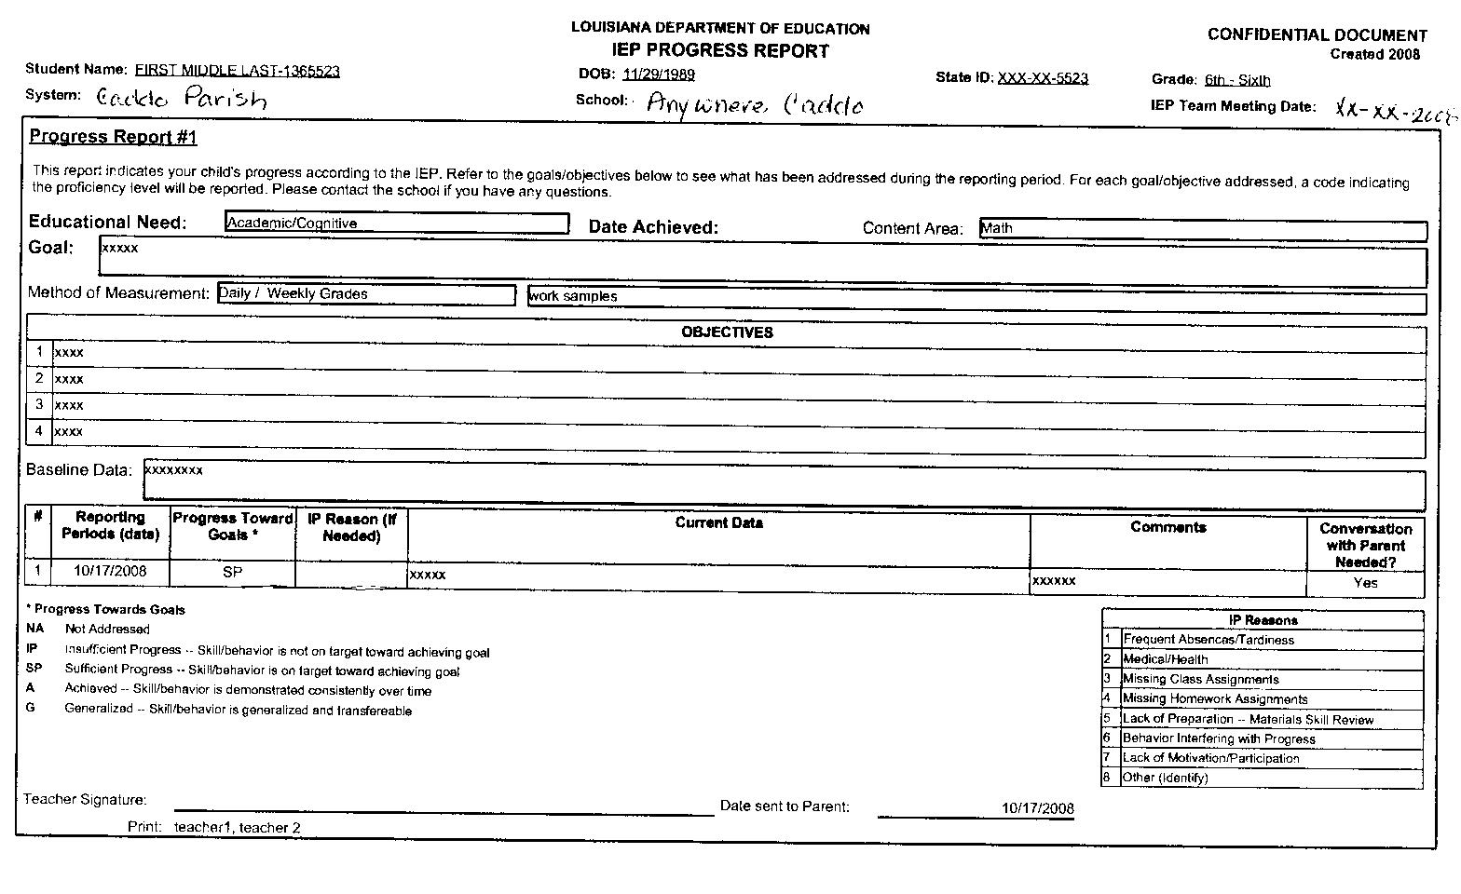
Remember to indicate date achieved for Goals and date achieved for objectives on the SER IEP forms (computer) as well as pages in the IEP folder. SER IEP Forms will only accept dates not comments.
Click on the blue circle with the question mark when you are on the IEP form page for SER IEP Forms help.

Used with permission:
Linda S. Smith, Caddo Parish

