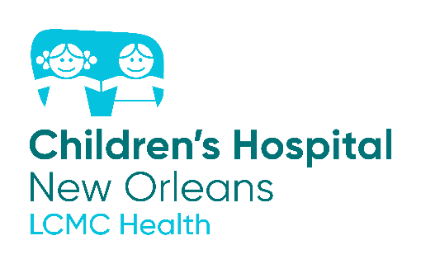
ThriveKids
Enroll today!
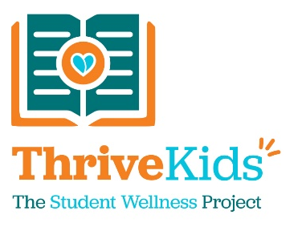

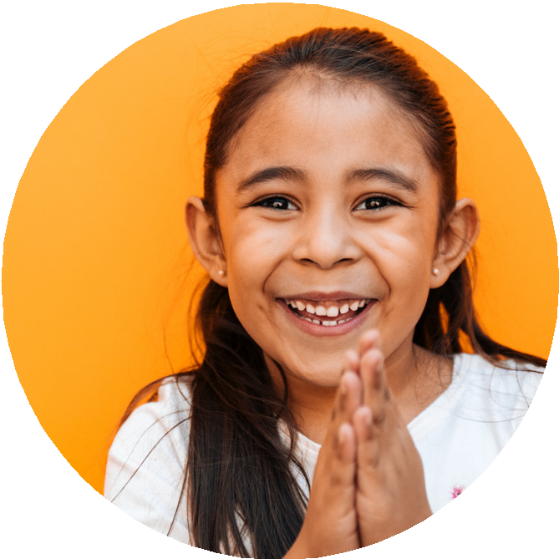

ThriveKids Student Wellness Program through Children’s Hospital New Orleans strives to optimize healthcare and academic outcomes for kids.

Through this partnership with Jefferson Parish Schools:

Students and families have access to additional health resources

Staff can receive professional education, training, and a dedicated Medical Director

School nurses and mental health professionals can facilitate communication between families, healthcare providers, and school staff to ensure holistic care

Families may have access to continued care during natural disasters and prolonged school closures

By choosing to enroll in this voluntary, free program:

Students have access to a ThriveKids care coordinator that can connect them with specialists to meet their needs and be successful in school.

Bridges a communication gap and provides clarity / insight regarding pertinent student health information like test results, procedures needed in school, asthma attack, post-op surgical care, etc.

Provides prompt communication between families, school nurses, school mental health professionals, and healthcare providers.

Helps to improve academics and attendance by allowing school staff to identify needs and provide appropriate resources.

Scan the QR code to enroll TODAY

English Spanish

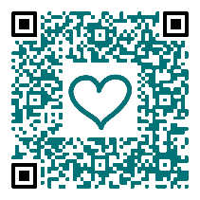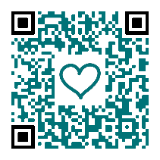

To learn more about our services and resources, please visit chnola.org/thrivekids, email ThriveKids@lcmchealth.org or call 504.837.7760

