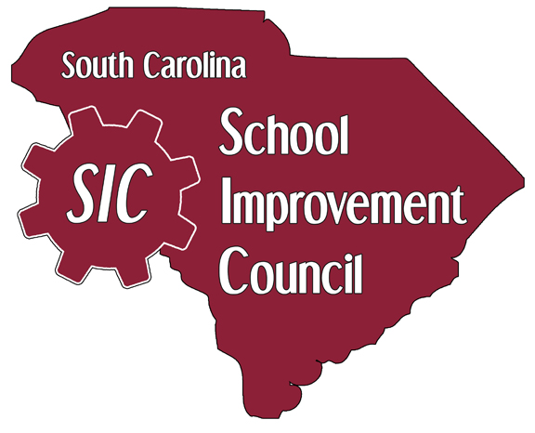
Attention SIC Chairs, SIC Officers and School Administrators
Richland County School District One District School Improvement Council Meeting Notice
Thursday, November 14, 2019
Heyward Career Conference Center
3560 Lynhaven Drive
5:30 pm



