Records Storage and Retrieval Services
Departments and Schools may request for Records Storage and Management Service through the District contract with Iron Mountain. The following information outlines instructions for accessing the Web site in order to use the contract:
Step 1:
Principal or Department Head for each school/department must appoint the person(s) authorized to prepare and store records for offsite storage (no more than 2 person). Once appointed, user must contact the Office of Procurement Services, Iron Mountain District Administrator, Yolanda Propps, at 803-231-7033 or via email at ypropps@richlandone.org. Provide the following information: Name, District email address, site address, phone number, fax number.
Designated person must request a “New User Account” to establish an account authorizing the use of Iron Mountain Connects. Once your account has been set up, notification will be sent from Procurement of the User Name and (Temporary) Password.
This person shall have the sole responsibility to order records, requesting records pick up and viewing/accessing records on-line via the Iron Mountain Web Site:
www.ironmountainconnects.com 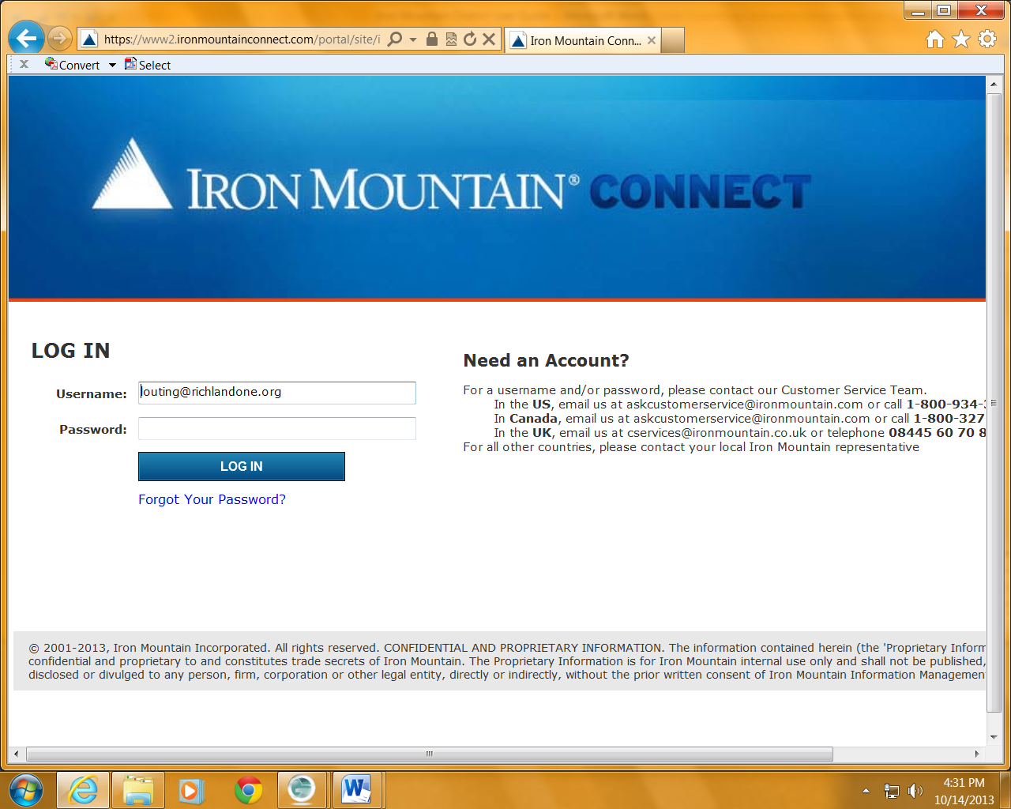

Step 2:
The first time Logging in, User will be prompted to reset your Password. Once you have successfully logged in, click on RESOURCES tab to access a Training Documents via the on-line web site:
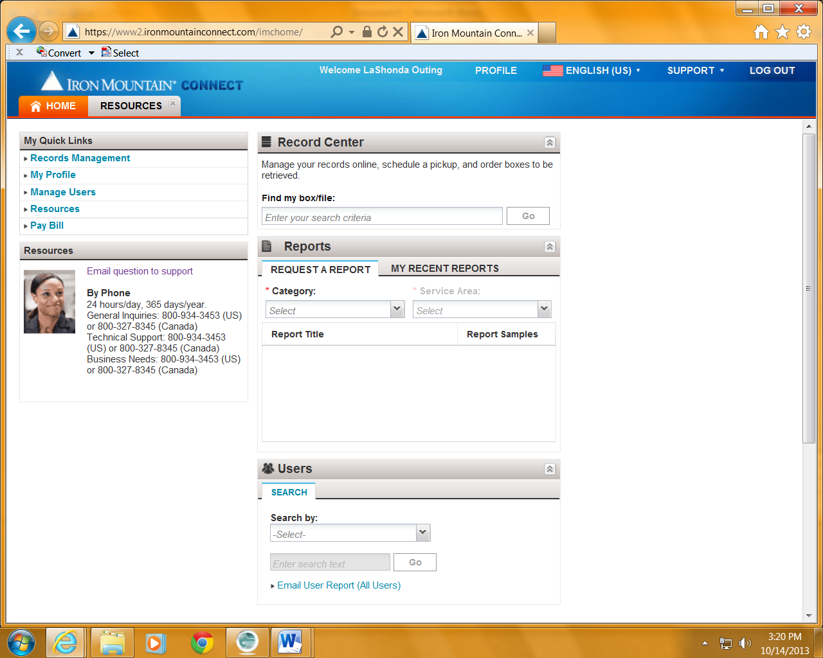
Click on RESOURCES to access Training Documents

Step 3:
Click on TRAINING, to access various Training Documents for viewing
This page provides important resources:
- Online Training for IMConnects Users
--Video Tutorial with step-by-step instructions

- Iron Mountain Connect User Guide
--Detailed User Guide with instructions

- How to Place a Pickup Order
--Instruction on how to place an order for record pickup

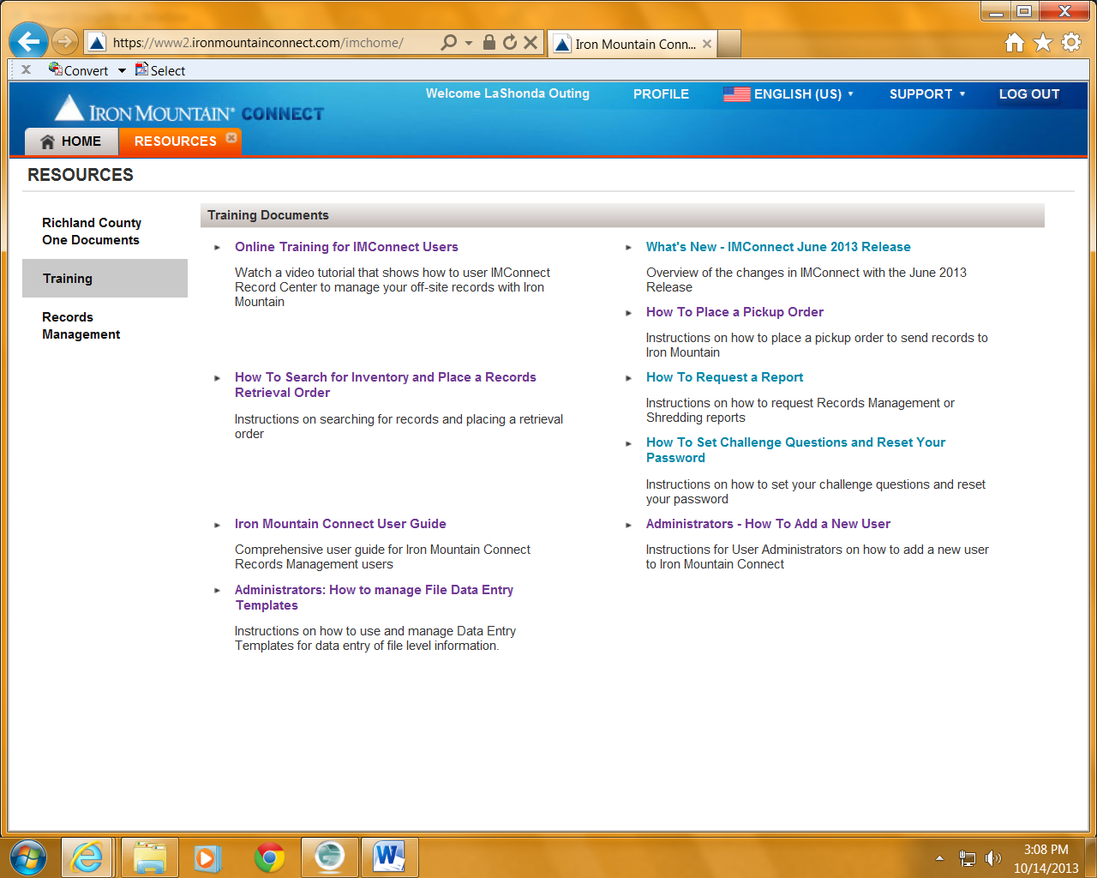
(3) How to Place a Pickup Order
(2) User Guide
- Video Tutorial

Important Contract Information:
Richland County School District One Iron Mountain Account No. SC505
Iron Mountain Connects Support (Forgotten Password) 1- 800-934-3453
District IM Administrator - Yolanda Propps – 803-231-7033 or ypropps@richlandone.org
Contract Administrator – LaShonda Outing, 803-231-7037 or louting@richlandone.org

