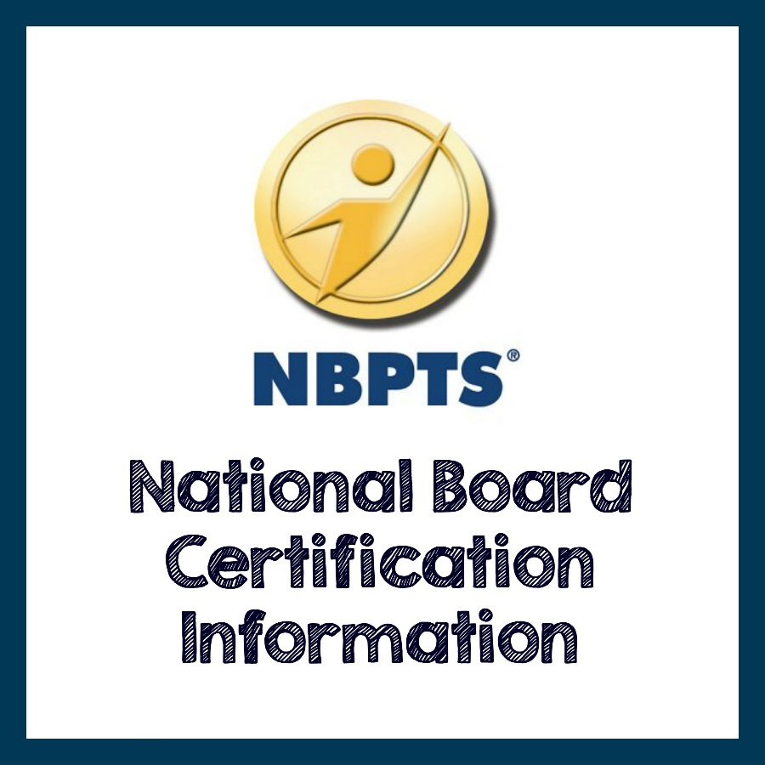
The Center for Educator Quality
621 Bluff Road
Columbia, SC 29201
803-400-1669

District Liaison: LaToya Curry-Jones, NBCT
Lead Facilitator: Deidre Murph, NBCT
Lead Facilitator: Pamela Williams, NBCT

National Board Candidates (First Time & Returning)
http://boardcertifiedteachers.org/first-time-candidates
Eligibility
To be eligible for certification, teachers must meet education, employment, and licensure requirements. You will be asked to verify these during registration. The requirements are:
• Verify a bachelor’s degree (NOTE: Candidates for the Career and Technical Education certificate are required to hold a bachelor’s degree only if their state required one for their current license.
• Have completed three years of successful teaching
• Hold a valid state teaching license or meet the licensure requirements established by your state for a school counselor (if applying for the ECYA/School Counseling certificate
• Prerequisite for World Languages candidates: In addition to the candidate eligibility requirements, World Languages candidates must provide official American Council on the Teaching of Foreign Languages (ACTFL) certified ratings of Advanced Low or higher from ACTFL speaking and writing proficiency assessments. Refer to the Guide to National Board Certification for details.
Important Dates and Deadlines

You are expected to complete all components for which you register during the assessment cycle in which the component is purchased.
The following information is applicable to candidates submitting components for scoring during the 2016-17 assessment cycle.
2016-17 Important Dates and Deadlines
Registration Window | April 1, 2016-January 31, 2017
Registration (includes payment of $75 fee) | January 31, 2017
Component Selection (includes payment of component fees) | January 31, 2017
Change of Certificate and/or Specialty Area | January 31, 2017
Fees
Fee Type | Details |  | Amount | 2015-16 Cycle  Deadline | 2016-17 Cycle  Deadline
Registration Fee* |  | Charged once per assessment cycle. You will not be able to select a component without payment of this nonrefundable and nontransferable fee. | $75 | No later than January 31, 2016 | No later than January 31, 2017
Component 2–4 Fee (first attempt and retake) | Required for all portfolio components. |  | $475, per component | January 31, 2016 | January 31, 2017
Component 1 Fee (first attempt) | Required for the Content Knowledge assessment. |  | $475 | January 31, 2016 | January 31, 2017
Component 1 Retake Fee | Required for each portion of Component 1 that you elect to retake. |  | $125 per exercise and/or the Selected Response section | January 31, 2016 | January 31, 2017
Component 1 Reauthorization Fee | If you require a certificate or specialty area change after the withdrawal deadline, miss your assessment center testing appointment, or do not cancel within 24 hours, you must be reinstated before you can schedule a new appointment. |  | $175 | August 30, 2016 | August 30, 2017
Returned Check Fee |  | This fee may be assessed if your personal check is returned for non-sufficient funds | $35 | 30 days after notification | 30 days after notification

Scholarships and Funding
Through the generosity of corporate and foundation partners, National Board is periodically able to offer a limited number of scholarships to help offset a portion of the fees for National Board Certification. Scholarships are allocated under the guidelines set by the donors on a first come, first served basis. If you are eligible for a scholarship, the funds will be automatically posted to your National Board account prior to the published payment deadline and you will be notified via email. Please note that funding is limited and you should not rely on a scholarship to cover your component fees.
* Richland County School District One will pay one registration fee of $75.00 for each candidate. See LaToya Curry-Jones for details.
RCSD1 Support Session Dates
Date | Time | Location | Topic | Facilitator
10/11/16 | 4:30pm-5:30pm | Olympia Learning Center | National Board Awareness | Pamela Williams, NBCT
10/25/16 | 4:30pm-5:30pm | Olympia Learning Center | National Board Renewal | Deirdre Murph, NBCT
11/15/16 | 4:30pm-5:30pm | Olympia Learning Center | Component 2 | Pamela Williams, NBCT
11/22/16 | 4:30pm-5:30pm | Webinar  Webinar Link : https://richlandonemeetings.webex.com/richlandonemeetings/j.php?MTID=mb04cadcb51cf3210769b96c21899d88a | Component 2 | Deirdre Murph, NBCT
12/13/16 | 4:30pm-5:30pm | Olympia Learning Center | Component 3 | Deirdre Murph, NBCT
1/17/17 | 4:30pm-5:30pm | Olympia Learning Center | Component 4 | Deirdre Murph, NBCT
1/31/17 | 4:30pm-5:30pm | Webinar  Webinar Link: https://richlandonemeetings.webex.com/richlandonemeetings/j.php?MTID=m7969f08ed3a026098a7de4407541e0ca | Component 3 | Deirdre Murph, NBCT
2/28/17 | 4:30pm-5:30pm | Olympia Learning Center | Component 1 | Pamela Williams, NBCT
3/21/17 | 4:30pm-5:30pm | Webinar  Webinar Link: https://richlandonemeetings.webex.com/richlandonemeetings/j.php?MTID=m0d8e40a2dc1fbc91fe479e85634d4fee | Component 1 | Pamela Williams, NBCT
4/18/17 | 4:00pm-6:00pm | Olympia Learning Center | National Board Support Session | Volunteer NBCTs
5/2/17 | 4:00pm-6:00pm | Olympia Learning Center | National Board Support Session | Volunteer NBCTs
5/16/17 | 4:30pm-5:30pm | Olympia Learning Center | National Board Awareness | Pamela Williams, NBCT

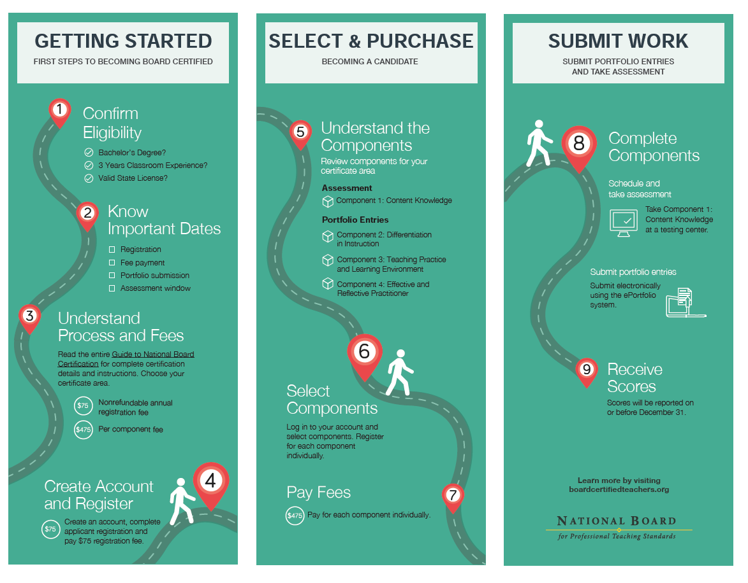

Renewal Process
Eligibility Requirements for Renewing Your Certification:
- Your initial or renewal certificate is still valid.
- Your teaching license is current and unencumbered.
- You are in the eighth/eighteenth, ninth/nineteenth, or tenth/twentieth year of certification.
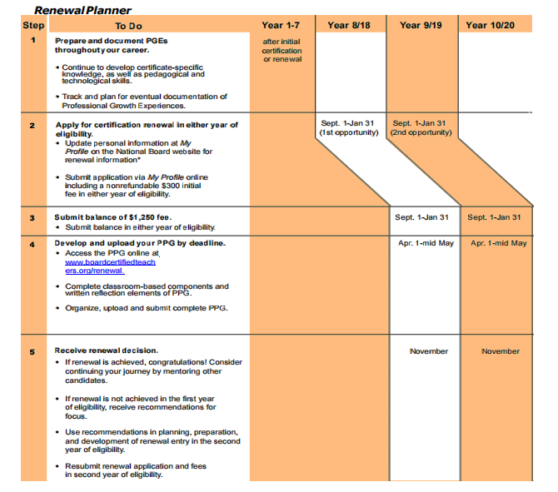

Profile of Professional Growth
The renewal process is not recertification. It’s a process by which you compile and submit a Profile of Professional Growth (PPG), demonstrating how your practices continue to align with the Five Core Propositions in your certificate area. In contrast to initial certification, the PPG is a single submission composed of three interrelated components and a reflection. These components draw upon a single group of Professional Growth Experiences (PGEs) you select.
IMPORTANT NOTICE:
Beginning in 2021, NBCTs will extend their certificate through a new process called maintenance of certification (MOC). Please click here for additional details.
Also, please note the Standards for your certificate area may have been revised since you initially achieved certification. Please click here for the current standards.
Component 1: This requires you to submit responses to prompts related to four areas of your professional growth that reflect your continuous commitment and contributions to professional activities that ultimately have an impact on student learning.
Component 2: This requires you to choose one of your PGEs featured in Component 1 and demonstrate its application in the same content and developmental level as your original certification. You do not have to be a full-time teacher in the classroom to complete this component.
Component 3: This requires you select another PGE from Component 1 (not the one used in Component 2) and demonstrate either a direct or indirect impact on student learning.
Reflection: Submit a written reflection that requires you to analyze the connections and patterns among the first three components, focusing on challenges encountered as well as plans for continued professional growth and efforts to impact student learning.
Previous renewal candidates report the PPG process takes 30-40 hours. Since candidates for renewal have already demonstrated they are highly accomplished teachers, approximately 9 out of 10 candidates successfully renew their certification.

Important Contact Information
Customer Support
Office: 1-800-22TEACH 8:00am-6:00pm
www.nbpts.org
http://boardcertifiedteachers.org/
CERRA
Jenna Hallman, State Contact
Email: hallmanj@CERRA
Office: 1-800-476-2387
Richland County School District One
Center for Educator Quality
LaToya Curry-Jones, District Contact
Lcurry-jones@richlandone.org
Office: 803-400-1711
Fax: 803-400-1686
Mail Code 582

References
Board Certified Teachers. (n.d.). Retrieved September 21, 2016, from http://boardcertifiedteachers.org/

