La Grange Elementary School Council
Oldham County Schools

A G E N D A

April 22, 2024

- Opening Business
  - Call to Order/Attendance
  - Agenda Approval
  - Approval of previous meeting’s minutes
  - Review Norms
  - Public Comment

- Council discussions stay within the group until the action item has been approved by the Council
- Start on time and end on time
- Maintain a focus on ensuring the learning of all students
- Be willing to share ideas and open to new learning

- Council Action Items
  - 24-25 Professional Development Draft (Enclosure A)
  - Leopard Spot Budget (Enclosure B)
  - Title I Evaluation Plan and Data (Enclosure C)

- Principal’s Report
  - Grant Writing Committee Report
  - Enter Closed Session to Discuss Certified Personnel Selection per KRS 61.801 (1) (f) for discussions that might lead to the appointment of an individual employee

- Adjourn

La Grange Elementary
School-Based Decision-Making Council
March 25, 2024
The La Grange Elementary School Site Based Decision Making Council met in the library for the regularly scheduled monthly meeting with the following members in attendance: Brittney Stephens – Teacher Rep, Tovah Jeffries – Parent Rep, Tracy Simpson – Teacher Rep, Nancy Valencia de Morgan – Teacher Rep and Heather Thomas - Chair. Abby Guinn, ECE Teacher also joined the meeting as a guest at 2:50 pm. Kiley Walker – Parent Rep joined the meeting at 3:03 pm.
Mrs. Thomas called the meeting to order at 2:40 pm.
1) A motion was made by Tracy Simpson to accept the agenda. The motion was seconded by Brittney Stephens and the motion carried with no opposition.
2) Mrs. Thomas went over the school budget for the 24-25 school year. She explained how all monies would be used, discussed student to teacher ratio and class sizes for next year. The plan was satisfactory to the Council and a motion was made by Tovah Jeffries to accept the budget as presented. The motion was seconded by Nancy Valencia de Morgan. The budget was passed with no opposition.
3) Mrs. Thomas discussed the proposed curriculum for the 24-25 school year. Mrs. Thomas explained the goal of Senate Bill 9 (2022), which is called the Read to Succeed Act and what its purpose is. She also explained what curriculum LaGrange Elementary uses. We have used Engage NY EL Education, which supports all the requirements for SB9. The district is currently piloting multiple reading curriculums and hosting collegial conversations with the school all with the goal of selecting 2 reading curriculums off the state approved list. All grade-level PLC’s met in January and unanimously opted to stay with EL Education. A motion was made by Tracy Simpson to approve the continued use of EL Education for the upcoming school year. The motion was seconded by Brittney Stephens and the motion carried with no opposition.
4) Mrs. Thomas reviewed the results of our Impact Survey with the Council. No action was necessary.
5) Abby Guinn left the meeting at 3:10 pm
6) The Council entered into Closed Session to Discuss Certified Personnel Selection per KRS 61.801(1)(f) for discussion that might lead to the appointment of an individual employee at 3:17 pm. The Council came out of Closed Session at 3:23.
7) With no additional business, a motion was made to adjourn by Brittney Stephens. The motion was seconded by Kiley Walker and the Council adjourned at 3:25 pm.

La Grange Elementary
School-Based Decision-Making Council
March 29, 2024
The La Grange Elementary School Council met in a special-called session in the library of La Grange Elementary School with the following members in attendance: Tovah Jefferies (parent), Brittany Stephens (teacher), Tracy Simpson (teacher), Nancy Valencia de Morgan and Heather Thomas (chair), called the meeting to order.
1. The meeting was called to order at 11:30 AM
2. The Council reviewed and approved the agenda.
3. The Council entered a closed session to discuss certified personnel selection as
provided by KRS 61.810 (1)(f) at 11:30 AM..
4. The Council resumed open session at 11:40 AM.
5. With no further business, the Council adjourned.

April 22, 2024
Enclosure A

La Grange Elementary School Council
Oldham County Schools
CONCERN:
Review Professional Development Plan for 2024-2025

DISCUSSION:
All certified staff must complete 24 hours of professional development. School based decision-making councils have authority over determining professional development. With that said, there are specialized areas (special education teachers and related arts teachers) that need specialized training. Also, there have been common needs identified by the district that would benefit all teachers. Our PD plan represents both district and school options to individualize the professional development based on the needs of the teacher.

RECOMMENDATION:
Review the 24-25 Professional Development Plan. Remand the plan back if changes, additions, or deletions are necessary. Approve the plan for implementation in the coming school year.

La Grange PD Plan
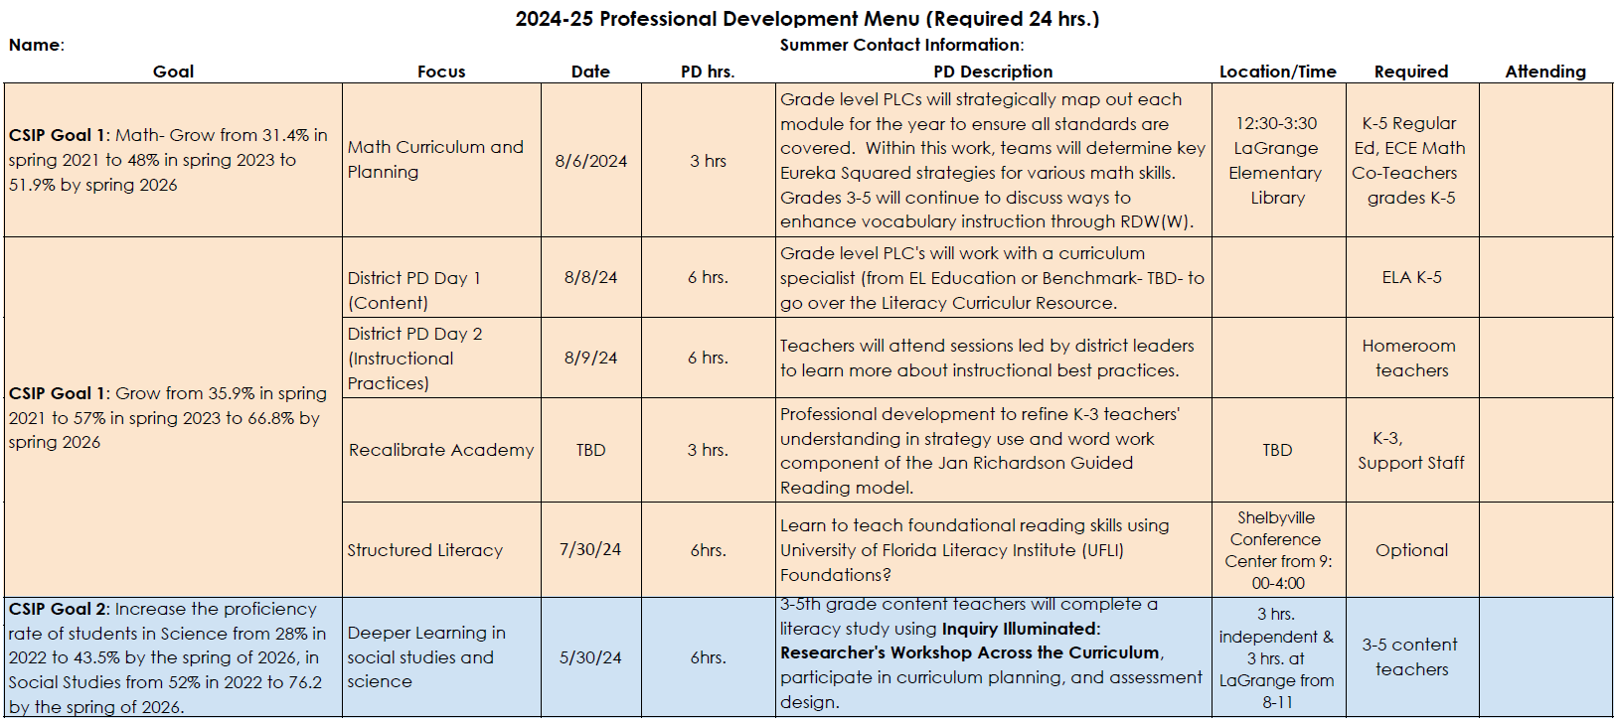
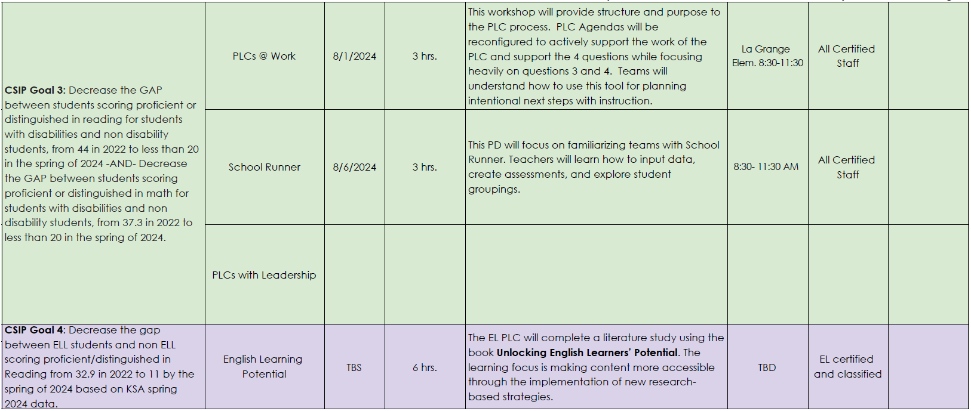
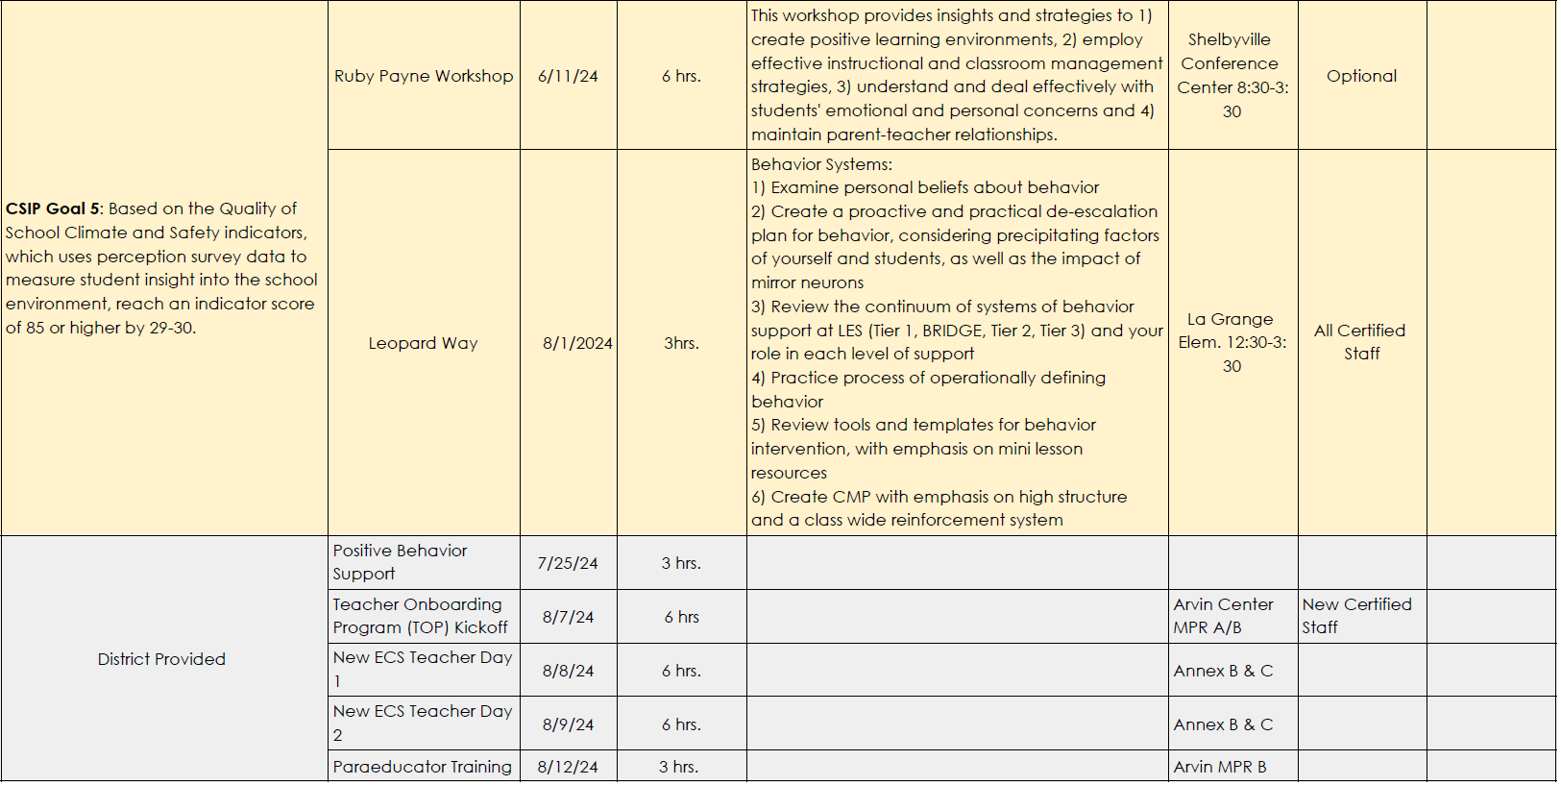

April 22, 2024
Enclosure B

La Grange Elementary School Council
Oldham County Schools

CONCERN:

La Grange Elementary, like the other schools in the district, operates a private, after-school child care program as a means of offering affordable options for families. The profits from the Leopard Spot program also help subsidize additional staff members, like our intervention teacher and second counselor.

DISCUSSION:

As a Council, we need to review operational costs, school financial support and overall profit to ensure bills are paid for the 24-25 school year and to forecast into the following year.

RECOMMENDATION:

Review and approve our Leopard Spot budget, pending no additional questions or suggestions.

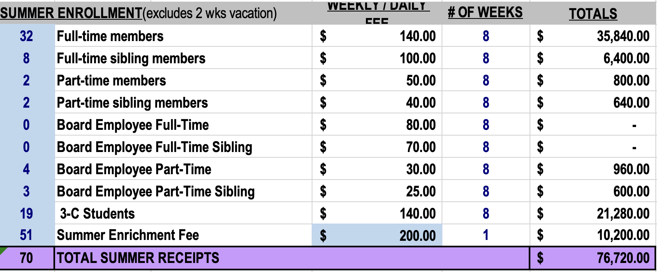

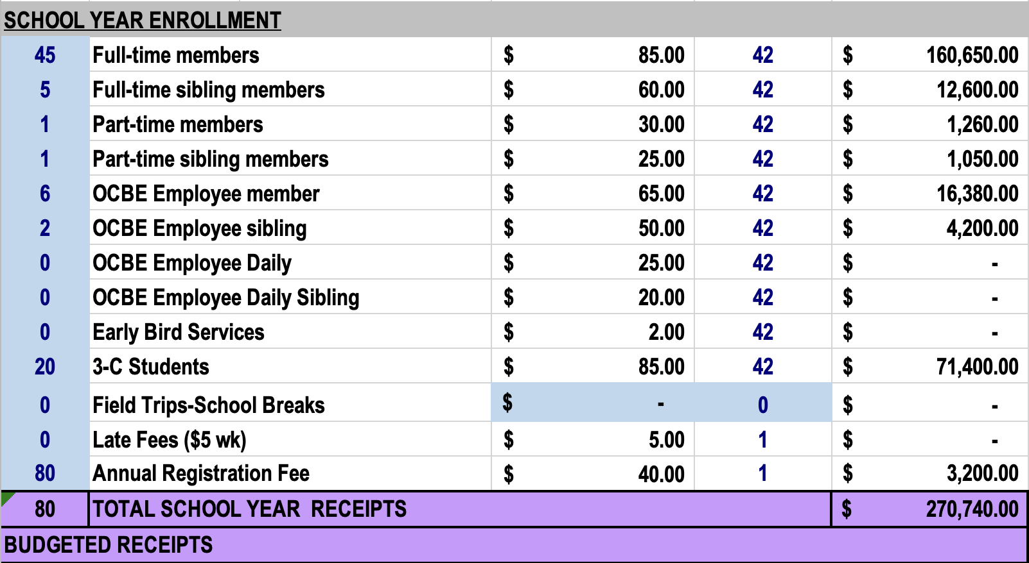

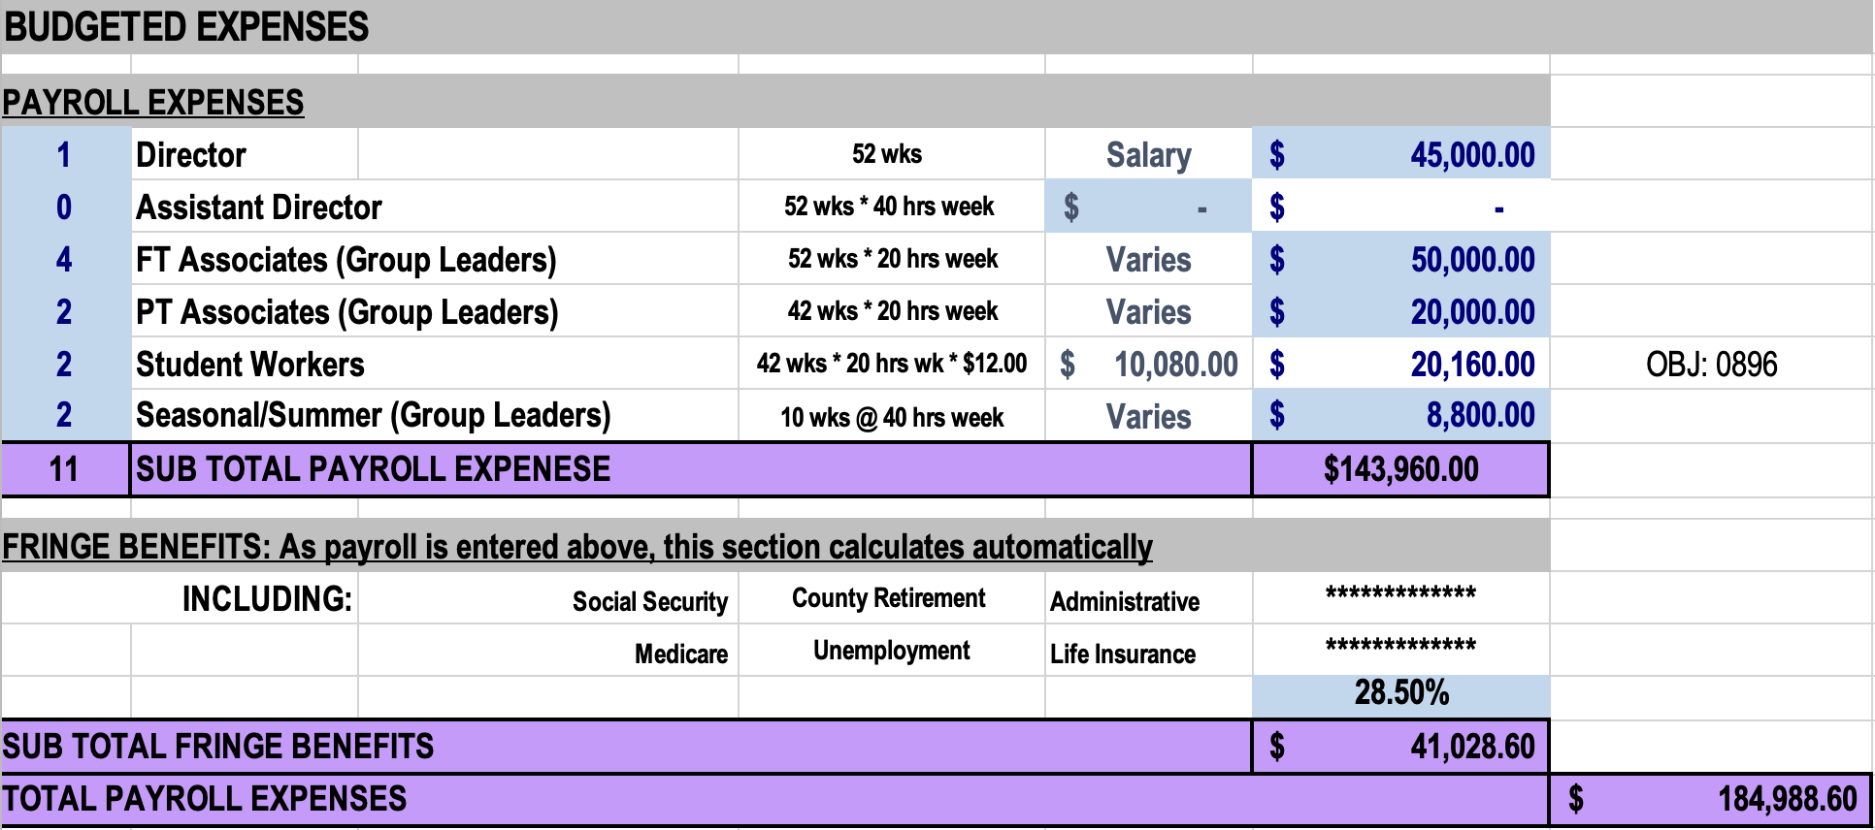

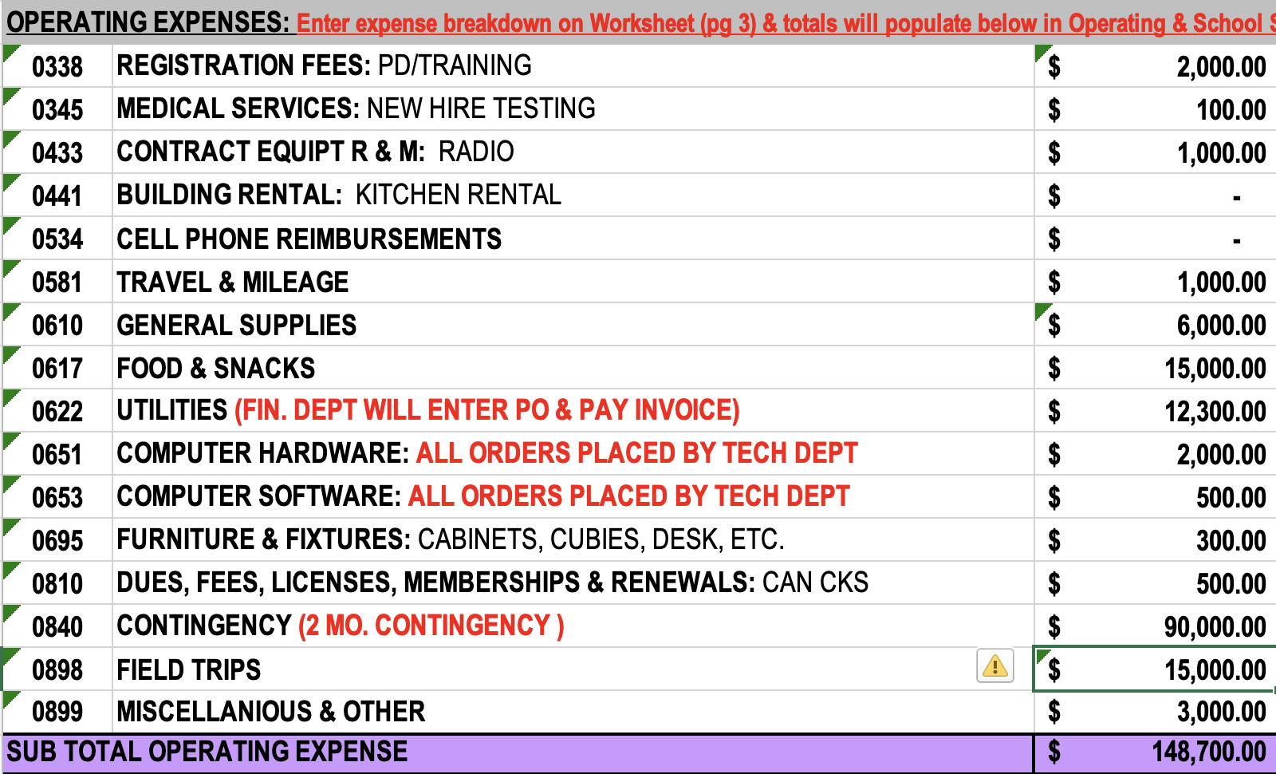

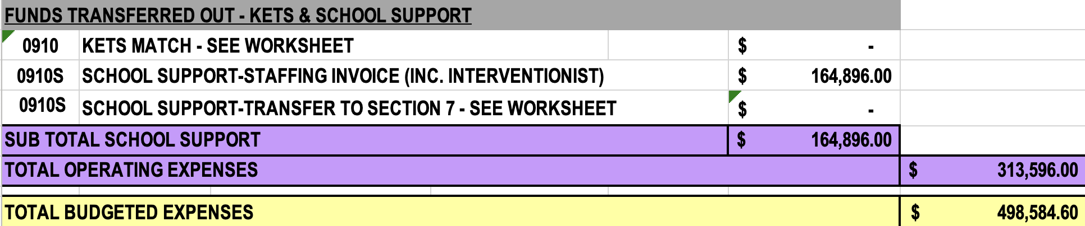

April 22, 2023
Enclosure C
La Grange Elementary School Council
Oldham County Schools
CONCERN:
The school council’s mission is to improve student achievement (KRS 160.345(2)(c)). Each school council must create an environment in its school that will result in students achieving high levels. All policies and decisions by the school council must contribute to the achievement of the overall school’s mission. As a Council, we need to review and evaluate our data in order to make programming decisions.

DISCUSSION:

Data:
- Jamie Parker: (Title 1)-This position showed to be effective. This teacher worked with students in Tier 3 Reading in grades K-5. The teacher used Jan Richardson in Guided Reading and the iReady Toolbox lessons as her methods of instruction. All students made growth according to the Spring iReady assessments. Second and Third grade showed the most growth.

K | 340 | 364 | 24
K | 361 | 390 | 29
K | 297 | 345 | 48
K | 355 | 374 | 19
K | 333 | 372 | 39
K | 343 | 371 | 28
1 | 321 | 363 | 42
1 | 339 | 385 | 46
1 | 368 | 409 | 41
1 | 358 | 391 | 33
1 | 339 | 404 | 65
2 | 424 | 436 | 12
2 | 365 | 427 | 62
2 | 388 | 448 | 60
2 | 428 | 441 | 13
2 | 391 | 479 | 88
2 | 427 | 463 | 36
2 | 391 | 500 | 109
2 | 389 | 440 | 51
2 | 447 | 488 | 41
3 | 469 | 524 | 55
3 | 487 | 518 | 31
3 | 459 | 558 | 99
3 | 445 | 483 | 38
4 | 489 | 511 | 22
4 | 482 | 531 | 49
4 | 481 | 492 | 11

- Taron Clark: (Title 1)- This position showed to be effective. The teacher supported students in math clinics for grades 3-5. The teacher used Do the Math and iReady Tools for Instruction as her method of instruction. All students showed growth using the iReady Spring diagnostic as her indicator. Third and fifth grades showed the most growth..

3 | 399 | 449 | 50
3 | 394 | 458 | 64
3 | 406 | 435 | 29
3 | 396 | 427 | 31
3 | 430 | 452 | 22
3 | 408 | 448 | 40
4 | 404 | 431 | 27
4 | 419 | 424 | 5
4 | 428 | 449 | 21
4 | 372 | 433 | 61
4 | 423 | 441 | 18
4 | 422 | 447 | 25
5 | 437 | 464 | 27
5 | 427 | 457 | 30
5 | 424 | 455 | 31
5 | 458 | 448 | -10
5 | 429 | 459 | 30
5 | 439 | 445 | 6

- Tracy Simpson: (Title 1)- This position showed to be effective. This teacher worked with students Tier 2 Writing. Writing students in grades 4-5. The teacher used RACE writing strategy in a small group setting. All students showed growth according to the Spring data assessments. 5th graders showed the most growth .

Grade | BOY iReady | EOY iReady | Pts Gained
3 | 399 | 449 | 50
3 | 394 | 458 | 64
3 | 406 | 435 | 29
3 | 396 | 427 | 31
3 | 430 | 452 | 22
3 | 408 | 448 | 40
4 | 404 | 431 | 27
4 | 419 | 424 | 5
4 | 428 | 449 | 21
4 | 372 | 433 | 61
4 | 423 | 441 | 18
4 | 422 | 447 | 25
5 | 437 | 464 | 27
5 | 427 | 457 | 30
5 | 424 | 455 | 31
5 | 458 | 448 | -10
5 | 429 | 459 | 30
5 | 439 | 445 | 6

