No or Low Cost Options for PSAT/SAT/ACT Preparation
Seniors and Juniors and even Sophomores looking for an early advantage - especially those taking advanced classes in math- can improve their scores on the SAT/ACT tests by doing some preparation. The summer between Sophomore/Junior or Junior/Senior years is the perfect time to study, then take the first test of the year.


Offers a self-paced online course for ACT prep at just $299. Click HERE
College Board and the Khan Academy have teamed up to offer cost free online preparation for the new version of the SAT. Link your past PSAT (and SAT) to the academy for
https://www.khanacademy.org/sat
https://www.khanacademy.org/test-prep/new-sat/new-sat-tips-planning

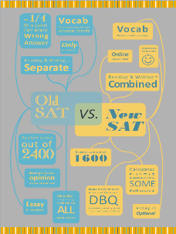
Scottsdale Public Library System offers great online ACT/SAT/PSAT as well as SAT Subject/ AP Subject Test preparation help. To get to these free resources, go to our homepage, www.scottsdalelibrary.org, click on "Browse the Library," click on "Learning & Research," then click on " Education” Icon and browse down the page to . These resources are available at all their libraries, including Palomino, without a library card and pin number, or at any other location (at home) with the card and pin number.

 a leader in textbook sales for years has expanded their online offerings. Free standardized test prep resources, tips, and lessons, and some great college resource materials are available.
SAT or ACT


Do you need to take or retake the SAT but are just too busy to study? Not sure if a test prep company will help? If you like video games and self study, try a monthly subscription toMAGOOSH Check it out at: https://sat.magoosh.com/plans They offer a 7 day, money back guarantee so you can test it out.
Interesting Free websites for prep:
- http://www.mometrix.com/academy videos
- erik the red http://www.erikthered.com/tutor/
- Princeton Review, Kaplan also offer free SAT/ACT testing and review dates. Check out their websites:
kaptest.com/hsevents
http://www.princetonreview.com/offer/free-practice-tests#!Test-ACT put in your zip
Download an app (many are free) to your phone
Click icons for lists
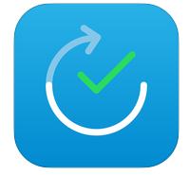
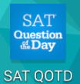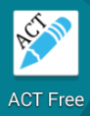
TimePrep for SAT
Buy a book:
The REAL ACT Prep Guide (available on Amazon)

All the BARRON’S Books are well liked: http://barronseduc.com
ACT Prep Plus 2018: 5 Practice Tests + Proven Strategies + Online (Kaplan Test Prep)

rev. 8.30.17

