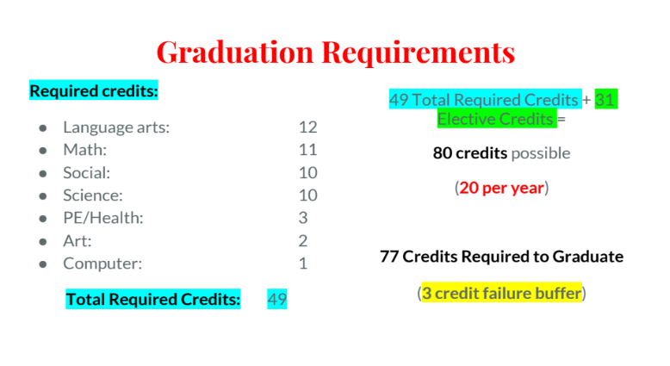
Credit Recovery is a term used to describe a wide variety of educational strategies and programs that give high school students, who have failed a class, the opportunity to redo coursework or retake a course. Attached to this email you will find the Credit Recovery application form; a service for making up credits to fulfill graduation requirements. As of now, Credit Recovery Night School will be offered on Wednesday’s @ Sauk Centre Secondary Media Center from 3:15pm-6:15pm. If this is the option you would like to do to recover your credit/s from any previous coursework not passed, or prior school year/s not passed please sign the form and return it to Mrs. Thiesen/Mrs. Nelson in the Counseling Office. In addition, the start date will be Wednesday, October 5, 2021.
The cell number and contact information needs to be filled out completely, that is extremely important when completing the application.
Heather Thiesen
Secondary & Middle School Counselor
Sauk Centre Public Schools
903 State Road
Sauk Centre, MN 56378
320-352-2258 ext. 2332
320-352-3404; fax
heather.thiesen@isd743.org

