Grade 5 Essential Understandings

Standards of Mathematical Practice emphasized through the year in grades K-5:

- Make sense of problems and persevere in solving them
- Reason abstractly and quantitatively
- Construct viable arguments and critique the reasoning of others
- Model with mathematics
- Use appropriate tools strategically
- Attend to precision
- Look for and make use of structure
- Look for and express regularity in repeated reasoning

Grade 5 – Marking Period 1

Students begin the year with a focus on deepening their understanding of place value in both whole numbers and decimals. The Next four topics will cover whole-number and decimal operations. Students use the standard algorithm to fluently multiply multi-digit numbers.
Examples include:

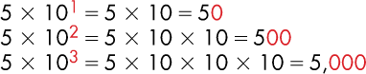
Place value work

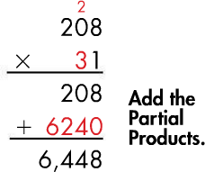
The use of partial products as a strategy to multiply.

Mathematical Focus | Topic Goals
Place Value and Decimals | Use exponents to write powers of 10 Understand multi-digit place value Read, write, and compare decimals to  thousandths *Round whole numbers and decimals Add and subtract decimals to the hundredths Multiply and divide by powers of ten. Multiply multi-digit whole numbers (3x2 and 4x2)  Multiply decimals to hundredths
Computational Fluency | Fluently multiply multi-digit whole numbers using  the standard algorithm

Grade 5 – Marking Period 2

During the second marking period students will use models and strategies including standard algorithms, to divide with 2-digit divisors and to perform all four operations on decimals through hundredths. Later in the second marking period, students will focus on a deep understanding of using equivalent fractions to add and subtract fractions and mixed numbers and then move on to multiplication and division from whole numbers to fractions.
Examples include:

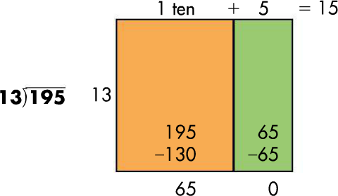
Divide using models and partial quotients.

Multiply and divide from whole numbers to fractions.
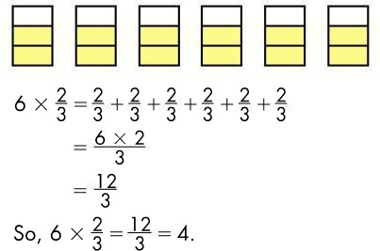

Mathematical Focus | Topic Goals
Place Value and Decimals | Divide multi-digit whole numbers (3x2 and 4x2)
Fractions | Add and subtract fractions with unlike denominators, including mixed numbers Solve addition and subtraction word problems with fractions  Multiply a fraction by a whole number and other fractions  Understand the relationship between the size of the product and the size of the factors

Grade 5 – Marking Period 3

In the third marking period, students will continue to apply their understanding of division to divide fractions. Next, they will deepen their understanding of the measurable attributes of volume and using numbers and operations to describe and compute the volume of a rectangular prisms and composite shapes. In topic 11, students will focus on using multiplication and division to convert measurements of length, capacity, weight, and mass within in either the customary or metric measurement system. Topic 12 with further student understanding about line plots to represent and interpret data, with an emphasis on data involving fractions. By the end of the marking period, students will shift their focus to using the

Order of Operations to evaluate, write and interpret numerical expressions with grouping symbols.
Examples include:
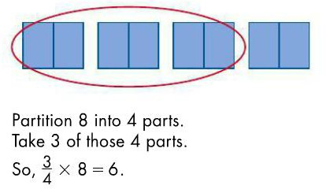

Students will use the order of operations to solve numerical expressions.
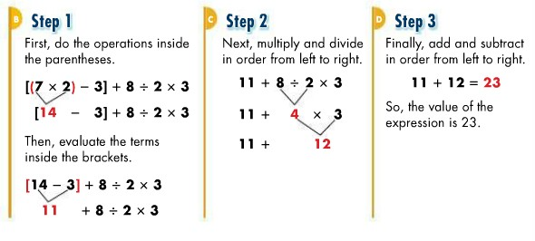

Mathematical Focus | Topic Goals
Place Value and Decimals | Explain patterns in the placement of the decimal  point when a decimal is multiplied or divided by a power of 10.
Division with fractions | Interpret a fraction as division of the numerator by the denominator (for example, interpret 3/4 as the result of dividing 3 by 4)  Divide unit fractions by whole numbers Divide whole numbers by unit fractions  Divide unit fractions by whole numbers and divide

whole numbers by unit fractions to solve word
problems
Measurement and Data | Measure volume  Find volume using the formula  Recognize volume as additive: find volumes of solid figures composed of two non-overlapping right rectangular prisms by adding the volumes of the non- overlapping parts  Convert measurements using like units and use these conversions in multi-step problems  Make a line plot to display a data set of measurements in fractions of a unit
Numerical Expressions and Patterns | Write and understand equations without solving for them  Use parentheses, brackets, or braces in numerical expressions

Grade 5 – Marking Period 4

In the last marking period, students will begin to develop an understanding of the Cartesian coordinate system. Students will graph ordered pairs in the first quadrant of the coordinate plane to solve real-world and mathematical problems. Students will also focus on patterns and relationships by generating number sequences using given rules. Students will generalize to describe the relationship between corresponding terms. Students will round out the year focusing on understanding that the attributes belonging to the category of two dimensional shapes also belong to all subcategories of that category. Students will begin to explore integers, rational numbers on the coordinate plane as well as rations, rates and percent’s.
Examples include:

The coordinate plane:
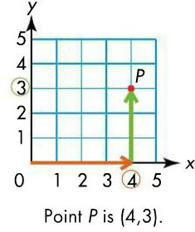

Classifying triangles:

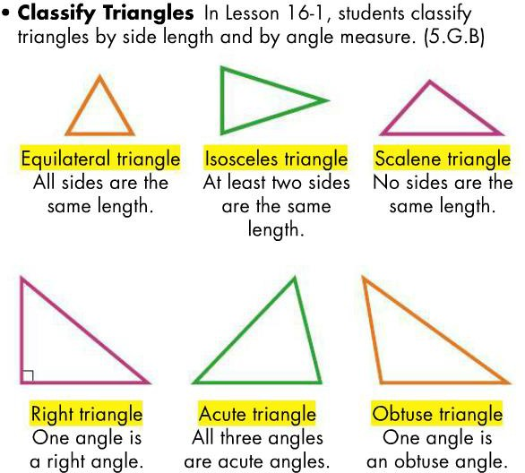

Mathematical Focus | Topic Goals
Geometry | Graph ordered pairs  Graph ordered pairs to solve problems Understand sub-categories of two-dimensional figures based on attributes (triangles and quadrilaterals)
Numerical Expressions Patterns | Use number patterns to solve equations involving  input/output machines

