Become an Amazon Future Engineer Sponsored Educator in Teaching Computer Science Grades K-6

Registration is now open for the 2024-2025 Cohort

The Amazon Future Engineer sponsorship provides professional development to elementary and middle school teachers on the content and pedagogy of computer science education.
Benefits of this Program
- Learn to incorporate Computer Science Technology tools and practices applied to all subject matter in your classroom.
- The Bootup Curriculum prepares teachers to facilitate open ended projects in the free coding platforms of Scratch Jr. and Scratch. No experience in teaching how to code required.
- Collaborate with other teachers in district and via the Amazon/Bootup National Network of Districts and Schools implementing this program.
- Access to the large database of Bootup lessons at www.bootuppd.org.
- Instructors participating receive STEAM materials and supplies for your classroom (Example: Micro:bits, Finch robots, Beebots, Spheros, Makey Makey and Lego).
- Teachers and students may participate in guided virtual tours or, when available again in the future, site visits to local Amazon fulfillment centers to discover how state of the art Engineering, Computer Science and People power the efficiency of Amazon’s delivery system. Please see https://www.amazonfutureengineer.com/fctours for more information.
- At the end of this program, teachers may apply for the annual Amazon Future Engineer Teacher Awards. Winners receive $25,000 funding for school projects plus a $5,000 stipend.
Eligibility, Professional Development, and Program Timeline
- All K-6 Classroom Teachers, Instructional Coaches, TAs, Library Media Specialists, STEM Teachers, Enrichment Teachers, Teachers of SWD, ELL/ENL and Technology Specialists.
- Onsite PD and support for 2023-2024 school year.
- Teachers attend 3 in person and 3 virtual PD workshops.
- Afternoon/Evening sessions from 3:45 pm to 6:45 pm from September to March.
- PD sessions are divided by 6 workshops for teachers in K-2 and 6 workshops for teachers in 3-

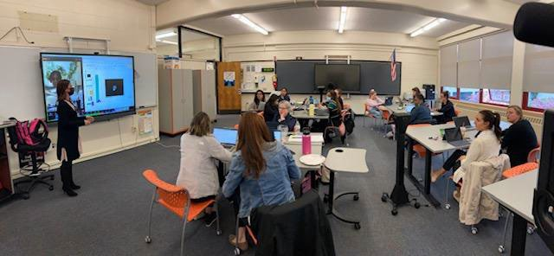
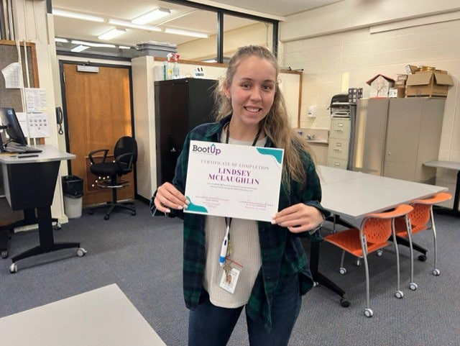
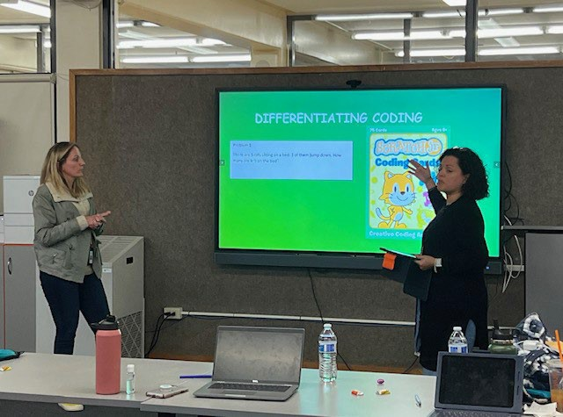
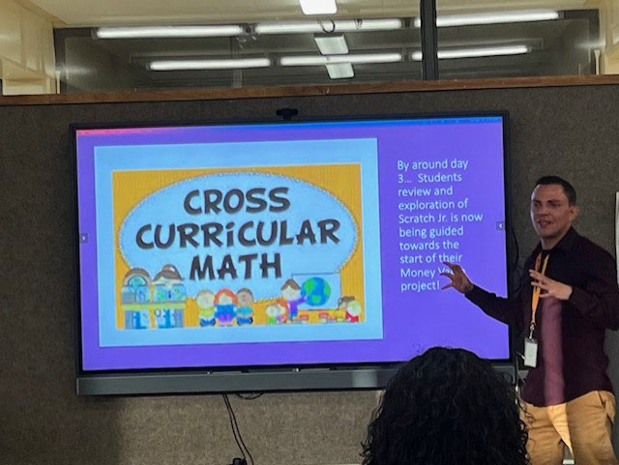
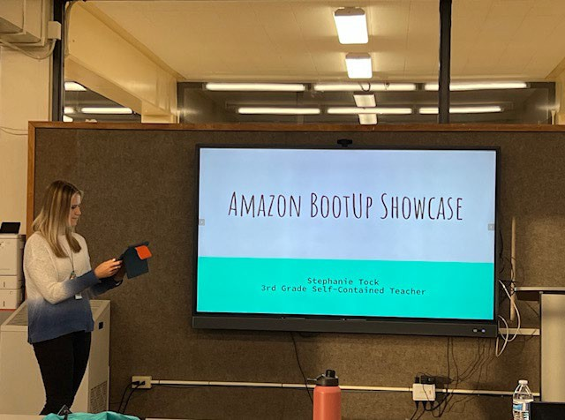
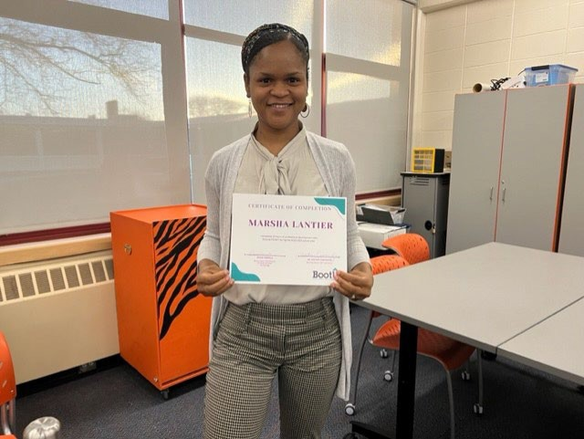
6 grade bands.
- Specialists who teach all grades in K-5 may opt to attend both grade band PD sessions totaling 12 workshops.
- Teachers participate in model teaching and coaching. A Bootup Instructor provides coaching visitations to classrooms to assist the teacher in lesson development and instruction.
How do I Apply?
Please contact your Building Principal or K-5/6th grade Coordinator first to request participation in this exciting program and fill out the following form HERE by May 29, 2023.

Attending Classroom teachers/Specialists are eligible for credit or stipend.

Contact roccovaruolo@wpcsd.k12.ny.us for further information regarding program specifics.


Professional Development Teacher Objectives

Teachers will ableto Introduce andJmplt. nt thefoUowinc,Into their'tuching:

- Computational Ttlinking con(ept'S: Algorithm, Decomposllion, Pattern Recognition, Abstraction, imd Analysis (Debugging)
- COdioC C011Up1$: Loops/Repelllion,Evtn1$,C<>ndfti0na1$, Vor13blOS, lttratiOn, Boolean LoSIC(IF, AND, NOT,OR), Input/Output
Process,and Equawn
- 21$1-Century skills:Communication,Collaborotl()I\, CrtllcalThinking.CteatMty

111111,. Foundallonl

Teachers willhe.fp theirstudtnts und«mnd theImportance of lum1ng codingby teachln1the nudfflts.:

- Foundations; 'NhytecilCh cod-,,g.What is Computer Science, What doesit took like-, All Kids Can Code, Digital Cititenihip
- Prattic:e-$/Sta.ndards:CSiA K•ll Framework
- AttitudM and 8eh1vion: COmmunrty of Pr ice (PLC}, G!owth•M1nds.et, R1sk•Ti1king. Persistence. Explortr,Tinkerer,
rocmtow. Problcm•Solv«,Cqulty, 011ildlJ>6 • PO!itlvt clouroom e,in,re, ond Pal,ed Progrommlng

Psf IIIV

Teachers win learnseveol oedacods,I tecbolam iodudin@=
- Manaeement: Manag·ng blcts & technology, De\1eloplng acolaboratfveclassroom,Content ufcty,ind Clas.iroom configuration
- Teaching Approaches: Modelrng, Whole group lesson, Guidedlesson (Ido, youdo),Reve-rse engineering. Scaffolding, Teacher
asfa<il4ator, RAG(self-martung ro, help), and 8eing• l'Ofle<tiv<? tea<her (usrna BootUp Journals),
- aa.woom Mott,lals/Confiaur41tfons:Resourc al\d setup

IIDolUp! 11<11

Teachers w;uleunbowtouse theBootUe lesson elam,whkbinclude:
- Protect based & interHt based lessons that can be adJusted to fit a myriad of [nterens/subJectareas, Coder resources that bongnewstudentsup to spttd nd helpguide struggUng students, "I wllllt-arn"stntemcr,ts, AssMSmt"nt questloM and actMtlies. reflectionqun:tloM, reveM eng1nfffins guidance,differentlatlon/extensk>ns; and Oestsn/storyboardlng8\ddance
Teachca willbc:come ocofk!tot at teacbtnccodincusfncthefotlowlnr onUnc tooli:
- ScratthJr (K·2) Sharing; projects, Findinglessons, App tutorials., and Usint;the pictureeditor
- Scratch (l-6}Creating teacher accounts, Managingstudios. Remixine, Commentin,on code, and Sharing pro;ects

PltyllcalC'iDmpulq

Jcadlcct WiH lnatn to sbaccdCYCIOOOlC/0t:aland AH iPP(OOditJC ph'(Hcal computfnc actiyjljt:5!
- unptuutd a«lvlUos
- Robo1$/Papu Robot$
- Optional Purchased Materials: Let'sGoCode, Robot MoU$0/Mats, Bee Bot Robou, Dash Robots,Deb<Jssing Ducks, Rosie's Runtime, Puzzlets,.Coding book.$, library activities, Ozobot, Mi<;rob1t, etc.

