Your Design Should:
- Control radiation, conduction and convection.
- Cook 1 egg.
Somers
Somers
A solar cooker uses the sun to cook food.
About 1.5 billion people don’t have electricity!

STEM
STEM
Solar Cooking Challenge

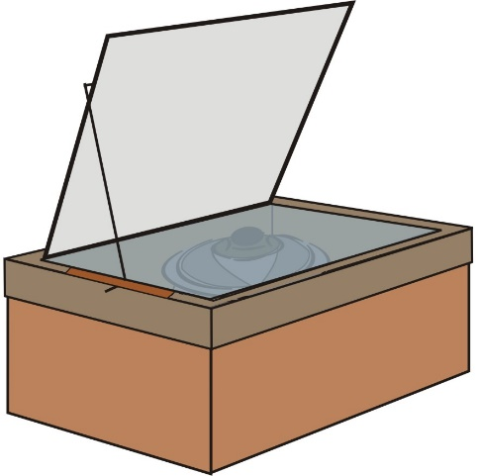
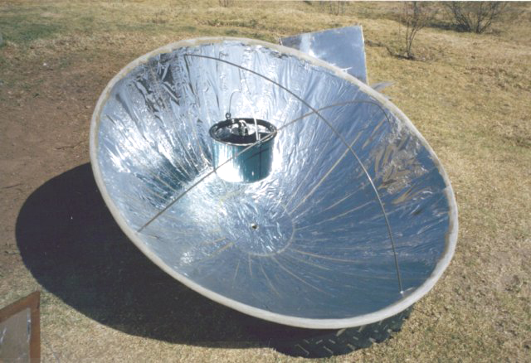

The Challenge:
You have been hired to design and build a solar cooker for people to use in Uganda.

