Somers
Somers
STEM
STEM
Help the Homeless

There are approximately 60,000 homeless people living in NYC

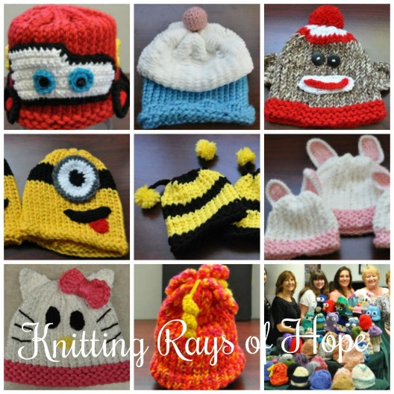


The Challenge:
Build a hat loom and make a warm winter hat to donate!

How to use a hat loom directions
https://www.youtube.com/watch?v=XKE_JK5oF7U

Your Design Should:
- Be a standard size hat to fit an adult.
- Colorful!

