Your Design Should:
- Be built from recycled materials.
- Use a renewable energy source. (wind, solar, geo-thermal…)
- Conserve water (rain collection system, tankless water heater…)
- Have a perimeter of 72” or less.
- Be creative and colorful. (landscaping – deciduous trees on the south side)
- Realistic – have doors and windows (smaller windows on north side if any)
Somers
Somers
A green home is a high performing home that is energy and water efficient. The home is also built out of environmentally friendly materials.
STEM
STEM
Green Home Challenge

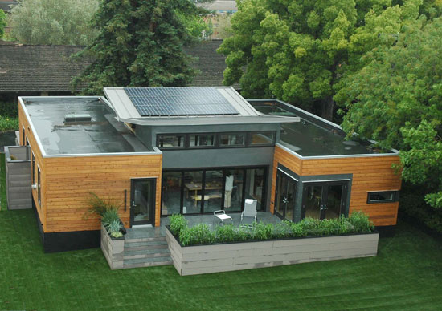
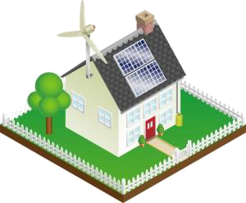

The Challenge:
You have been hired by the town of Somers to design and build a green home to serve a community center. Before the full sized version can be built, you must build a scale model of your design.

