Ollie Robot Innovation Design Challenge
Somers
Somers
STEM
STEM

Ollie – A App-controlled robot with a tough polycarbonate shell that will travel up to 6.3 m/s (20.6 f/s, 14 mph). The iOS & Android compatible app to control Ollie can be downloaded for free.

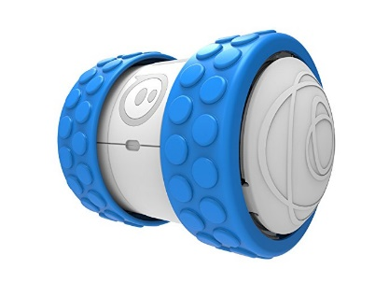

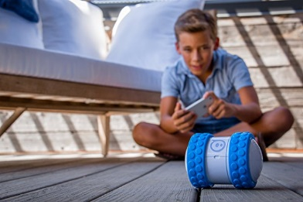

The Challenge:
You have been hired as an engineer by the Sphero Company to design and build a device that will allow Ollie to carry cargo.

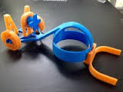
Your Design Should:
- Temporarily attach to Ollie
- Hold at least 2 hot wheels cars
- Allow Ollie to drive the 2 hot wheels cars across the entire MakerSpace as fast as possible
- Be made using materials found in the MakerSpace

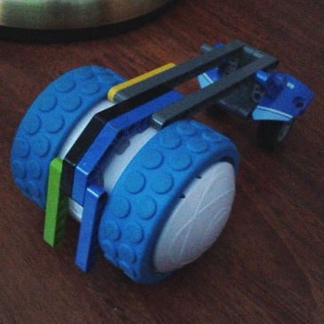
Sphero 3D Printing Story
https://www.youtube.com/watch?v=eoO6BSA3NNc

