Passive Speaker Design Challenge
Somers
Somers
STEM
STEM

Passive Speaker – a speaker that can amplify sound without using electricity.



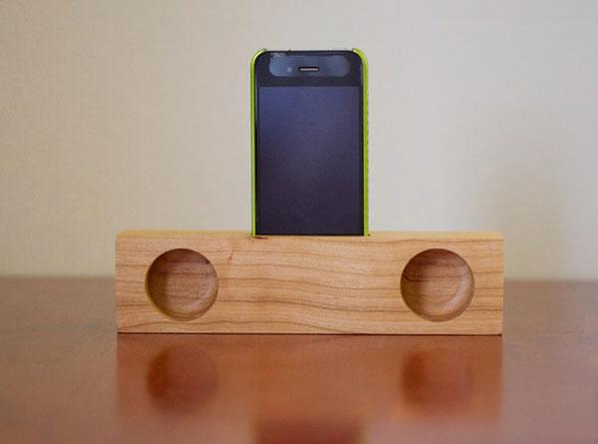

The Challenge:
You have been hired as an engineer by Apple to design a universal passive phone speaker docking station.

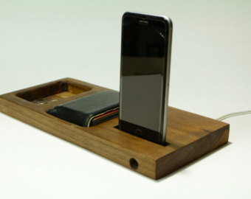
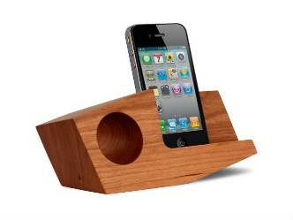
Your Design Should:
- Be able to amplify sound
- Hold a cell phone
- Be 3 ½” x 10” or smaller
- Have a creative design
- Be made using wood and recyclables
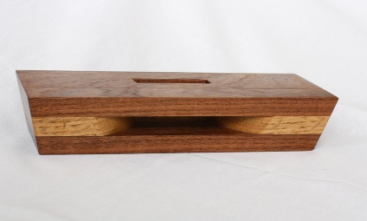
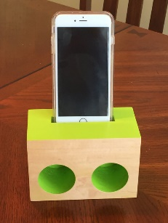

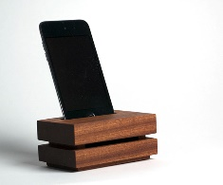
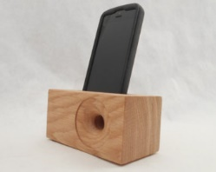
The video link below shows the process of creating a speaker
https://www.youtube.com/watch?v=pojJIMo8U2I

