Your Design Should:
- Have a perimeter of 50” or less.
- Be creative and inviting for the species.
- Be presented to the zoo board of directors.
- Be submitted with a completed 7 Steps of Problem Solving worksheet.
Somers
Somers
Habitat: A habitat (which is Latin for "it inhabits") is an ecological or environmental area that is inhabited by a particular species. It is the natural environment in which an organism lives, or the physical environment that surrounds (influences and is utilized by) a species population
STEM
STEM
Habitat Design Challenge

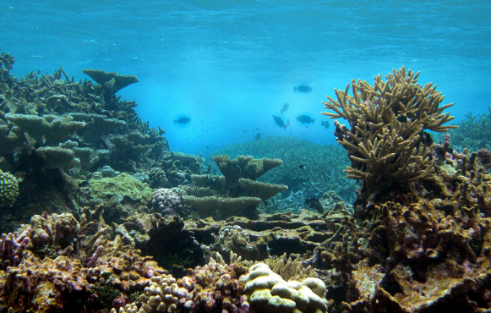
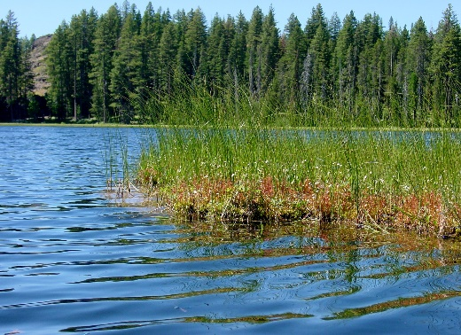

The Challenge:
You have been hired as a bio-engineer by the Bronx zoo to design and build a model habitat for a specific species.

