Your Design Should:
- Be wind powered.
- Carry 1 small empty water bottle as cargo.
- Have a perimeter of 19” or less.
- Be creative and colorful.
- Be able to compete in the class tournament.
- Be submitted with a completed 7 Steps of Problem Solving worksheet.
Somers
Somers
Sailing is the propulsion of a vehicle and the control of its movement with large (usually fabric) foils called sails.
STEM
STEM
Tundra Ferry Challenge

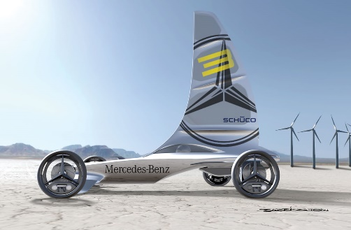
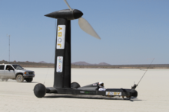

The Challenge:
You have been hired as an engineer by an Austrailian shipping Company to design and build a wind powered vehicle that can carry a water bottle. Your design will be used in the Somers Middle School Wind car tournament. The tournament will take place at the conclusion of this project.

