Skate Park Design Challenge
Somers
Somers
STEM
STEM

Skateboarding – riding on an oblong piece of wood, plastic, or aluminum mounted on large roller-skate wheels.

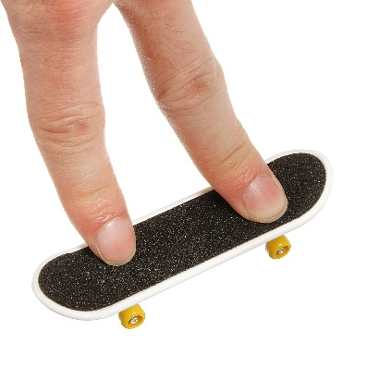
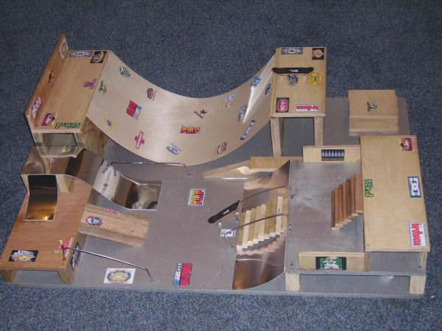
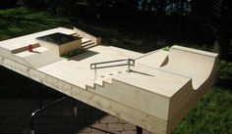

The Challenge:
You have been hired as an engineer by the town of Somers to design and build a new community skate park.

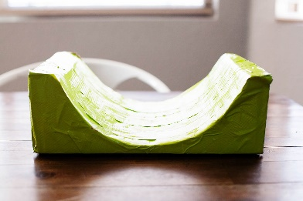
Your Design Should:
- Be made using materials found in the MakerSpace
- Have a creative color design and theme
- Incorporate one 3D printed part
- Incorporate your own finger skateboard, BMX bike, or hover board design.
- Have a minimum of 4 ramps, jumps, or other obstacles

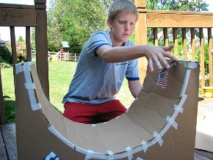
How to make a finger Skate Park
http://www.wikihow.com/Make-a-Fingerboard-Skatepark

