Robotic Hand Design Challenge
Somers
Somers
STEM
STEM

Robotic Hand – a type of mechanical device with similar functions to a human hand.

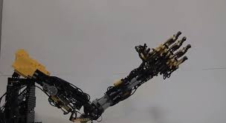
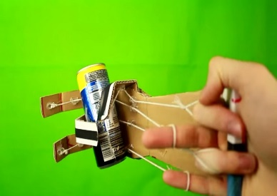
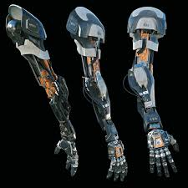

The Challenge:
You have been hired as an engineer by the Somers Robotics Corporation to design an improved cardboard robotic hand.

Your Design Should:
- Be able to grip and move 3 objects of your choice
- Be made using materials found in the MakerSpace
- Be safe for people to use
- Have a creative color design
- Incorporate one 3D printed part

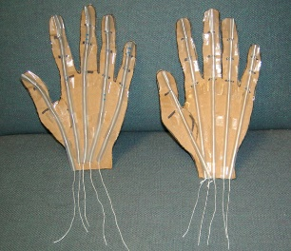
Use the video link below for hand building instructions.
https://www.youtube.com/watch?v=PqOetlij6G4

