Rube Goldberg Design Challenge
Somers
Somers
STEM
STEM

A Rube Goldberg machine is a complicated device made of simple machines. It is designed to accomplish a simple task. Such devices are inspired by a classic comic strip by American cartoonist Reuben Lucius ("Rube") Goldberg that featured wildly intricate inventions.


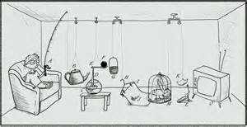

The Challenge:
You have been hired as an engineer by the Tusker Invention Corporation to design and build your own Rube Goldberg machine.

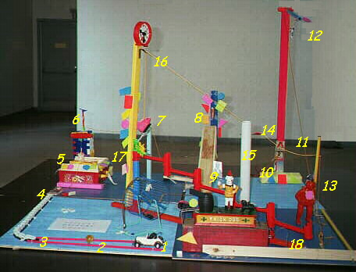
Your Design Should:
- Use a minimum of 5 separate steps.
- Move an empty water bottle 10 inches in the final step.
- Display the name of the simple machine used for each step.
- Be creative and reliable.
- Have a perimeter of 96” or less.
- Be safe to play.
- Incorporate one 3D printed part.
- Have short video summarizing your project.

