Roller Coaster Design Challenge
Somers
Somers
STEM
STEM

Roller coasters are thrill rides that operate like a railroad track and are a highlight of theme parks around the world. They are made from steel or wood and comprise a series of hills and drops, sudden turns, track loops and corkscrew-like elements. The roller coaster is a favorite ride of thrill seekers, and has evolved considerably from its days as a glorified slide.

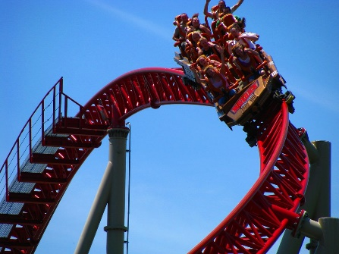
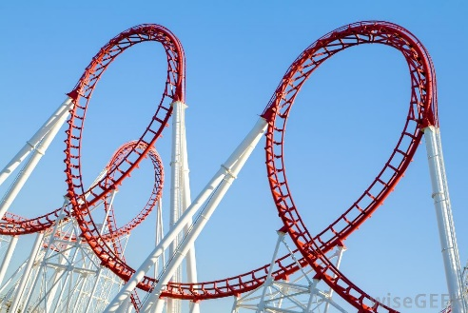

The Challenge:
You have been hired as an engineer by Six Flags to design and build the world’s most exciting marble roller coaster.

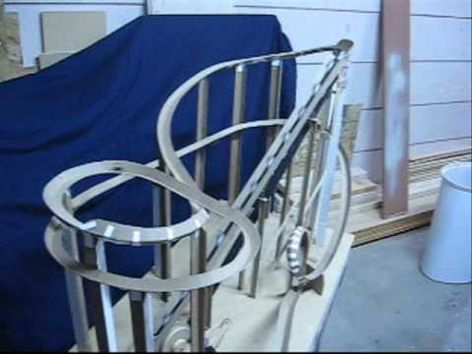
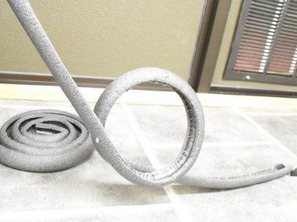
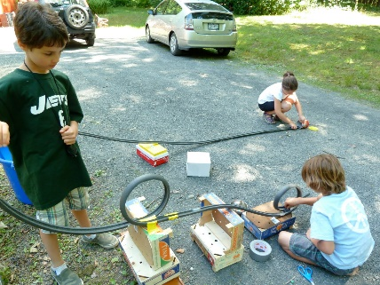
Your Design Should:
- Be built using pipe insulation tubes.
- Use pegboard to support the track.
- Have a 3-5 hills, corkscrews, or flips.
- Transport a marble from the top of the first hill to the end of the track.
- Have short video summarizing your project.

