Cardboard Arcade Design Challenge
Somers
Somers
STEM
STEM

Caine’s Arcade is a short film about 9-year-old Caine Monroy who built his own handmade cardboard arcade in his father’s used auto body shop. After a summer of waiting for customers with no luck, filmmaker Nirvan Mullick discovered the arcade and became Caine’s first customer. Nirvan created a short film about the arcade and Caine went on to have thousands of customers visit his cardboard arcade.
http://cainesarcade.com/

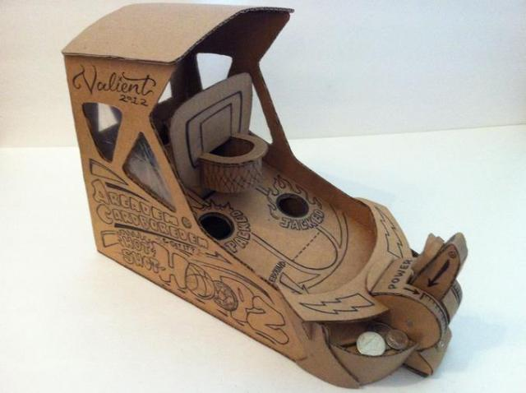
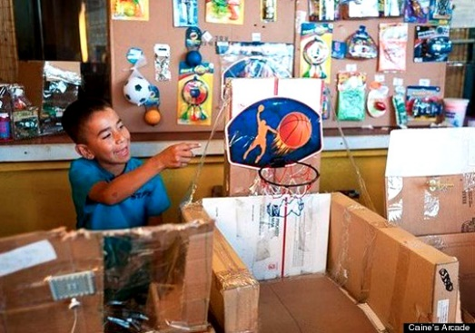
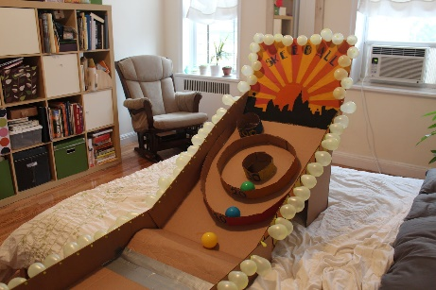

The Challenge:
You have been hired as an engineer by the Cardboard Creations Company to design and build a new version of a cardboard arcade game. Your design will be used by SMS students.

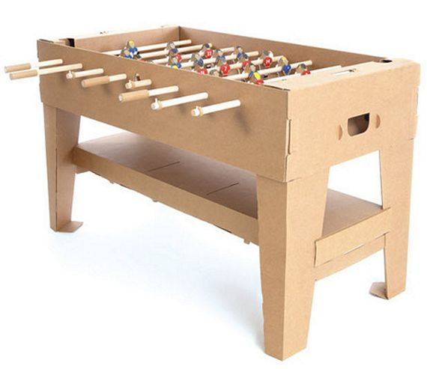
Your Design Should:
- Be creative and colorful.
- Have clear directions.
- Have a perimeter of 72” or less.
- Be safe to play.
- Incorporate one 3D printed part.
- Have short video summarizing your project.

