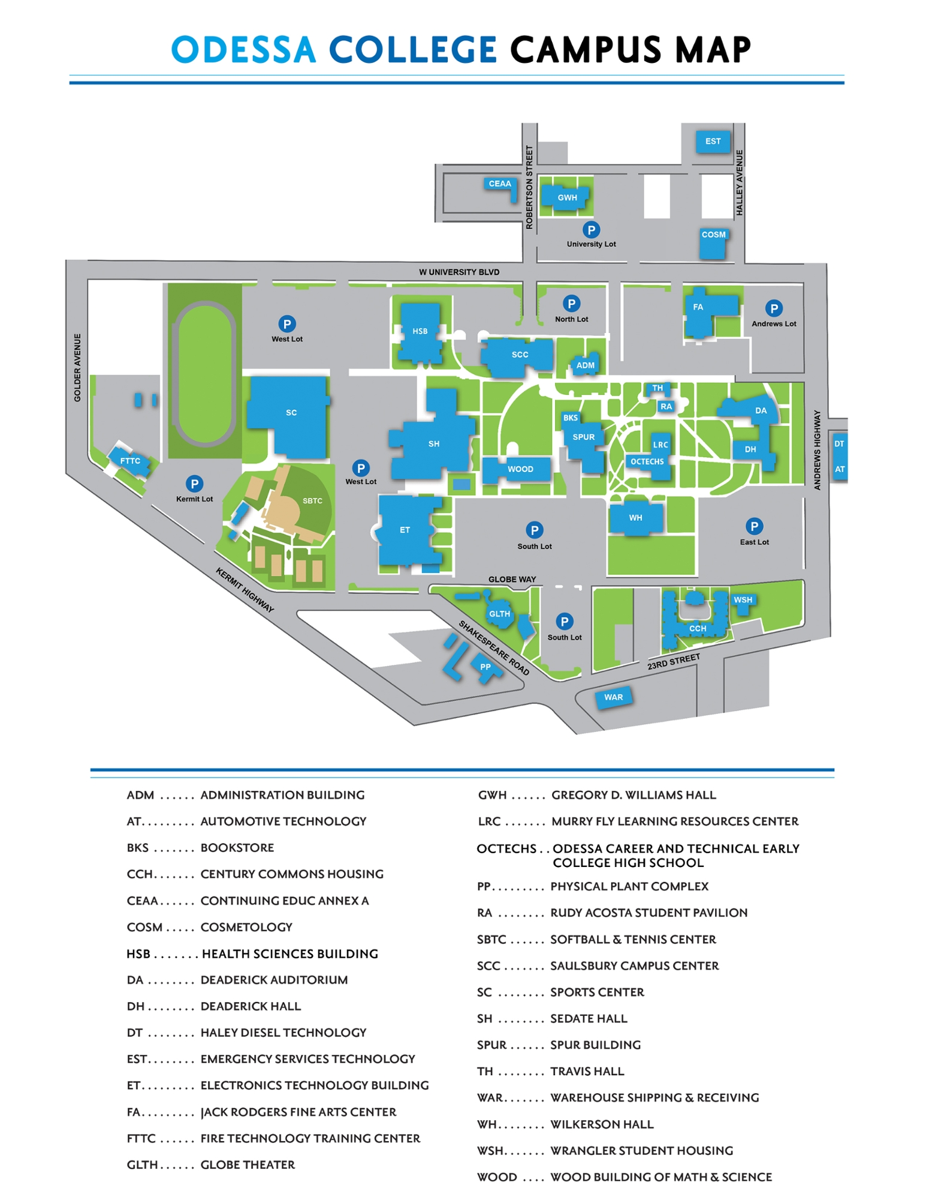
New HSB
You will drop off & pick up your
student HERE
EVERY DAY for Summer Bridge.

South Lot

Deaderick Auditorium

