
- Use a STUDENT Chromebook
- Do NOT login
- Click the Apps tab in the bottom left corner of the Chromebook
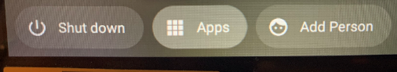

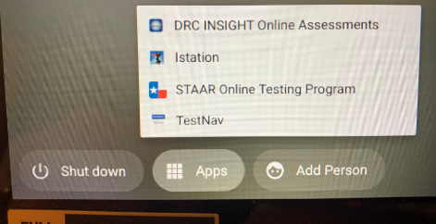

- Click on DRC INSIGHT.

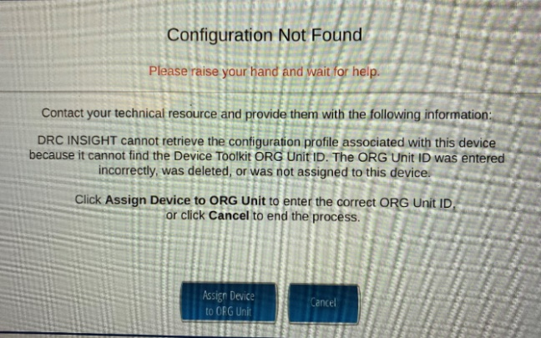
- Click Assign Device to ORG Unit

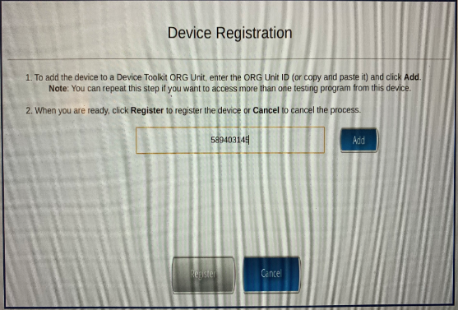
- Enter the organizational code 589403145
- Click ADD

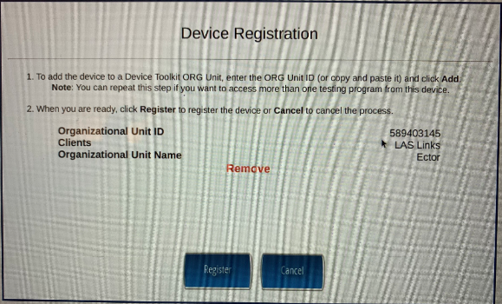
- Click Register

IF your Chromebook does not have the app or you are you are using an iPad,
you can go to the remote testing link

- Teacher or student login to CHROME

- Go to https://wbte.drcedirect.com/LL/#login
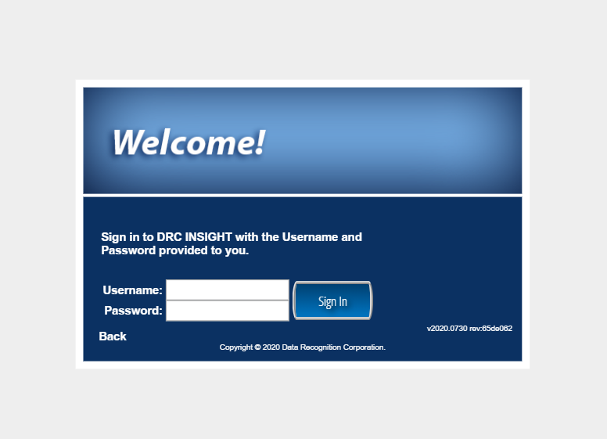

- Enter student ticket information

