The Bronx Charter Schools for Better Learning
Re-Opening Plan 2020-2021
July 31, 2020
UPDATED: DECEMBER 21, 2020

Executive Director
Thomas Howard, Jr., Ed.D.

Table of Contents

Response 1: R-01-Executive Summary …...................................................................................3
Response 2: Reopening Operations, Monitoring, Containment & Closure...............................7
R-02a– Reopening Operations …..............................................................................7
R-02b – Monitoring ….............................................................................................18
R-02c – Containment …...........................................................................................21
R-02d - Closure …....................................................................................................26
Response 3: Pre-Opening, School Calendars & Scheduling.....................................................27
R-03a – Pre-Opening...............................................................................................27
R-03b – School Calendar …......................................................................................31
R-03c – Scheduling for Students …..........................................................................32
R-03d – Scheduling for Staff …................................................................................34
Response 4: Enrollment & Attendance....................................................................................36
R-04a – Enrollment ….............................................................................................36
R-04b – Attendance................................................................................................36
Response 5: Academic Program...............................................................................................38
R-05a – Curriculum ….............................................................................................38
R-05b – Instruction ….............................................................................................38
R-05c – Assessment …............................................................................................39
R-05d – At-Risk Populations...................................................................................44
Response 6: Pre-Existing School Plan Attachment(s).............................................................46
R-06 – Pre-Existing School Plan(s)….......................................................................46

UPDATE: December 21, 2020
ATTENTION: BBL WILL BE FULLY REMOTE FOR THE REMAINDER OF THE 2020-2021 SCHOOL YEAR.

UPDATE: November 13, 2020
ATTENTION: BBL SCHOOLS GO INTO FULLY REMOTE LEARNING AS OF NOVEMBER 13, 2020. 100% OF OUR STUDENTS WILL BE LEARNING FROM HOME UNTIL WE CAN SAFELY TRANSITION TO THE HYBRID MODEL TENTATIVELY SCHEDULED FOR JANUARY 4, 2021, GIVEN THAT ALL DATAPOINTS SUPPORT IN-PERSON LEARNING. WE WILL CLOSELY MONITOR THE DATA, MAINTAINING THE HEALTH AND SAFETY OF OUR STUDENTS AND STAFF AT THE FOREFRONT OF OUR DECISION-MAKING.

UPDATE: AUGUST 17,2020
ATTENTION: BBL WILL BEGIN THE 2020-2021 SCHOOL YEAR REMOTELY. 100% OF OUR STUDENTS WILL BE LEARNING FROM HOME UNTIL WE CAN SAFELY TRANSITION TO THE HYBRID MODEL OUTLINED IN THIS PLAN. WE HAVE SET A TENTATIVE DATE FOR TRANSITIONING TO THE HYBRID MODEL OF MONDAY, OCTOBER 5TH, GIVEN THAT ALL DATAPOINTS SUPPORT IN-PERSON LEARNING. WE WILL CLOSELY MONITOR THE DATA, MAINTAINING THE HEALTH AND SAFETY OF OUR STUDENTS AND STAFF AT THE FOREFRONT OF OUR DECISION-MAKING.

Response 1: Executive Summary
Overview
Founded in 2003, the Bronx Charter School for Better Learning (BBL) runs two community-based schools, currently serving over 1,000 students. Our performance history shows that BBL provides students with a solid academic foundation that exceeds citywide averages and meets New York State standards. In 2019, BBL schools scored 60% and 67% in English Language Arts, and 75% on average in Mathematics. Approximately 80% of BBL students are from low-income to moderate-income families and are primarily (95%) comprised of Hispanic or African American families.
The data associated with COVID-19 shows that communities of color, such as ones in the Bronx, NY, are experiencing a disproportionate rate of severe illness and death. Some of the families we serve share similar social and economic factors already in place prior to the pandemic. Our aim with this reopening plan is to sustain a high-quality educational program and exceed the Interim Guidance for In-Person Instruction at Pre-K to Grade 12 Schools, published by the New York State Department of Health (NYSDOH).
Problem
The closing of BBL schools in March 2020 due to COVID-19 had an overpowering effect on the lives of children, parents, and staff at BBL. We felt the classroom's influence shift as teachers moved from traditional brick-and-mortar instruction to completely remote education.
Parents already suffering from the health and economic impact of COVID-19, now had to open their home’s privacy as an extension of the school’s learning environment. More so, our students, eager to learn, had to engage the rigors of BBL’s educational philosophy, the Subordination of Teaching to Learning, in their homes without in-person interaction with staff and peers.
BBL values equity in education as well as the health and safety of staff and students. As such, the reopening plan not only demonstrates accountability to NYSDOH requirements but remains true to the mission of our organization.
The Bronx Charter Schools for Better Learning provide their students with a solid foundation for academic success through achievement that exceeds citywide averages and meets or exceeds New York State Standards and national norms in all curriculum areas tested, especially in mathematics and language arts.
Our teaching continually adjusts to our students' needs, leading to independence, autonomy, responsibility, and a sustained love of learning, all of which contribute directly to high academic achievement.

Opportunity
The plan, following five months of remote teaching and learning, shows how BBL can now continue a high-quality educational approach while using a hybrid model and embracing new guidelines of the NYSDOH and the New York State Education Department (NYSED). The plan maintains accountability to our authorizer, the State University of New York (SUNY), Charter School Institute in the following areas:
- Educational Program – Implement a hybrid reopening program with high-quality remote and in-person instruction
- Safe and Equitable Teaching and Learning Environment – Monitor the health conditions for all constituents in two collocated public-school buildings
- Enhanced Safety and Hygiene Practices – Take assertive measures to contain the potential transmission of the 2019 novel coronavirus (COVID-19)
- Contingency Planning – Use a data-driven decision-making mode to close school facilities and in-person instruction, if compelled by an uptick in virus transmission
Based on the uncertainty of a proven vaccine and other medical solutions, BBL assumes that COVID-19 will continue through the 2020-21 school year and potentially beyond. While we can’t predict challenges that may surface over the months, we attest that our plan includes measures to run a safe and orderly return to school in September 2020.
Core Elements
BBL’s reopening plan builds on discussions with stakeholders, including parents, staff, faculty, school administration, and board of trustees. The plan considers different input in the following areas:
Core Focus
- PPEs and Face Coverings  - Social Distancing  - Classroom Cohort Structures  - Restructuring Space to Maximize In-Class Instruction  - Transportation  - Food Service | - Aftercare  - Extracurricular Activities  - Screening  - Contact Tracing  - Cleaning and Disinfecting  - Staffing  - Academic Program

Collocated Schools
As an organization with two collocated schools, the plan demonstrates the flexibility necessary to implement a unique solution in two public school facilities. Currently, BBL administrators serve as active participants of the Building Councils at PS 111 and MS 144. The councils will continue to meet often to approach issues and advance strategies with health and safety as a shared priority.
Collocated School Locations
School | Building Address | Collocated School
BBL1 | 3740 Baychester Ave-Annex, Bronx, NY 10466 | PS 111
BBL2 | 2545 Gunther Ave, Bronx, NY 10469 | MS 144

Educational Environment
BBL derives a high-quality environment for teaching and learning from an investment in human capital. Throughout the reopening period and beyond, staff will receive coaching to help create a trauma-informed organization and trauma-sensitive classrooms. We judge that a trauma-informed organization can best serve the social-emotional needs of students by also supporting the needs of staff.
We further believe that a healthy adult, following COVID-19, is better suited to provide a caring and nurturing environment for students whose families may be suffering from the impact of the pandemic. As such, each staff member will have a network of support that may include one-on-one coaching or peer-to-peer engagement in teams. Also, BBL will maintain a team of academic leaders and professional development staff to further offer their support in a time of need or opportunity for growth.
Between March and June 2020, BBL closed its physical doors due to COVID-19. Yet, parents stepped up and played a pivotal role in their children's educational experience. Parents voluntarily allowed the use of their homes to become a platform for continual learning. And they also participated in an ongoing regimen of communication, including the use of the Parent Portal, coordinated virtual parent meetings, and weekly family check-in calls from teachers and a seasoned team of Guidance Counselors.
Further, BBL created a Parent Resource Center page on our website. The tool provided parents with timely information on social-emotional learning, parent-webinars hosted by our Guidance Department, and content related to e-learning and community resources. As we consider the reopening options for the 2020-2021 school year, families will play an essential role in our student's education. Thus, we will sustain a partnership with families in their children's' education, through and beyond this period of COVID-19.
Reopening Planning Team
As a collaborative organization, BBL involved a cross-section of groups in the planning process. A panel of educators had an opportunity to contribute ideas to the plan and added subsequent feedback as we sought to improve the plan. Staff described feeling like their input mattered and being part of the strategic management process was motivating.
The process gathered information and ideas from the following means: small group meetings, anonymous online surveys, assessment data, parent meetings, and staff meetings. The contributors to the plan included the Executive Director, Principals, Assistant Principals, Director of Professional Development, Director of Students Services, Academic Leaders, Assessment Team, and Board of Trustees.
CARES Act Funding
On March 27, 2020, Congress passed the Coronavirus Aid Relief and Economic Security (CARES) Act, which the President then signed into law. New York State received $1.037 billion under the Elementary and Secondary School Emergency Relief Fund (ESSER).
BBL schools are eligible to receive CARES Act funding, and will apply for a total of $434,146, through the single CARES Act Combined Funding Application. A successful application will help the school combat the added cost of COVID-19 and support measures to safeguard the health and safety of all constituents in BBL schools.

Response 2: Reopening Operations, Monitoring, Containment, Closure
2a. Reopening Operations
Our plan builds on the discussions that we have been having with the various BBL stakeholders, including parents, staff, faculty, school administration and the board of trustees. We believe a blended learning model, with students in class on some days and remotely learning on others, balances our safety concerns with the need to bring students back. Also, in recognition of the fact that some parents will opt out and require 100% online instruction, as well as child care, we are investigating an option to partner with a community-based organization for childcare for working parents on the days of online learning when they cannot be physically present at home with their children.
- Capacity:
BBL has created a comprehensive plan for a schedule that is a hybrid of both in-person and remote learning which adheres to state and local health and safety guidelines and ensures social distancing practices. Our schools are working collaboratively with the district schools with whom we share space. Principals and United Federation of Teachers chapter leaders at the district schools conducted walkthroughs in June to determine how many people each school building could safely accommodate. Then, given the school’s projected enrollment and staff, we have calculated how many cohorts would likely need to be formed. We are forming three cohorts whereby each class will have a ‘Cohort A,’ ‘Cohort B,’ and a ‘Cohort C.’ The students in Cohorts A and B follow the blended model and those students in ‘Cohort C’ will learn remotely 100%. Students in Cohorts A and B will remain in their assigned cohorts for the duration of the plan. Parents who want their children to ‘opt in’ or ‘opt out’ of remote learning during the year will have the opportunity to do so on a quarterly basis.
A BBL student in Cohort A or B will receive 2 to 3 days in school every week. Each cohort will have 90 in-person instructional days in the 2020-2021 school year (assuming the New York City Department of Education, herein DOE, does not shut down). Cohort A will attend Mondays and Wednesdays and 'alternating' Fridays. Cohort B will attend Tuesdays and Thursdays and 'alternating' Fridays. The Fridays each cohort attends will be based on the days off in the week. The Fridays each cohort attends will be indicated on the BBL school calendar. Families who request 100% remote learning will be placed in Cohort C. BBL is exploring the use of private space to house students who need childcare during remote instruction.

- Social Distancing:
Parents/guardians will be asked to take their child’s temperature either before coming to the facility or upon arrival at the facility (those who transport kids to school) and confirm instances where children do have fever, shortness of breath or cough. Parents will be told to keep these children at home and to seek medical attention. The school nurse will follow up with these parents to ensure that all Centers for Disease Control, herein CDC, guidelines are followed when COVID-19-related symptoms and subsequent cases are identified.
BBL has developed a plan for social distancing, which it will implement and enforce in all school facilities and on school grounds, including transportation. The largest size of the in-person groups of students is determined to be a maximum of 12, since this is the number of students who can be in full size classrooms while maintaining six feet social distancing.
Since we operate in co-located facilities, we are working with our District partners to stagger arrival and dismissal times and to allow for increased social distancing on buses, in the school yard as well as in classrooms. We are dividing up student entry points rather than funneling all students through the same entry space, to limit the amount of close contact between students in high-traffic areas (corridors, lobbies, stairwells). We will use separate entrances for arrival and dismissal times will be staggered. Our partners will begin dismissing at 2:00 p.m. each day, while BBL will begin at 3:00 p.m. All additional entrances/exits will be monitored by Security or non-instructional staff in order to ensure that all safety requirements are followed. All staff being considered for such assignments will be trained by the Building Response Team (BRT). Designated areas for student drop-off and pick-up have been established to limit contact and entry of parents/guardians into the building. All visits to our buildings by parents/guardians/visitors will be to our Main Offices and will be subject to hand sanitizing, temperature check and wearing of a mask. Hand sanitizing stations will be set up at the Security Desk and in the Main Office.
In order to maximize social distancing in our school areas, there are modified class schedules and transitions to reduce in-school movement. The same cohort of students will have the same teacher each day and special area teachers (Music, Art, Physical Education) will go to individual classrooms to teach. Physical Education classes will be held outside and remotely, as much as possible. Bathroom use will be staggered and be monitored by Teaching Assistants to ensure social distancing, to make sure the bathrooms are clean, and that students are washing hands after use. All kidney, trapezoid and rectangular tables will be removed from all classrooms and be replaced with individual student desks and chairs. Desks (including the teachers’) will be turned to face in the same direction rather than to each other to reduce transmission caused by virus-containing droplets (e.g., from talking, coughing, sneezing). Individual student belongings will be separated, and shared supplies will be limited to one group of students only. If for any reason, there must be sharing across groups, cleaning will take place between use. These cleanings will be done by Teaching Assistants. Visual aids (pre-made banners/posters, painter’s tape, stickers, posters, cones etc.) will be used to illustrate traffic flow and appropriate spacing to support social distancing. Both breakfast and lunch will be served in classrooms and each room will be supervised by Teaching Assistants to ensure that all guidelines relating to social distancing are maintained and that the room is appropriately cleaned/sanitized before the children transition to the next activity.
Students will not carry an unreasonable number of books or materials throughout the day and no backpacks will be allowed in school. Each student will have his/her cubby/ bin to store classroom supplies and no sharing of student supplies will be allowed.
Playground use will be staggered, and multiple classes will not be allowed to play together. Handwashing will be required before and after touching play structures and six feet of space will be maintained between children as much as possible while on the playground. There will be one Teaching Assistant to every 12 students, and all will be required to wear a mask. When possible, built-in visual cues that demonstrate physical spacing will be posted. There will be a limited amount of activities that include singing and/or the playing of a musical instrument. However, in the event of such circumstances, twelve feet of space, in all directions will be maintained between individuals. All in-person student assemblies, school-wide parent meetings, field trips, after school and enrichment activities are canceled for the duration of the plan; all such meetings/events will be virtual. Visitors to the school building will be limited and subject to change once the restriction guidelines from the DOE are announced; no more than two visitors will be allowed in our Main Offices at any one time.
- PPE and Face Coverings:
According to the Centers for Disease Control, herein CDC, “COVID-19 spreads mainly from person to person through respiratory droplets produced when an infected person coughs, sneezes, or talks. These droplets can land in the mouths or noses of people who are nearby or possibly be inhaled into the lungs.” Our staff and students will wear cloth face coverings to limit the spread of the virus and slow unknowingly infected people from transmitting it to others.
All individuals in school facilities and on school grounds will be required to put on a face covering if another person unexpectedly cannot socially distance. All students and staff members will be required to wear face coverings whenever they are within six feet of someone, in hallways, in restrooms; and in other congregate settings, including buses.
BBL will provide acceptable face covering to employees and students and have an adequate supply in case of the need for replacement per Executive Order 202.16. BBL will allow an employee to wear his/her own acceptable face covering but will not require they supply their own face coverings. Employees with healthcare provider documentation stating they are not medically able to tolerate face coverings will not be required to do so. Face coverings may be challenging for students (especially younger students) to wear all day in school, so scheduling mask breaks will be incorporated in the daily schedule. Face coverings will not be placed on students where such covering would impair their health or mental health, or where such covering would present a challenge, distraction, or obstruction to educational services and instruction, anyone who has trouble breathing or is unconscious, or on anyone who is incapacitated or otherwise unable to remove the face covering without assistance.
BBL will instruct students, parents/guardians and staff, contractors and vendors on the proper way to wear face coverings, and to wash hands before putting on and after removing their face covering.
Face shields will be made available to individuals, staff and students who are unable to medically tolerate a face mask.
The DOE and/or the New York City Department of Health and Mental Hygiene (herein DOH) will provide additional PPE for staff, whose interaction with students requires additional protection. For example, school nurses will be fit-tested for N95 masks, gloves, gowns and face shields.
- Operational Activity:
The plan adopted by BBL is a blended one – students will spend two (2) days in school and two (2) days at home using remote learning – and each group will be present at school on ‘alternate’ Fridays. Siblings will be on the same schedule. No student will be present at school for the full five days in any week but there will be a group of students who are fully online. All classrooms will be fitted with single desks and chairs. Main classrooms will be able to accommodate a maximum of 12 students, and half classrooms have the capacity for small groups of about five students.
We are in a shared facility and the Building Council is in the process of determining how to utilize the larger spaces such as the Gym, Cafeteria, Library and Auditorium; discussion is centered around using the spaces for their intended activities on alternate days. All field trips have been suspended until further notice. All in-school large group meetings, i.e. staff meetings, parent meetings, will be online.
Daily deep cleaning will be done by custodial staff and periodic cleaning of our technological tools will be done by Teaching Assistants.
Where appropriate, we will be making some accommodations for those among us who, for various reasons, prefer to work from home or to receive instruction from home. There is administrative work that can be done from home, e.g. in the areas of HR/Finances and professional development, and this will help to create additional space to accommodate instruction. Masks will be made available to everyone and for those who have an intolerance for wearing masks, shields will be provided. Everyone will be expected to do safe distancing of six feet apart even with masks designed to minimize COVID-19 risks.

- Restart Operations:
BBL operates at two locations (BBL 1 and BBL 2) that are collocated facilities. School-wide cleaning of classrooms, restrooms, cafeterias, libraries, playgrounds and all other school facilities, as well as operations such as restarting building ventilation, water systems, and other key facility components are all managed by the DOE through its custodial engineers and staff. Since we left our buildings in March, there have been various operations carried out by these staffs and other related contracted services, to ensure that all buildings are deep cleaned, fumigated and disinfected. There has been lead testing on the water supply. The heating and cooling systems have been inspected and repaired where necessary. Additionally, hand sanitizer dispensers have been installed in all classrooms.
BBL is currently ensuring that online academic and social emotional support is given to our most vulnerable and needy populations during the months of July and August. When the buildings re-open, we will perform training and promotion of hand and respiratory hygiene for all staff.
- Hygiene, Cleaning & Disinfection:
School custodial staff will perform nightly deep cleanings. School custodial staff will clean touchpoints, such as doorknobs, light switches and student desks, throughout the day and will replenish hand hygiene and other cleaning supplies. Additionally, all technologies (Smartboards, laptops, iPads) will be cleaned by staff between 7:00 and 7:30 a.m. each morning, prior to students entering classrooms.
Every instructional and common space will be equipped with hand sanitizers and/or disinfectant spray.
The school buildings will be equipped with upgraded cleaning equipment, including electrostatic sprayers. The schools’ ventilation systems have been inspected and will be repaired, wherever needed. Also upgraded air filters are being installed.
The school will provide training and promotion of hand and respiratory hygiene for both staff and students prior to the opening day. Signage posted throughout the building to remind staff and students of the proper hygiene procedures. See page 16 in this report for details.
- Extracurriculars:
All extracurricular activities involving sports and after school programs, as well as general assemblies, have been suspended for the duration of the plan.

- Before and After Care:
There will be no before care and after care. The academic support for students at risk that we normally provide before school opens or after the regular school day will be done online. All enrichment programs, e.g. choir, culinary arts, archery, AimHigh, etc. have been suspended.
- Vulnerable Populations:
To meet the current social-emotional and well-being needs of students and staff returning to an in-person educational environment, our school will:
- implement a school-wide, comprehensive school counseling program, developed under the direction of our certified school counselor(s), that is reviewed and updated to meet the current needs of the BBL community
- provide resources and referrals to address mental health, behavioral, and emotional support services and programs
- provide professional development opportunities for faculty and staff on how to talk with and support students during and after the ongoing COVID-19 public health emergency, as well as provide supports for developing coping and resilience skills for students, faculty, and staff
Staff - All staff members are expected to return to work virtually, in-person or a combination of both. We know that some staff members may have accommodation requests based on their own or their families’ needs, and we will do our best to respond to those accommodation requests in a reasonable and equitable manner.
Accommodation requests will be prioritized in order of the following:
- Employees who are immunocompromised or otherwise medically diagnosed as being high risk* according to the CDC for contracting COVID-19
- Employees whose immediate family member(s) is immunocompromised or otherwise at high risk* according to the CDC for contracting COVID-19
- Other circumstances that would be determined on a case-by-case basis
*Medical Documentation Required
Students - The Director of Student Support Services, who works with the related service providers, will ensure each student with special needs who receives related services such as speech therapy, occupational therapy, physical therapy and/or counseling, will continue his/her telehealth sessions whether the student is in the building or learning remotely.
For students who have a level of intolerance to wearing a mask, we will have one-on-one conversations with parents to determine if the child needs a remote learning plan or if in school, the child needs a face shield or more face mask breaks scheduled throughout the day.
We are aware there may be other staff and students who do not fall into the above categories and we will address the needs as they arise.
- Transportation:
In accordance with Chancellor’s Regulation A-801, the DOE provides transportation to all eligible New York City students in public, charter, and non-public schools.
The school bus is an extension of the classroom and services will be provided to all students with consistency and equity in conjunction with the Office of Pupil Transportation and the bus company. The bus company will be required to: perform regular school bus disinfection measures; train students and school bus staff regarding social distancing on the bus, at stops, and at unloading times; and train students and staff regarding the wearing of masks. The school will conduct similar training with staff who are assigned as bus monitors (staff who escort students on and off the bus, mornings and afternoons). Both students and drivers will wear masks and social distance on the bus. Districts will continue to provide transportation to homeless students, students in foster care, those who attend religious, independent or charter schools – and those with disabilities – just as they always have.
- Food Services:
Breakfast and lunch will be provided through School Meals and their satellite program, where the food is prepared by the host school’s cafeteria and then transported to classrooms in BBL facilities. Breakfast is scheduled from 7:30 to 8:15 a.m. and will be served in classrooms. An alternate area will be set aside for those students who are late and have not yet had breakfast. This meal will be offered irrespective of when they arrive, and special accommodations will be made for them to be housed in our staff room. The lunch boxes of those students who bring lunch from home will be sanitized and stored appropriately.
All classrooms will be staffed by our Teaching Assistants and they will ensure that protocols like social distancing, handwashing and bathroom breaks are maintained. They will be responsible for sanitizing classrooms before and after breakfast and lunch; they will also be monitoring hallway traffic and escorting students to recess. In times of inclement weather, recess will be held inside the classroom.
For students with food allergies, the following measures will be in place:
- staff will have a list of students with food allergies provided by the nurse
- no food sharing (this measure holds true for all students)
- food consumed is only from School Meals or from home
- The School Foods Menu is sent home to parents each month to preview foods and to provide the option of sending food from home

- Mental Health, Behavioral, and Emotional Support Services & Programs:
We are fortunate to have a cadre of Guidance Department staff with substantial clinical background and years of experience working with our population. Since the onset of the pandemic and eventual school closing, our Guidance Department has pivoted the themes of our Social Emotional Learning lessons to focus on trauma, specifically by providing psychoeducation on coping strategies, building capacity and developing a sense of personal safety through the lockdown and beyond. In addition to working with our students, we have extended support to adults, including staff and parents.
Our Guidance Department had virtual meetings with staff to help them process their own experiences, building on lessons learned regarding COVID-19 and other social justice-related events around the country and even locally. We recommended to them how to handle conversations that students and/or parents/guardians may raise about the pandemic or other issues. Staff were asked to defer to the Guidance staff when faced with situations or questions that they did not feel comfortable to handle.
Also, in line with the resolve to support our stakeholders, we had parent training and support sessions (over two days on June 29 and June 30). The virtual sessions specifically provided parents/guardians with opportunities to share their personal/family COVID-19 or other adverse experiences, how they coped and to share with them the importance of fostering healthy, supportive and nurturing relationships with their children in order to build capacity and resilience to handle traumatic and challenging life events. We plan to have more sessions like these with families early in September.
As we prepare for the new school year, we have put in place training and support sessions for students and staff to reorient them to school systems and structures. The sessions will be trauma-focused and will prepare staff to have a better understanding of and be able to practice trauma sensitivity. They will also be provided with tools to help them to teach students who have experienced trauma.
Staff will be trained to recognize the following behaviors of students, such as but not limited to being withdrawn, sleepy, crying often or incessantly, and nonresponsive/not participating in activities.
Staff, working in-person and remotely, will refer students who need a deeper level of care to the Guidance Department who will discuss and work with teachers, families, and principals to devise an intervention plan. This plan will be reviewed and updated to meet the needs of the child.

- Communication:
BBL plans to disseminate information through our website, www.bronxbetterlearning.org, on our social media pages, Facebook and Twitter, through e-mail communications to families and staff within school’s database Plus portals, and via phone calls made through School Messenger. Our communication to parents is available in Spanish.
Below are some examples of the email communication we will send or post through Parent Portal/Facts for Website:
General guidance tips from the DOH:
  - wash your hands often with soap and water for at least 20 seconds, especially before you eat
  - avoid touching your eyes, nose, and mouth with unwashed hands
  - avoid close contact with people who are sick. Keep a distance of at least 6 feet to help slow the spread of COVID-19
  - cover your cough and sneezes with a tissue and discard it in a closed container
  - clean frequently touched surfaces and objects.
Individuals must wear face coverings when they are in a public and are:
  - within six feet of distance from other individuals; or
  - in a situation or setting where they are unable to maintain six feet of distance from other individuals; or
  - in a public or private transportation carrier or for-hire vehicle.
When wearing cloth face coverings in public settings, where social distancing measures are difficult to maintain (e.g., grocery stores and pharmacies), especially in areas of significant community transmission, you should:
- make sure that they fit snugly and cover their nose and mouth
- be changed frequently and laundered when they are soiled or wet
- not become complacent with other protective measures
- do not touch the cloth covering or face
- continue to be vigilant with thorough and frequent hand washing with soap and water, or alcohol-based hand sanitizer of 60%+ alcohol
- practice respiratory etiquette and cover your coughs or sneezes
- practice social distancing – even when wearing masks.
Link to NYS Dept of Health: https://coronavirus.health.ny.gov/home
Link to CDC Guidance: https://www.cdc.gov/coronavirus/2019-nCoV/index.html

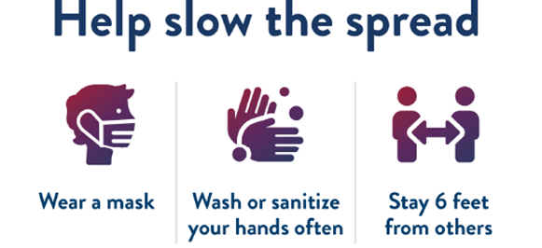

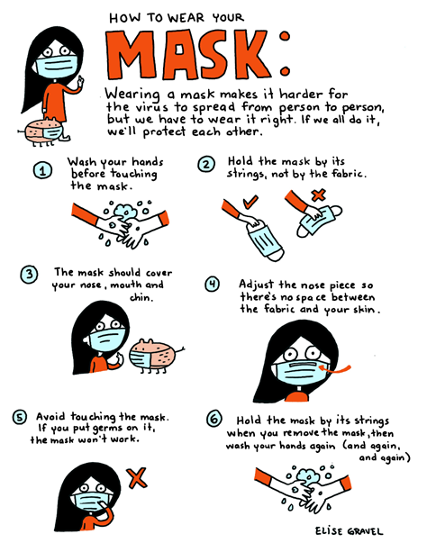

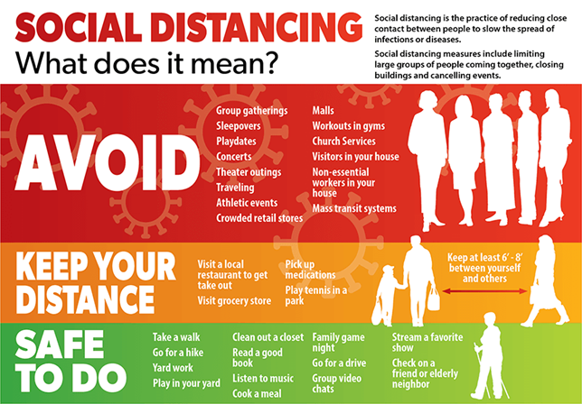

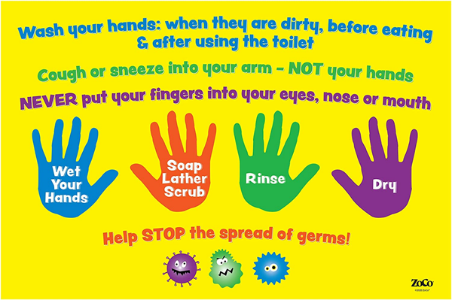

Facebook/Twitter:
- Social Distancing Video: https://www.youtube.com/watch?v=fPrYN0C3Kvw
- Baby Shark Handwashing Video: https://youtu.be/L89nN03pBzI
- Graphics from the CDC on handwashing: https://www.cdc.gov/handwashing/buttons.html
- What Coronavirus is: Video from BrainPOP: https://www.brainpop.com/health/diseasesinjuriesandconditions/coronavirus/?mkt_tok=eyJpIjoiWkRjMU5URTBPRGRqT1RWbSIsInQiOiJYc1VuWmtLNlBMSk5FYjV1XC9qN1ZzaXk2aDg4cFVSQXBmQWFnQWRvczFxSGt4Z01TeXp2bWU2QmcrcFZQZTB6UVFWazVlMUpkR3VXYWp4dWh0RmZQNGc9PSJ9
- How to Talk to Your Kids About Coronavirus: PBS Article and Videos: https://www.pbs.org/parents/thrive/how-to-talk-to-your-kids-about-coronavirus?fbclid=IwAR3GwvHoZ87YqY1QWYY6CBCGvN0Wyfm8UcFFXq-1TrwSwTq2Se9NRfWPW7Q
- How to wash your hands: Video from BrainPOP: https://jr.brainpop.com/health/bewell/washinghands/?mkt_tok=eyJpIjoiWkRjMU5URTBPRGRqT1RWbSIsInQiOiJYc1VuWmtLNlBMSk5FYjV1XC9qN1ZzaXk2aDg4cFVSQXBmQWFnQWRvczFxSGt4Z01TeXp2bWU2QmcrcFZQZTB6UVFWazVlMUpkR3VXYWp4dWh0RmZQNGc9PSJ9

2b. Monitoring
The following protocols and procedures follow the guidelines of the CDC, DOH and DOE. Some procedures will change due to updated guidelines from these stakeholders.
- Screening:
- Before entering the school building, all BBL staff, students, contractors, vendors, and visitors (parents /guardians only) will be required to have a temperature check with a non-contact thermometer.
- Screening of all BBL staff, students, contractors, vendors, and parents /guardians includes a daily temperature check and periodic completion of a screening questionnaire. A screening questionnaire determines whether the individual has:
  - knowingly been in close or proximate contact in the past 14 days with anyone who has tested positive through a diagnostic test for COVID-19 or who has or had symptoms of COVID-19
  - tested positive through a diagnostic test for COVID-19 in the past 14 days
  - has experienced any symptoms of COVID-19, including a temperature of greater than 100.0°F in the past 14 days
  - and/or has traveled internationally or from a state with widespread community transmission of COVID-19 per the New York State Travel Advisory in the past 14 days
- BBL will collect screening information from staff and parents/guardian using paper checklists to indicate if the individual passed or failed the temperature check.
- If an individual presents a temperature of greater than 100.0°F, the staff or student will be denied entry into the building or sent directly to a space (isolation room) isolated from others and sent home immediately. Students will be supervised in the isolation room while awaiting transport home.
- BBL will refer such persons to a healthcare provider/school nurse and who will provide resources on COVID-19 testing. Students and staff are required to notify the school when they develop symptoms or if their answers to the questionnaire change during or outside school hours. Staff and parents/guardians will be advised to send this information via email or telephone to the Principal.
- BBL will encourage staff to complete required screenings prior to arrival at school and encourage parents/guardians to screen their child(ren) before sending them to school. Screening by the parent/ guardian prior to school is preferred in lieu of temperature checks and symptom screening being performed after arrival to school.
- Parents/guardians and staff members will be provided resources from the CDC or the DOH to educate them regarding the careful observation of symptoms of COVID-19 and health screening that must be conducted each morning before coming to school. BBL will communicate to parents/guardians and staff that any student or staff member with a fever of 100.0°F or greater and/or symptoms of the COVID-19 virus will be sent home. Per the CDC, the list of symptoms of Coronavirus is on its website. Some individuals may display other symptoms or none.
The most common symptoms of COVID-19:
    - fever or chills (100.0°F or greater)
    - cough
    - shortness of breath or difficulty breathing
    - fatigue
    - muscle or body aches
    - headache
    - new loss of taste or smell
    - sore throat
    - congestion or runny nose
    - nausea or vomiting and/or diarrhea.
- All staff will be educated to observe students or other staff members for signs of any type of illness such as:
    - flushed cheeks
    - rapid or difficulty breathing (without recent physical activity)
    - fatigue, and/or irritability
    - frequent use of the bathroom
- Students sent home (and have to remain home for a period of three to fourteen days, the protocol for which is discussed below) will participate in the remote learning program provided by BBL staff for students in the same grade level cohort who are partaking in the Educational Continuity Plan (see Appendix A in Response 6) online learning option.

- Health Testing Protocols:
- Consistent with CDC’s recommendations, individuals with COVID-19 signs or symptoms will be encouraged to see a healthcare provider for evaluation on whether testing is needed. Also, individuals can be referred to the NYC testing website to find a testing location near them.
  - TBD: We will look to state/city guidelines regarding whether we will be able to exclude students/staff who decline to test.
- BBL will follow the CDC guidance for allowing a student or staff member to return to school after exhibiting symptoms of COVID-19. If a person is not diagnosed by a healthcare provider (physician, nurse practitioner, or physician assistant) with COVID-19 they can return to school:
  - once there is no fever, without the use of fever reducing medicines, and they have felt well for 24 hours
  - if they have been diagnosed with another condition and has a healthcare provider written note stating they are clear to return to school.
- If a person is diagnosed with COVID-19 by a healthcare provider based on a test or their symptoms or does not get a COVID-19 test but has had symptoms, they should not be at school and should stay at home until:
  - it has been at least ten days since the individual first had symptoms
  - it has been at least three days since the individual has had a fever (without using fever reducing medicine)
  - and it has been at least three days since the individual’s symptoms improved, including cough and shortness of breath.

- Health Testing Responsibility:
- The school nurse for each of the co-located buildings will be responsible for referring individuals for testing, especially if large-scale testing in the co-located schools is needed.
- The party responsible for the sourcing of the COVID-19 tests is the DOH.
- Administration of testing is the responsibility of the NYC Test & Trace Corps who provides free, safe and confidential testing for COVID-19.

- Early Warning Signs:
- The metrics BBL will use as an early warning signs that positive COVID-19 cases may be rising are:
  - national data trends and daily briefings by the Governor of NY State
  - positive cases in the community reported by the DOH
  - the number of cases reported by schools in the co-located buildings
- BBL will monitor news reports, the DOH website and the daily emails sent by Governor Cuomo.
- BBL will follow the CDC guidelines for when there is minimal to moderate community transmission https://www.cdc.gov/coronavirus/2019-ncov/community/schools-childcare/guidance-for-schools.html . Methods used to offset the early warnings by implementing multiple distancing strategies:
  - canceling field trips, assemblies, and other large gatherings
  - canceling or modifying classes where students are likely to be in very close contact
  - avoid mixing students in common areas by staggering bathroom time and use of the yard for breaks
  - increasing the space between desks
  - staggering arrival and/or dismissal times
  - limiting nonessential visitors
  - reminding staff, students, and their families to maintain distance from each other in the school

2c. Containment:
BBL will engage in regular monitoring and screening of student and staff health to ensure that we can appropriately exclude those who might be infected and break the chain of transmission for the potentially impacted cohorts of students and staff.

- School Health Offices:
Students and staff with symptoms of illness must be sent to the health office. A school nurse (Registered Professional Nurse, RN) if available, is needed to assess individuals as chronic conditions such as asthma and allergies or chronic gastrointestinal conditions may present the same symptoms as COVID-19 but are neither contagious nor pose a public health threat.
  - If a child is running a fever/ showing signs of illness, he/she is taken to nurse for examination. Nurse confirms signs. Child goes back to class, remains with nurse or is taken to the isolation room. Nurse will call the parents of children who are in the isolation room to pick them up. The child remains in the isolation room until the parent arrives. Nurse makes the recommendation for the child to be taken to his/her doctor. Child must be absent for 14 days. If testing is done and the test result is negative, the child returns in 10 days. COVID testing is not mandated for re-entry.
  - If an adult is running a fever, they are sent home and COVID test is recommended. If tested positive, they must be absent for a minimum of 10 days. DOH will conduct contact tracing to determine if any other persons would be considered ‘exposed.’ These ‘exposed’ individuals must be out for a minimum of 14 days if no test has been conducted.

- Isolation:
Per the decision by the Building Council, the location of the isolation room or rooms will be determined. The isolation room will always have a staff monitor. BBL will immediately separate students and staff with COVID-19 symptoms at school by sending them to an isolation room.

- Collection:
Individuals who are sick will be required to go home or to a healthcare facility, depending on how severe their symptoms are, and they or their caregivers (in the case of minors) will be directed to follow CDC guidance for caring for oneself. Individuals will also be advised to watch for emergency symptoms and seek emergency medical care if symptoms occur.
Any sick child will be sent to the nurse and the nurse will call to notify the parent of the need to pick up his/her sick child. A child who is not showing COVID –19 symptoms, per the CDC, will stay with the nurse until the parent arrives. Students with COVID-19 symptoms will be sent to the isolation room to await their parent’s arrival. The parent will pick up his/her child by reporting to the main office. When the parent arrives, there will be a temperature check. If the parent passed the temperature check he/she will be directed to wait in the Main Office. The Main Office staff or another member of staff, will retrieve the child from the nurse’s office or from the isolation room and will bring the child to the parent. Added precautionary PPE measures in addition to the mask (face shield, gown, gloves) will be available for the office staff to have if the need arises to retrieve a child from the isolation room. Changes to this procedure may be warranted after guidelines are issued, per the DOE, for schools in shared spaces.
- Infected Individuals:
- BBL will follow CDC guidance for allowing a student or staff member to return to school after exhibiting symptoms of COVID-19. If a person is not diagnosed by a healthcare provider (physician, nurse practitioner, or physician assistant) with COVID-19 they can return to school:
  - once there is no fever, without the use of fever reducing medicines, and they have felt well for 24 hours
  - if they have been diagnosed with another condition and has a healthcare provider written note stating they are clear to return to school.
- If a person is diagnosed with COVID-19 by a healthcare provider based on a test or their symptoms or does not get a COVID-19 test but has had symptoms, they should not be at school and should stay at home until:
  - it has been at least ten days since the individual first had symptoms
  - it has been at least three days since the individual has had a fever (without using fever reducing medicine)
  - and it has been at least three days since the individual’s symptoms improved, including cough and shortness of breath
The CDC provides specific guidance for individuals who are on home isolation regarding when the isolation may end, Discontinuation of Isolation for Persons with COVID-19 Not in Healthcare Settings https://www.cdc.gov/coronavirus/2019-ncov/hcp/disposition-in-home-patients.html.
- Exposed Individuals:
- In accordance with state and local laws and regulations, school administrators will notify the DOH, staff, and families immediately of any case of COVID-19, while maintaining confidentiality in accordance with the Americans with Disabilities Act (ADA).
- The School will inform those who have had close contact with a person diagnosed with COVID-19 to stay home and self-monitor for symptoms, and follow CDC guidance if symptoms develop.
- The New York State Department of Health considers a close contact to be someone who was within six feet of an infected person for at least 10 minutes starting from 48 hours before illness onset until the time the person was isolated. The New York City DOH will be contacted if the extent of contact between an individual and a person suspected or confirmed to have COVID-19 is unclear.
- To prevent the further spread of disease, COVID-19 exposed individuals are encouraged to stay home and maintain social distance (at least six feet) from others until 14 days after their last exposure to a person with COVID-19 Contacts should monitor themselves by checking their temperature twice daily and watching for symptoms of COVID-19.

- Hygiene, Cleaning, and Disinfection:
- Healthy hygiene practices will be taught and re-taught in school for both students and staff. Videos for training: https://www.youtube.com/watch?v=qJG72sycQB8; https://www.youtube.com/watch?v=d914EnpU4Fo&t=12s
- Hand and respiratory hygiene, along with providing adequate supplies and time to allow for frequent hand hygiene.
- Hand hygiene includes time in the school day, when students enter the classroom, periodically during the morning, before and after lunch and before dismissal. Hand hygiene includes:
  - traditional hand washing (with soap and warm water, lathering for a minimum of 20 seconds), which is the preferred method
  - use of alcohol-based hand sanitizers (60% alcohol or greater) when soap and water are not available, and hands are not visibly dirty. Hand sanitizer will be placed throughout common areas (e.g. entrances, cafeteria), near high touch surfaces
  - signage will be placed near hand sanitizer indicating visibly soiled hands should be washed with soap and water
  - some students or staff who are unable to use alcohol-based hand sanitizers for health reasons will be permitted to wash their hands with soap and water
- Respiratory hygiene includes training students and staff to cover their mouths or noses with a tissue when coughing or sneezing and dispose of the tissue appropriately. A supply of tissues and no lid trash cans will be available in each room. If no tissue is available, staff and students will be instructed to use the inside of the elbow (or shirtsleeve) to cover the mouth or nose and to always perform hand hygiene after sneezing, coughing and handling dirty tissues or other soiled material.
  - Posted signs will be placed throughout the school and will share messages with the school community. Signage will remind individuals to:
      - stay home if they feel sick
      - cover their nose and mouth with an acceptable face covering when unable to maintain social distance from others
      - properly store and, when necessary, discard PPE
      - adhere to social distancing instructions
      - report symptoms of, or exposure to, COVID-19
      - follow hand hygiene, and cleaning and disinfection guidelines
      - follow respiratory hygiene and cough etiquette
  - Healthy hygiene practices will be taught in person, by videos, announcements, and posters or signs posted in highly visible areas such as: entrances, restrooms, classrooms, and administrative offices. Video https://www.youtube.com/watch?v=W-zhhSQDD1U
  - Per the CDC guidelines the school will be disinfected daily by the custodial staff. The building will be deep cleaned on a nightly basis with electrostatic disinfectant sprayers, which dispense disinfectant so that it adheres to surfaces without the need to physically touch them.
  - The DOE has begun to order cleaning supplies for schools before the start of the year, including an initial order of 11,000 cases of hand sanitizer and 100,000 cases of disinfectant wipes, in addition to providing disposable face coverings to students and staff, and many other cleaning supplies.
  - Areas to be cleaned daily include classrooms, isolation rooms, restrooms, cafeteria, library, and buses. Additional staff may need to be trained to clean and disinfect frequently though out the day high touch surfaces. Examples of high touch includes tables, doorknobs, light switches, countertops, handles, desks, phones, keyboards, tablets, toilets and restrooms, and faucets and sinks.

  - Contract Tracing:
BBL will assist public health department by communicating who may have had contact at school with a confirmed case by:
  - keeping accurate attendance records of students and staff members ensuring student schedules are up to date
  - keeping a log of any visitors which includes date, time and where in the school they visited
  - assisting DOH in tracing all contacts of the individual at school in accordance with the protocol, training, and tools provided through the New York State Contact Tracing Program
  - families/staff/ children will be monitored daily by the DOH to ensure neither students nor adults return to school during infectious period.

- Communication:
Protocols and safety measures will be shared with parents/guardians, staff, students and administration of the co-located schools via telephone calls, text, or emails as each case occurs. Weekly phone calls made through School Messenger (telephone, text and emails) will provide updates as will postings on the BBL website, Facebook and Twitter accounts.

2d. Closure
- Closure Triggers:
BBL will collaborate with collocated school administrators and the DOH to determine the parameters, conditions or metrics (e.g., increased absenteeism or increased illness in school community) that will serve as early warning signs that positive COVID-19 cases may be increasing beyond an acceptable level. BBL will also close if any of the schools in the collocated space have staff absentee rates that will impact the ability of the schools to operate safely.
- Operational Activity:
- Upon a school closure all school operations will continue remotely, and all academic programs will be remote following the procedures put in place for the March 2020 closure.
- The plan for an orderly closure of the school is multi-tiered and to be determined by the guidance provided by DOH, DOE, CDC and the school building council. Closure of the school is not subject only to our students but is compounded by the shared facility and the COVID-19 data regarding the surrounding community. Therefore, the phasing, milestones and involvement of key personnel is TBD.
- Meal Hubs provide free grab-and-go meals to all New Yorkers. Service is available from 7:30 a.m. to 1:30 p.m., Monday through Friday. Parents/guardians can visit schools.nyc.gov/freemeals for more information and to find the Meal Hub nearest to their home.

- Communication:
BBL will continue to communicate with staff and parents via email, weekly phone calls made through School Messenger (phone, text, email), BBL website, Facebook, Twitter and Zoom meetings to provide updates on the closure process.

Response 3: Pre-Opening, School Calendars & Scheduling
3a. Pre-Opening:
In developing the plans for the 2020-2021 school year, we gathered a team of administrators and other staff members, with different areas of expertise in BBL, to address all areas of the opening plan. We also met with parents/guardians and staff and surveyed them.
Parents/Guardians - We scheduled three meetings at different times during the day on July 20th to allow parents/guardians the opportunity to attend a meeting that best fit their schedule. In these meetings, we discussed guidance from the CDC, DOH, DOE, and the New York State Education Department around the opening plans. We also invited parents/guardians to ask questions and share their concerns so that we had a better understanding of what was important to them as we wrote our plans for re-opening. After these meetings, we sent parents a short survey to get quantitative information about their concerns around health and safety, technology, and academics. The survey can be found in Response 6, Appendix C.
We welcomed families new to BBL via a Zoom welcome meeting on July 23rd. We also asked our newest families to complete the survey to gauge their thinking and feelings about sending their children to school and what supports they are thinking about for their children.
We have also scheduled a more formal orientation for our new families for the week before school opens. As we normally do, we have an extensive and enriching onboarding procedure for all new BBL families and students. This includes the following:
- individual intake meeting with administration, following social distancing rules
- formal version of the Home Language Survey, following social distancing rules
- Kindergarten orientation meeting, which will take place virtually
- targeted assessment of Kindergarten readiness by teaching staff, in-person is ideal, remotely if necessary
Staff - We met or otherwise consulted with our Professional Development Staff, Academic Leaders and Assessment Team. We then met with our entire staff to review our reopening plan. During the meeting, we obtained data around their concerns about health and safety, teaching and learning in a blended/remote environment, and meeting the students’ social/emotional needs.
Timeline of information-gathering leading up to the writing of the re-opening plan:
- June 29, 30 – Parent Training with Director of Student Support, Guidance Staff and outside consultant which covered the following topics: (1) foster/strengthen home-school relationships, (2) build support in a time of uncertainty, and (3) identify approaches to coping/resilience within ourselves and our children
- June 30 – July 23 – Academic Leaders, Teachers and Teaching Assistants provide small group instruction, remotely, for those students who needed it most
- July 15 – Opening Plan guidance released by SUNY CSI
- July 20 – Professional Development, Academic Leaders, and Assessment Team meet
- July 20 – 3 parent meetings held (9:00 a.m., 12:00 p.m., and 6:00 p.m. to accommodate different parent schedules). We had 454 attendees.
- July 20 – Parent Survey sent via email. 553 parents responded to the survey
- July 23 – Welcome meeting for new BBL families
- July 24 – Staff meeting

Pre-Opening Plan for Staff:
Every summer, our Professional Development Department offers a range of workshops. This summer, we will continue to provide workshops in these areas with an additional focus on planning for remote teaching, planning for a blended instructional model, and curricular recuperation. Moreover, each year, our staff members return one week prior to the start of the school year to plan with their classroom, grade level, and subject area teams, participate in professional development on topics including but not limited to health and safety, Response to Intervention, classroom management, mandated reporting, communication, assessment, and curricular updates. This year, our Staff Orientation will begin on August 26th. It will include the above-listed topics as well trauma informed classroom and habits, using Google Classroom, using SeeSaw, maximizing effectiveness of Zoom meetings, and planning for remote learning (both a fully remote learning environment and a blended learning environment). Staff Orientation will take place in person to the greatest extent possible and by following social distancing practices.
Pre-Opening Plan for Students:
We will have three half days of student orientation activities (remotely) during which Teachers, Teaching Assistants and Guidance Counselors will provide activities for current students to meet their new teachers, talk about their learning experiences in the 2019-2020 school year, and prepare to learn in the 2020-2021 school year. These activities will be driven by our culture of community (which has a foundation in Responsive Classroom) as well as trauma-informed care for children. Our Back to School Night is scheduled for September 8th (Kinder – 2nd) and September 9th (3rd – 5th) to present to parents the overview of the 2020-2021 school year. For our incoming Kindergarten students, we will have an orientation on Tuesday, September 1st.

Pre- Opening Schedule:
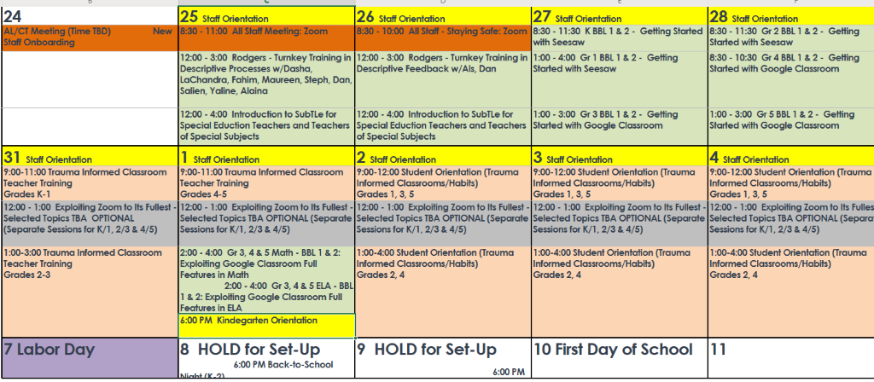
Statement of Assurances:
The Bronx Charter Schools for Better Learning will meet all required state mandates for fire and safety drills for all cohorts of students. We will conduct the drills using social distancing practices. We will coordinate with the schools with which we are collocated to ensure that students and staff safely exit the building during fire drills and are safely out of view during lockdown drills. If bus transportation is provided to students in the 2020-2021 school year, we will also conduct bus safety drills as required by state mandates.
Technologies:
In planning for a blended learning environment, we recognize that devices, connectivity and training in how to use them, particularly for our youngest learners, are all necessary requirements in meeting learning expectations.
In terms of materials, we loaned over 160 devices to students in the spring when we went into remote learning. Through June, parents were able to request a device from BBL. As part of our survey in July, we asked parents to tell us if they had a working device and internet connectivity for their child/children to participate in remote lessons and complete remote learning assignments. We will confirm, through teacher conversations with parents in September that each child has a device and that the parents have no issues with connectivity. We will provide any child with a device who needs one.

We are incorporating different technologies to meet the learning needs of students and the instructional requirements for teachers.
- Zoom – platform for remote learning meetings. For extra security, the ‘waiting room’ feature is enabled for all class meetings and teachers are required to change the password each week.
- Google Classroom – Grades 3 – 5 will use Google Classroom to post new and receive completed assignments for asynchronous learning.
- SeeSaw – Grades Kindergarten – 2nd will use SeeSaw to post new and receive completed assignments for asynchronous learning.
- Remote learning apps – IXL, Achieve 3000, Kidblog, SplashMath, Reading A to Z
- BBL-developed apps – iRead Better, iCount Better, iSpellBetter
Teachers – training for effectively using the technology platforms will be provided during the summer and training will continue during the school year. As with all of our professional development, our training is robust, comprehensive and ongoing. This year we will have a deeper focus on training around technology and remote learning-based platforms.
Parents/Guardians – current parents/guardians have experience with our online learning platforms and resources from the spring. As part of our Back to School Night program, we will give an overview of how the technologies will be used to provide remote instruction for their children. We will provide parent training workshops, on a grade level/classroom level to answer specific questions and address specific concerns. In the Spring 2020, we established our virtual Parent Resource Center, located on our website. The purpose of the center is to provide current resources for parents/guardians on topics most important to them as identified through conversations and email exchanges with them. We started the center with a video series on supporting children during remote learning and various community, e-learning and social/emotional resources. We will use the center to provide information about the platforms for remote learning so parents can access it at their convenience.
Students – as part of their instruction, teachers will ensure students know how to access our online learning platforms and resources and log on for classes during in-person instruction for those students who opt to come to the brick and mortar and during synchronous sessions with students via Zoom. For our younger students, teachers will work with parents and students together to ensure their facility with logging on to Zoom, using SeeSaw and completing assignments on the remote learning platforms and resources. For those students learning remotely, our Teachers and Teaching Assistants will work in small groups via Zoom with parents/guardians and their children to ensure their understanding and use of the technology platforms and applications students will be using.

Technology Budget Implications:
We are currently reviewing and assessing our technology needs for the 2020-2021 school year. We are prepared to make any adjustments needed to our budget to accommodate any and all technology requests to ensure equity and access for all. Furthermore, we are prepared to continue to operate under a balanced budget even if accommodations are necessary.

3b. School Calendar
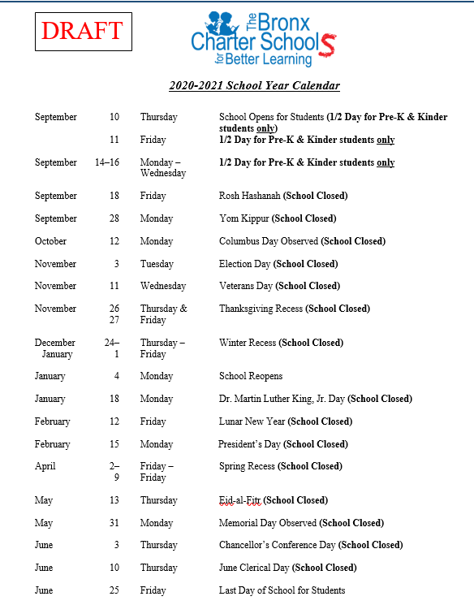

Total Amount of Instruction by Month:

Month | Total Instructional Days | Total Cohort A In-Person Days | Total Cohort B In-Person Days | Total  Cohort A in person hours | Total  Cohort B in person hours | Total Cohort A synchronous | Total Cohort A asynchronous | Total Cohort B synchronous | Total Cohort B asynchronous
September | 13 | 7 | 6 | 42 | 36 | 6 | 24 | 7 | 28
October | 21 | 10 | 11 | 60 | 66 | 11 | 44 | 10 | 40
November | 17 | 9 | 8 | 54 | 48 | 8 | 32 | 9 | 36
December | 17 | 8 | 9 | 48 | 54 | 9 | 36 | 8 | 32
January | 19 | 9 | 10 | 54 | 60 | 10 | 40 | 9 | 36
February | 18 | 9 | 9 | 54 | 54 | 9 | 36 | 9 | 36
March | 23 | 12 | 11 | 72 | 66 | 11 | 44 | 12 | 48
April | 16 | 8 | 8 | 48 | 48 | 8 | 32 | 8 | 32
May | 19 | 9 | 10 | 54 | 60 | 10 | 40 | 9 | 36
June | 17 | 9 | 8 | 54 | 48 | 8 | 32 | 9 | 36
TOTAL | 180 | 90 | 90 | 540 | 540 | 90 | 360 | 90 | 360

3c. Scheduling for Students

The planned days and times students (by grade level and cohort) will attend in-person instruction along with the planned total of in-person instructional hours for the 2020-2021 school year are as follows: Cohort A, for grades K-5, will have in-person instruction on Mondays and Wednesdays of each week and ‘alternating’ Fridays. Cohort B, for grades K-5, will have in-person instruction on Tuesdays and Thursdays and ‘alternating’ Fridays. In total, each cohort will receive 540 in-person instruction hours for the 2020-2021 school year.

The planned days and times students will attend remote instruction (by grade level and cohort) for the 2020-2021 school are as follows: Cohort A, for grades K-5, will have remote instruction on Tuesdays and Thursdays and ‘alternating’ Fridays. Cohort B, for grades K-5, will have remote instruction on Mondays and Wednesdays and ‘alternating’ Fridays. On remote instruction days, grades K-5 will receive at least one hour of synchronous instruction per day and four hours of asynchronous instruction per day for a total of 450 remote instructional hours for the 2020-2021 school year. The ‘alternating’ Fridays for both cohorts will be determined by holidays during the week. For example, if there is no school on Monday, Cohort A will attend on Wednesday and Friday regardless of whether Cohort A also attended the previous Friday so that in a 4-day week, all students will have 2 days of in-person instruction. Over the course of successive months, the number of Fridays students attend balances evenly.

The planned total amount of instructional time for each cohort by grade is 990 hours.

Table 1 is a sample schedule for our primary grades. Table 2 is a sample schedule for our upper elementary grades.

Table 1:
Sample Schedule for BBL Primary Grades

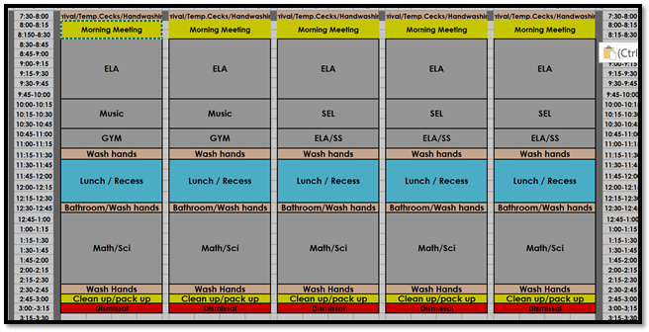

Table 2:
Sample Schedule for BBL Upper Elementary Grades

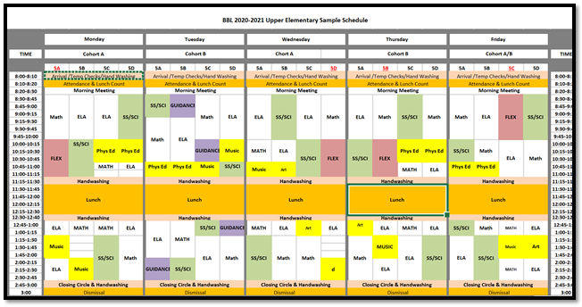

3d. Scheduling for Staff

BBL plans to deploy staff to support student scheduling as follows:

All Teachers who are willing and able to provide in-person instruction will report to school by 8 a.m. and dismiss at 4 p.m. Teachers, including those providing special education services, will provide a full day of in-person instruction to their assigned cohort. One 45-minute prep will be scheduled each day as well as a one-hour lunch break. Additionally, Academic Leaders and Teaching Assistants will continue to support students by providing remote instruction to specific groups within the cohorts, as assigned.

Teachers who are unable to provide in-person instruction will provide remote instruction to assigned groups within the cohorts or to the cohorts themselves. This may include students who are working remotely on their assigned remote learning days or cohorts of students who are enrolled in full-time remote learning. Additionally, if there are regular education and special education teachers who cannot provide in-person instruction, they will support students by providing remote instruction to specific groups, as assigned.

Teaching Assistants who are willing and able to provide in-person instruction will report to school by 7:30 a.m. and dismiss at 3:30 p.m. Teaching Assistants will support their assigned homeroom/group providing support as needed to small groups of students within the larger cohorts. Teaching Assistants will also provide support in escorting students to the restrooms while ensuring social distancing, assist in handwashing schedules and other duties as assigned by building administration. Teaching Assistants who are unable to provide in-person instruction will provide remote instruction to assigned groups from home. This may include students who are working remotely on their assigned remote learning days and cohorts of students who are enrolled in full-time remote learning.

Art and Music teachers who are willing and able to provide in-person instruction will have a modified schedule to limit in-person contact. Each grade will be assigned Art or Music on a quarterly rotation. The Art and Music teachers will travel to their assigned classes to provide in-person instruction. For those Art and Music teachers who are unable to provide in-person instruction, they will provide remote instruction for students working remotely on their assigned days, or, for students who are engaging in fully on-line instruction.

Physical Education Teachers who are willing and able to provide in-person instruction will provide physical education classes outside (weather permitting) so that students can engage in physical activity with at least a 12-foot distance between each student. During inclement weather, the Physical Education Teacher will provide in-person instruction in the classrooms or gymnasium if available, in the topics of health and hygiene, mindfulness and yoga, while following the NYS Physical Education Curriculum. For those Physical Education Teachers who are unable to provide in-person instruction, they will provide remote instruction for students working remotely on their assigned days, or, for students who are engaging in fully on-line instruction. Table 3 is a sample teacher schedule.

Table 3:
Sample BBL Teacher Schedule
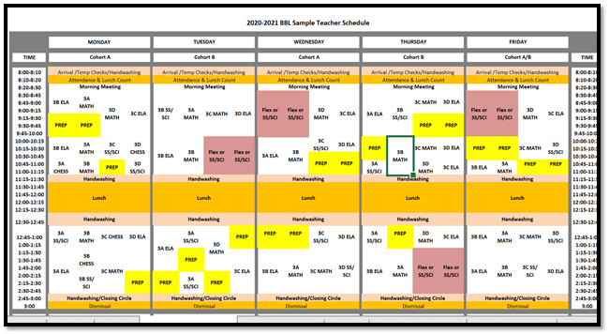

Response 4: Enrollment and Attendance
4a. Enrollment
BBL’s anticipated efforts on student enrollment include the gathering of evidence and information that corroborates and justifies the student enrollment count BBL will use for billing during the 2020-2021 school year. This evidence includes our Daily Student Attendance Tracker, as used during the spring of 2020 when school was closed due to COVID-19. The Daily Student Attendance Tracker captures each student’s synchronous and asynchronous attendance during remote instruction on each day. The touchpoints with families and students include daily phone calls, emails and text messaging with families and teaching staff. Each homeroom teacher is responsible for managing and organizing these touchpoints. If a teacher is unable to contact a family, administration will then become a touchpoint to make every reasonable effort to contact the family. Additionally, our existing attendance system, ATS, will continue to serve as our evidence of attendance when students are in the school building.

4b. Attendance
Since BBL is planning on a blended model, we will be taking attendance in two ways and reporting in one way (pending guidance from the DOE). BBL will collect attendance for every student for every day of attendance. For students who are scheduled to attend with their cohort for the in-person instruction, we will take attendance as we did when we were fully in the brick and mortar setting, by entering attendance into ATS. For the cohort who is learning remotely for the day or for those students who have opted for 100% remote instruction, we will collect attendance data through participation in the daily Zoom session on the Attendance spreadsheet (which can be found in Response 6, Appendix B-1) and then a designated member of our staff will enter attendance data for these students in ATS.
Attendance Procedure:
1) Homeroom teachers will take attendance during the daily morning meeting and enter it into the Student Attendance Tracker each day by 2pm. Content area teachers will also track student participation in asynchronous and synchronous attendance in the Student Daily Tracker on a daily basis.
2) A designated member of the Main Office staff will capture absences from the Student Attendance Tracker and enter the absences into the ATS system for the previous day.
3)

If there is a challenge to the validity of our attendance, we will have not only the ATS records, but also, for those students learning remotely, we will have The Daily Student Attendance Tracker, mentioned above, which comprehensively tracks synchronous and asynchronous learning. The Daily Student Attendance Tracker sample can be found in Response 6, Appendix B-2. We will continue to use this spreadsheet to track those students who are fully remote as well as tracking the groups who are learning remotely on their assigned remote day. Our plan is to have this information entered into ATS as well.
Our plan for contacting and engaging students who dis-engage from on-line learning is preventative in nature and encompasses a collaborative effort of our teachers, guidance counselors, and administration. Our teaching staff will have daily contact with every student, either in-person or remotely via Zoom and weekly contact with families via email, text or phone communication. This contact will be recorded in our Parent Log, a sample of which can be found in Response 6, Appendix B-3. Our guidance staff will have weekly contact with each student. Through these contacts, we will gauge how students are feeling and their level of engagement with the work and school in general. If we suspect that a student is disengaging from online learning, we will work with his/her parents/guardians to address the issue that is preventing the student from fully engaging in the online work. For example, if the student is feeling depressed, we will offer individual counseling. If the student’s disengagement is resulting from a technology issue, we will work with the family to provide a working device or access if necessary. Administration will direct any added supports or additional communication with the family.
Our review process and authorization of attendance records is a two-tiered process. The attendance records will be reviewed on a daily basis by the teaching staff. The attendance records will then be authorized on a weekly basis by our administration or office staff.

Response 5: Academic Program
5a. Curriculum
The curricula in both of our schools remain, in all essentials, unchanged. We will continue our long-established, annual practice of refining materials, techniques and activities used to engage our students in their tackling curriculum content, along with any tweaks to scope and content, especially as informed by our experiences during the full-time, distance learning thrust upon us last spring.
As usual, our Academic Leaders will lead those refinement efforts with their teams of teachers during scheduled sessions in August, with the support of our full-time Professional Development Specialists and oversight by our Assistant Principals. We will also continue our multi-year endeavor further to coordinate and integrate our ELA instruction with subject matter content, i.e., science and social studies.
Our students’ social and emotional well-being has always been a primary purpose and integral to our established pedagogy, the subordination of teaching to learning. Still, we recognize our responsibility to provide further, explicit support in those areas, in light of both the enduring pandemic and a heightened awareness and clarity about systematic racial inequality and oppression in our country.
Towards those ends, we will maintain initiatives provided by our established cadre of social workers and guidance staff, which were in place before we had to abandon instruction in our facilities, and which were intensified afterwards. Those practices involve whole group lessons, led by our Guidance Counselors and Social Workers, and either small group or individual attention, based on need, and provided through synchronous options, including Zoom sessions and phone calls at those times the students are not with us in the buildings.
In addition, we are initiating a close examination, during the upcoming school year, of opportunities to weave, more intentionally and extensively, into all curricula areas, a focus on the wide range of contributions of persons of color to all areas of human endeavor, with an emphasis on the humanities. In brief, we will look to spread and increase throughout the school year those topics more typically reserved for concentration during Black History month, including, as age appropriate, investigations into the causes and effects of racism and prejudice.

5b. Instruction
For those periods of time when we will provide our students in both of our schools with virtual instruction, we intend to implement the plans outlined in Response 6, Appendices A and B1-B3, which spell out teacher-student options for interaction and a description of how we will continue to collect and retain documentation of that interaction, established and implemented in the spring. Please note that our current plan, for blended learning, differs mainly from our previously submitted “Updated Educational Continuity Plan” in two important aspects:
- After close examination and trial implementation of several remote, learning management systems, we have settled on using, during those days students are not physically present, Seesaw for grades K through 2 and Google Classroom for grades 3 through 5. Those platforms will enable (a) maximum flexibility in providing a full range of synchronous and asynchronous instructional strategies, (b) ease of use for students within the two sets of grade levels and (c) structured opportunities to continue to differentiate and provide high quality instruction for our vulnerable populations.
- For all of our students, who will likely be attending school halftime in our facilities, our face-to-face lessons will consist almost entirely of introducing them to new challenges and content. During those lessons, we will endeavor to ensure their awareness of new learning challenges and how to employ their innate intelligence to tackle them, to provide information that they could not otherwise invent or likely discover on their own and to create space for initial errors and missteps that are part & parcel with meeting something new. That phase of instruction remains entirely consistent with the subordination of teaching to learning and is more easily managed when physically present with students, since it involves continuous feedback, including moment-to-moment adjustments by teachers according to what they observe in their students’ learning, where errors are welcome guideposts for the adjustment of questions, techniques and activities.
We will reserve opportunities for practice primarily for those times the students are not physically present with us, while we supervise and manage that phase of instruction, also essential to our core pedagogy, through Seesaw or Google Classroom. We recognize the purpose of practice as building speed and accuracy, leading to mastery of skills and content.

5c. Assessment
Kindergarten: RazKids (ELA) and Aimsweb (Math) will be administered in September to identify areas of strength and deficiencies in math and reading comprehension. Information will inform teachers of student needs and will inform instruction.
Grades 1-5: All students will be administered ELA and Math STAR assessments each month beginning in September in order to identify areas of strength and deficiencies in math and reading comprehension. Data gathered will be used to inform instruction.
Testing will begin in all grade levels during the month of September in order to assess student proficiency and best inform instruction, lesson planning, and grouping of students. STAR has been used before, but not as early in the school year. We hope that the online platform will allow us to get data more quickly from students whether the instructional model is in person, remote, or a combination of both.
Monthly testing through use of STAR will inform growth and/or regression while also indicating individual student needs thus informing instruction.
EdVista Benchmarks will continue as in years past, through which we can compare the results of previous cohorts to the current one and also monitor cohorts from year to year. Secure testing can take place both in house and online. Student growth will be compared from benchmark to benchmark to measure growth within individual objectives.
BBL Assessment Calendar
Grade | September | October | November | December | January | February | March | April | May | June
Pre-K | ESI-R |  | Work Sampling  11/13 |  |  | Work Sampling  2/26 |  |  |  | Work  Sampling  5/28
K | NYSITELL  9/7 – 9/18  AIMS Web  9/21 –9/25  RAZ Kids  9/29-10/2 | Fountas & Pinnell  10/19 – 11/6 | Fountas & Pinnell  10/19 – 11/6 |  | Cloze – Chart 3  1/15  Fountas & Pinnell  1/11 – 1/22  AIMS Web  1/25 – 1/29 | Cloze – Chart 4  2/26  Carol DR | Cloze – Chart 5  3/19 | Cloze – Chart 6  4/23  NYSESLAT (speaking)  4/19 – 5/28 | Cloze Chart 7 - 5/21  Fountas & Pinnell  5/17 – 6/4  NYSESLAT  (listen, write, read)  5/17 – 5/28  AIMS Web  5/17 – 5/21
1 | Cloze –Chart 5  9/25  NYSITELL  9/7 – 9/18  STAR  Math  9/21-9/25  ELA  9/29-10/2 | Cloze – Chart 6 10/23  STAR  Math  10/19 - 10/23  ELA  10/26 - 10/30 | Cloze –Chart 7  11/13  STAR  Math  11/9 - 11/13  ELA  11/16 - 11/20 | Cloze–Chart 8  12/11  STAR  Math  12/7 - 12/11  ELA  12/14 - 12/18 | Cloze – Chart 9  1/15  STAR  Math  1/19 - 1/22  ELA  1/25 - 1/29 | Cloze – Charts  10 & 11  2/26  STAR  Math  2/8 - 2/12  ELA  2/22 - 2/26 | Cloze–Chart 11&12  3/19  STAR  Math  3/15 -3/19  ELA  3/22 - 3/26  EdVistas A1  ELA – 3/5  Math – 3/12  Carol DR | Cloze – Chart 13  4/23  STAR  Math  4/12 -4/16  ELA  4/19 - 4/23  NYSESLAT (speaking)  4/19 – 5/28 | NYSESLAT  (listen, write, read)  5/17 – 5/28  STAR  Math  5/17 - 5/21  ELA  5/24 - 5/27  EdVistas A2  ELA – 5/14  Math – 5/21 | Cloze–Charts  14-16  6/4  STAR  Math  6/7 - 6/11  ELA  6/14 - 6/18
2 | Cloze – Chart 9  9/25  STAR  Math  9/21-9/25  ELA  9/29-10/2 | STAR  Math  10/19 - 10/23  ELA  10/26 - 10/30 | Cloze–Chart 10&11  11/13  STAR  Math  11/9 - 11/13  ELA  11/16 - 11/20  Carol DR | Cloze–Chart 11&12  12/11  STAR  Math  12/7 - 12/11  ELA  12/14 - 12/18 | Cloze–Chart 13  1/15  STAR  Math  1/19 - 1/22  ELA  1/25 - 1/29  EdVistas A1  Math – 1/17  ELA – 1/24 | Cloze Chart 14–16  2/26  STAR  Math  2/8 - 2/12  ELA  2/22 - 2/26 | Cloze–Chart 14-18  3/19  STAR  Math  3/15 -3/19  ELA  3/22 - 3/26  EdVistas A2  ELA – 3/6  Math – 3/13 | Cloze-Chart 14- 20  4/23  STAR  Math  4/12 -4/16  ELA  4/19 - 4/23  NYSESLAT (speaking)  4/19 – 5/28 | NYSESLAT  (listen, write, read)  5/17 – 5/28  STAR  Math  5/17 - 5/21  ELA  5/24 - 5/27  EdVistas A3  ELA – 5/8  Math – 5/15 | STAR  Math  6/7 - 6/11  ELA  6/14 - 6/18
3 | STAR  Math  9/21-9/25  ELA  9/29-10/2 | STAR  Math  10/19 - 10/23  ELA  10/26 - 10/30  EdVistas A1  Math – 10/23 | STAR  Math  11/9 - 11/13  ELA  11/16 - 11/20  EdVista A2  Practice Test  ELA–11/4 & 11/5 | STAR  Math  12/7 - 12/11  ELA  12/14 - 12/18 | STAR  Math  1/19 - 1/22  ELA  1/25 - 1/29  EdVistas A2  Math – 1/15  Carol DR | STAR  Math  2/8 - 2/12  ELA  2/22 - 2/26  EdVistas A3  NYS Practice  ELA–2/3 & 2/4 | STAR  Math  3/15 -3/19  ELA  3/22 - 3/26  EdVista A3  NYS Practice  Math-3/4 & 3/5 | STAR  Math - 4/12-16  NYSESLAT (speaking)  4/19 – 5/28  NYS ELA  4/20 & 4/21  Makeup 4/22 – 4/27 | STAR  ELA- 5/24 - 5/27  NYS Math  5/4 & 5/5  Makeup 5/6 – 5/11  NYSESLAT  (listen, write, read)  5/17 – 5/28 | STAR  Math  6/7 - 6/11  ELA  6/14 - 6/18
4 | STAR  Math  9/21-9/25  ELA  9/29-10/2 | STAR  Math  10/19 - 10/23  ELA  10/26 - 10/30  EdVistas A1  Math – 10/23  Carol DR | STAR  Math  11/9 - 11/13  ELA  11/16 - 11/20  EdVista A2  Practice Test  ELA–11/4 & 11/5 | STAR  Math  12/7 - 12/11  ELA  12/14 - 12/18 | STAR  Math  1/19 - 1/22  ELA  1/25 - 1/29  EdVistas A2  Math – 1/15 | STAR  Math  2/8 - 2/12  ELA  2/22 - 2/26  EdVistas A3  NYS Practice  ELA–2/3 & 2/4 | STAR  Math  3/15 -3/19  ELA  3/22 - 3/26  EdVista A3  NYS Practice  Math-3/4 & 3/5 | STAR  Math - 4/12-16  NYSESLAT (speaking)  4/19 – 5/28  NYS ELA  4/20 & 4/21  Makeup 4/22 – 4/27 | STAR  ELA- 5/24 - 5/27  NYSESLAT  (listen, write, read)  5/17 – 5/28  NYS Math  5/4 & 5/5  Makeup 5/6 – 5/11  NYS Science Performance  5/25 – 6/4 | STAR  Math  6/7 - 6/11  ELA  6/14 - 6/18  NYS Science  Written  6/7  Makeup  6/8-6/9
5 | STAR  Math  9/21-9/25  ELA  9/29-10/2 | STAR  Math  10/19 - 10/23  ELA  10/26 - 10/30  EdVistas A1  Math – 10/23 | STAR  Math  11/9 - 11/13  ELA  11/16 - 11/20  EdVista A2  Practice Test  ELA–11/4 & 11/5 | STAR  Math  12/7 - 12/11  ELA  12/14 - 12/18  Carol DR | STAR  Math  1/19 - 1/22  ELA  1/25 - 1/29  EdVistas A2  Math – 1/15 | STAR  Math  2/8 - 2/12  ELA  2/22 - 2/26  EdVistas A3  NYS Practice  ELA–2/3 & 2/4 | STAR  Math  3/15 -3/19  ELA  3/22 - 3/26  EdVista A3  NYS Practice  Math-3/4 & 3/5 | STAR  Math - 4/12-16  NYS ELA  4/20 & 4/21  Makeup 4/22 – 4/27 | STAR  ELA- 5/24 - 5/27  NYS Math  5/4 & 5/5  Makeup 5/6 – 5/11 | STAR  Math  6/7 - 6/11  ELA  6/14 - 6/18

Guide to the Assessment Calendar 2020-2021
Assessment | Type | Subject | Description | Grade Levels | Population and Frequency
Cloze | Formative  Instructional | ELA | Words in Color chart to assess vocabulary and reading comprehension | K | All students: 4 times annually
 |  |  |  | 1 | All students: 9 times annually
 |  |  |  | 2 | All students: 8 times annually
Aims Web | Progress Monitor | Math | Nationally normed exam administered as a tool for universal screening in math.  Aims Web is a progress monitoring tool for math PAT students. | K | All students:  3 times annually in math.  Math PAT students:  Monthly
RazKids | Progress Monitor | ELA | Nationally normed ELA reading comprehension program. | K | All students:  September – initial assessment
Fountas & Pinnell | Progress Monitor | ELA | Nationally normed ELA reading comprehension exam. | K | All Kindergarteners  3 times annually.
 |  |  |  | 1-2 | PAT students  3-5 times annually.
EdVista | Formative Interim Assessments | Math  &  ELA | Assessments for learning used to measure student mastery of common core math and ELA standards.  Assessment 3 for grades 3-5 ELA and Math is released NYS Exams from previous years. | 1 | All student: 2 times annually.
 |  |  |  | 2 | All students: 3 times annually.
 |  |  |  | 3-5 | All students  2 times annually in ELA  3 times annually in Math
Star | Progress Monitor | Math  &  ELA | Nationally normed computer-based Math and Reading Comprehension exam, which satisfies universal screening for RTI.  STAR is a progress monitoring tool for Math/ELA PAT students. | 1-5 | Monthly  (Universal Screening 3x annually)  Administered more frequently at teacher discretion.

*NYS Exams: NYSITELL, NYSESLAT, ELA, Math, Science are administered in accordance with state requirements.
5d. At-Risk Populations
In line with our policy of supporting students who need academic and/or behavioral interventions, we will continue to identify students through our benchmark assessments, observations and other measures. Following the Child Find procedures, the incoming Kindergarten cohort and new entrants in other grades coming in through backfilling, will be assessed prior to school opening. Using the assessment results, we will follow our guidelines on referral of students to our academic intervention team, Pupil Assistance Team (“PAT”). For returning students, we will follow the timeline on our Assessment Calendar to identify students who may need supplemental instruction. Progress monitoring will continue as specified in our RTI guidelines. Program delivery will continue to be by our team of Support Teachers who provide supplemental instruction for this group of students. Program delivery, which occurred prior to and through school closing, will continue with our blended model of school reopening.
We will continue to ensure that we provide optimal services, as mandated in the respective IEPs of our Special Education population. We will make special dispensation to maximize the number of days that our students with IEPs attend school in person, against the backdrop of “social distancing and other considerations,” including family-related issues and/or concerns. In addition, we will continue to provide rigorous targeted remote learning, aligning learning activities with the IEP goals of our special education students. We continue to work with related service providers (agencies and independent individual providers registered with the DOE). Consultation is going on between our organization and the providers (new set of providers for the coming school year), to work out the schedule, and to encourage face-to-face sessions and telehealth where such is necessitated by health and safety considerations.
We will continue to work closely with teachers and parents to identify students suspected to have a disability and with our local Committee on Special Education (herein CSE), to evaluate such students, to explore their eligibility for special education services. We have a good working relationship with our local CSE and we hope to continue with this.
For our students who need Section 504 Accommodations, we will continue to follow our guidelines which include referral by teachers, parents/guardians or outside licensed clinicians who work with the students. Referrals will go to our Coordinators of Support Services (one at each site), who will initiate the process, in consultation with parents/guardians. Upon creation of the 504 plan, accommodations made in the plan will be implemented and will be monitored by the Coordinators.
As part of our registration process in past years, we have administered the Home Language Questionnaire to all incoming Kindergarten students. Since our registration process this year was virtual, we were unable to administer it, per instructions from NYSED. These interviews will be conducted in person if we return to the brick and mortar, pending guidance from the Governor. Any in-person interview will follow social distancing guidelines and face coverings will be required to maintain the health and safety of all. If the Governor does not open schools in September, we will await further guidance on the Home Language Questionnaire from NYSED. Assuming we open, our Coordinators of Support Services will conduct the Home Language Questionnaire with parents of incoming Kindergarten students and any backfilled students who are new to the system and then review the results with the Director of Student Support to identify those students to whom we will administer the NYSITELL. If a student is identified as Entering, Emerging, Transitioning, or Expanding by the NYSITELL, we will create a Literacy-focused Individualized Learning Plan (herein ILP). Supplemental instruction, as guided by the student’s ILP will be provided by the Coordinators. This instruction will be in-person if the student is in Cohort A or Cohort B and virtual if the student is in Cohort C. Additionally, the Coordinators will work closely with the student’s homeroom teacher to also include his/her ILP goals into classroom instructional activities. We will maintain ongoing communication with the families to discuss progress and share with them resources/strategies that they can implement at home.
In recognition of developmental characteristics of our students in the lower elementary grades, we will make it a priority that they maximize the number of days when they are physically present in our buildings, in order to ensure increased and quality engagement, especially on-task time. To control for situations where students have difficulty accessing remote learning, we provided families who raised such concern with electronic devices to address such issues. As we plan for “reopening,” in situations when students may not have parents to assist with remote learning, we will accommodate such students in alternative location where remote instructions, with adult supervision, will be available.

Response 6: Pre-Existing School Plans and Attachments
Included here are Appendices A, B1, B2, B3, and C. They are referenced in different sections in Responses 1 – 5.

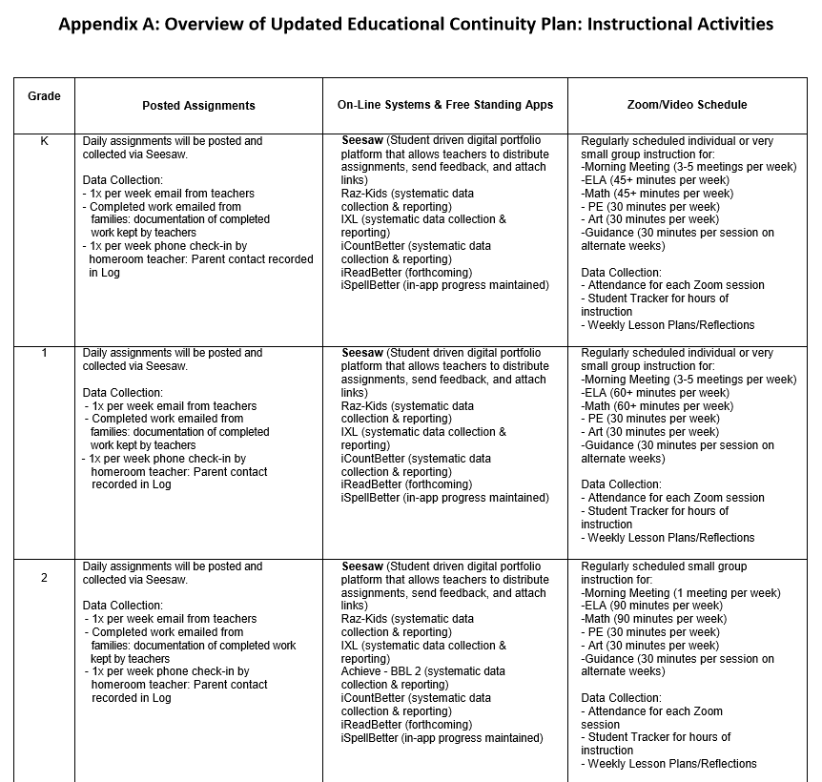

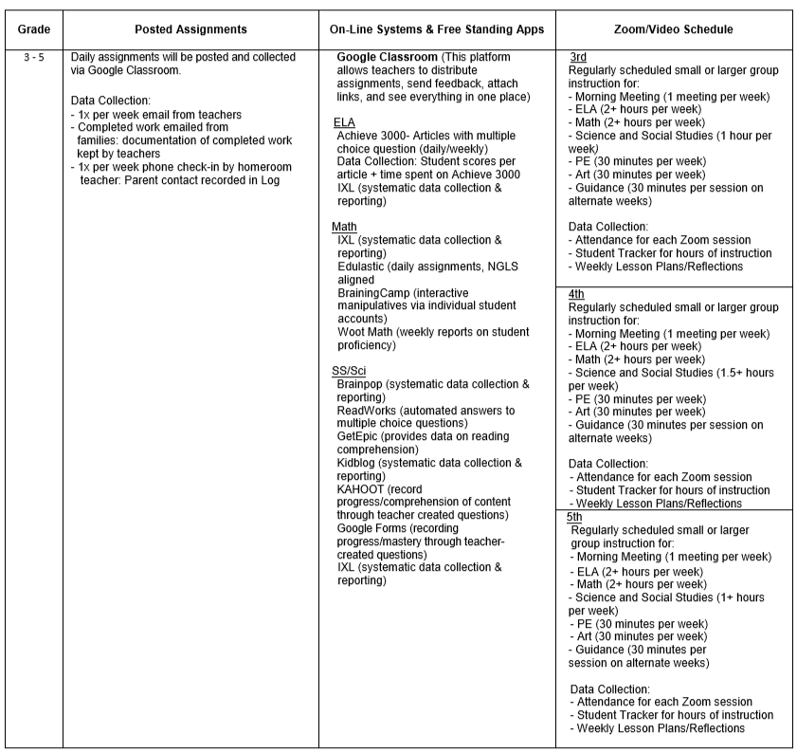

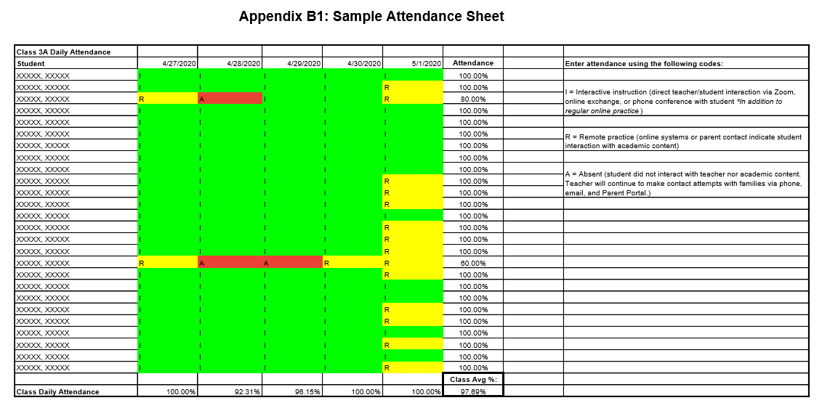
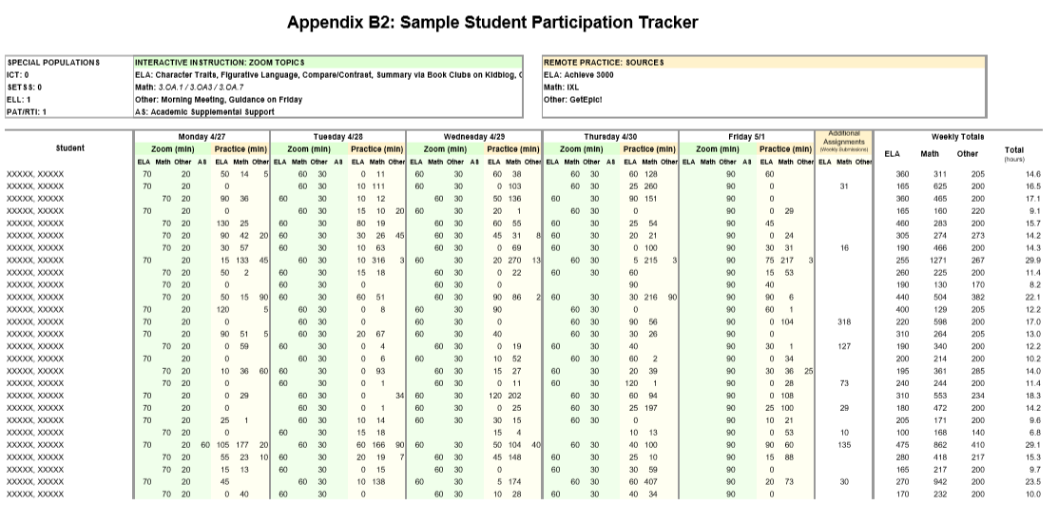

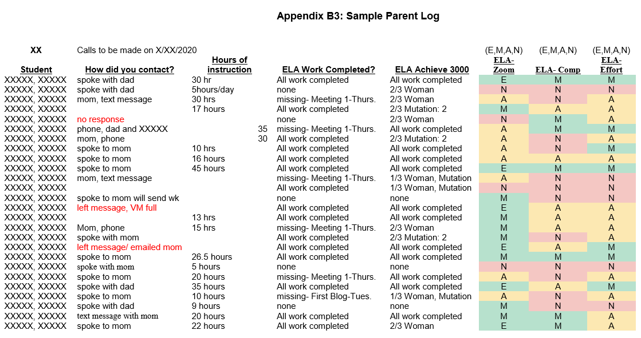
Appendix C – Parent Survey

