Continuing Education Activity Plan 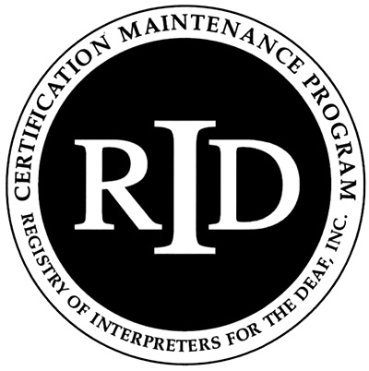

Instructor’s Form

This form is to be completed by either the instructor or RID Sponsor and kept on file with the Sponsor form.
The RID Sponsor will submit the completed Activity Plan online by logging in to their account at myaccount.rid.org prior to the start of the activity.

RID Sponsor Name: SCSDB Division of Outreach Services

Presenter/instructor name(s) (Please attach bio/resume):

Date(s)/time of activity:

Title of activity:

Level of participant’s prior knowledge of topic:

Little/None

Some

Extensive

Teaching

Target audience:

Is this activity closed to the public and should not be listed in the searchable RID database?

Yes No

Subject Code (Select all that apply):

01 Medical

04 Legal

07 Deafblind

10 Business Practices

13 Deaf Culture

16 Team Interpreting

19 Transliteration

22 Deaf

25 Ergonomics

28 PPO

02 Mental Health

05 Educational (K-12)

08 Oral

11 Tri-Lingual

14 Mentoring/Teaching

17 Religious

20 Visual/Auditory

23 Voice to Sign

26 Video

03 Drugs/Alcohol

06 Ed. (Post-Secondary)

09 Performing Arts

12 ASL/Linguistics

15 Sign to Voice

18 Ethical

21 Memory Building

24 Other

27 Repetitive Motion Injury

Media/Materials (List the equipment and materials you will use and who is responsible for providing them):

Workshop/course description:

Observable and measurable educational objectives (List specific measurable actions by participants that will demonstrate comprehension and integration of information presented. For example, Upon completion, participants will be able to: Determine and apply “minimum amount necessary rule” to their work, identify actual and/or potential FERPA & HIPAA violations in their work, integrate strategies to safe guard against violations into their work. Refer to the list of verbs for formulating educational objectives):

Upon completion of this workshop, participants will be able to:

Evaluation & Assessments (Describe how you will evaluate student learning & presentation effectiveness. For example, Presenter will check for understanding periodically and invite questions throughout and at the conclusion of the workshop. Additionally, participants will apply concepts to scenarios and complete a program evaluation.):

List of Verbs for Formulating Educational Objectives
The following verbs have been found to be effective in formulating educational objectives.

Those that communicate knowledge

Information:

cite
identify quote
relate tabulate count indicate
read
repeat
tell

define
list
recite
select
trace
describe name recognize state
update

draw
point
record summarize write
Comprehension:

assess
contrast
distinguish
interpolate
restate
associate
demonstrate
estimate
interpret
review
classify
describe
estimate
interpret
review
translate
compare
differentiate
express
predict
compute
discuss
extrapolate
report

Application:

apply
employ
match
relate
sketch
calculate
examine
operate
report
solve
choose
illustrate
order
restate
translate
complete
interpolate
practice
review
treat
demonstrate
interpret
predict
schedule
use
develop
locate
prescribe
select
utilize

Analysis:

analyze
criticize
diagram
infer
question
appraise
debate
differentiate
inspect
separate
contract
deduce
distinguish
inventory
separate
contrast
detect
experiment
measure

Synthesis:

arrange
construct
formulate
organize
produce
assemble
create
generalize
plan
propose
collect
design
integrate
prepare
specify
combine
detect
manage
prescribe
validate
compose
document

Evaluation:

appraise
critique
evaluate
rank
score
assess
decide
grade
rate
select
choose
determine
judge
recommend
test
compare
estimate
measure
revise

Those that impart skills

demonstrate
hold
massage
pass
visualize
diagnose
integrate
measure
write
diagram
internalize
operate
project
empathize
palpate
record
listen

Those that convey attitudes

acquire
exemplify
plan
reflect
transfer
consider
modify
realize
revise

Those that should be avoided

Appreciate
have faith in
know
learn
understand
believe

