Revised 3-1-2024

Roadmap to Reopening Schools
School Year 2023-2024

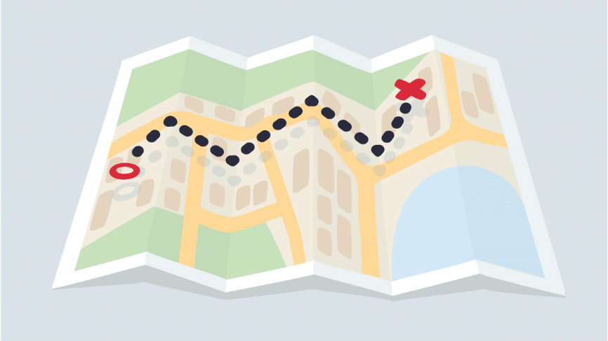

This roadmap provides guidance for Chickasaw City Schools in reopening schools for the 2023-2024 school year. This document follows guidance and expertise provided by the Alabama State Department of Education’s Roadmap to Opening Schools, the ADPH, and the CDC. Information from other state plans was also taken into consideration in the development of this plan.

GUIDING PRINCIPLES

Five principles will guide all planning, decision making, and execution of plans to return to school in the 2023-2024 school year.

- We will be transparent. We will share what we know and what we do not know and be clear about what we can control and what is outside of our control.
- We will be equitable. We will center decisions on what is best for all students, families, and educators.
- We will listen. We will bring together stakeholders and experts to understand realities on the ground and to creative solutions.
- We will put safety first. We will leverage data and public health leadership to inform the choices we make.
- We will be decisive. Given the size and scope of the challenge, we must move deliberately and make tough choices. We may need to adapt and if so, we will adapt quickly.
Chickasaw City School Systems primary areas of concern are wellness, operations and facilities, instruction, and technology. Our district will address these concerns through communication, prevention protocols, entry/exit of school campus, breakfast/lunch meals, transitions, large group gatherings, student learning environment, physical education and physical activity, vulnerable populations, staff or student illness at school, and health services.

STUDENT LEARNING ENVIRONMENTS

- Virtual Learning:
- Virtual Learning is a learning experience that is enhanced through utilizing computers and the internet. Virtual Learners will be able to login from home. The instruction will take place through online programs.

- Traditional School:
- Students in the traditional school setting will attend regular classes on site.
- Social distancing will take place when available.
- All students diagnosed with COVID-19 will become Virtual Learners for quarantine time recommended by Alabama Department of Public Health (ADPH) .
- If class/school closures occur, Virtual Learning guidelines will be followed. Chickasaw City Schools will ensure all staff and students are prepared to transition to virtual learning in response to directives by the Governor of Alabama, Alabama Department of Public Health (ADPH), local health officials, and the Board of Education if/when necessary.

Chickasaw City SCHOOLS ROADMAP TO REOPENING SCHOOLS
The Alabama State Department of Education (ALSDE) has provided recommended strategies that school systems may choose to implement to protect the health of staff and students and minimize the spread of COVID-19.

ALSDE recommendations are divided into three categories:
- Essential – Required by law, policy, governmental order, or a critical practice.
- Guidance – Best practices gleaned from research and long-term experience and highly recommended for implementation when feasible.
- Consideration – Additional best practices informed by emerging research, recent studies, and practical experience to be considered for implementation when feasible.

Chickasaw City Schools recognizes that all ALSDE recommended guidelines will not be possible in all settings and have been amended based on the needs of our school as appropriate.
Communication | Chickasaw City Schools will communicate with parents through:  - School Website  - Schools’ Facebook Page  - All-Call Phone Notification through SchoolStatus  Teachers will communicate with parents through:  - School Status (phone calls, texts, and emails)  Chickasaw City Schools will post information on the school’s website to communicate how to stop the spread of COVID-19, how to identify symptoms that indicate when staff and students must stay home, preventative measures (including staying home when sick), good hygiene, self-reporting symptoms to health officials, and school-specific protocols.  Specific situations will be sent to the school nurse for determination based on State Department and CDC guidelines.
Prevention | To prevent the spread of COVID-19, Chickasaw City Schools will:  - Provide face masks for students as needed.  - Instruct students on appropriate ways to wear mask or face shield.  - Order hand sanitizer, hands-free sanitizer stations, and cleaning materials for the school.  - Post signs throughout the school to educate students on proper ways to wash hands. All teachers will teach and reinforce handwashing with soap and water for at least 20 seconds and/or the safe use of hand sanitizer that contains 60% or more alcohol by staff and older students.  - Conduct deep cleaning of schools prior to students/staff returning; schedule additional cleanings during weekends or school holidays/breaks. Undergo frequent cleaning each day during instruction and after school. Areas of frequent touching, such as door handles, push bars, stair handrails, desk, chairs, bathroom doors, bathroom handles, will be cleaned five times a day or more (Procedures/guidelines forthcoming)  - Arrange student desk with as much separation as possible.  - Limit student passes out of class and prevent large gatherings.  - Educate students on physically distancing themselves from others.  - Implement one-way traffic within reason in classrooms and hallways with social distancing measures as much as possible.  - Notify local health officials, affected staff, and student families immediately of a positive case while maintaining confidentiality consistent with the Americans with Disabilities Act (ADA) and other applicable federal and state privacy laws.  - Teach students proper communication methods if they are feeling sick. These include raising hand to report feeling ill. Stress the importance of washing hands and personal hygiene.  Additional preventive procedures will include the following:  - Students are strongly encouraged to bring water bottles from home.  - Teachers, staff, and parents must consistently educate students about hygiene and proper ways to wash hands.
Student and  Staff Screening | Home is the initial point of screening each. Parents/Guardians should self-report/notify Chickasaw City Schools if their student exhibits COVID-19 symptoms to include fever, new onset of cough, etc. Parents/Guardians should check their student’s temperature regularly. Any fever of 100.1 or higher will not be allowed to attend school. Any student exhibiting symptoms should be taken to a health-care provider.  As part of the procedures for screening students and staff, Schools will:  - Train all staff on visually checking students for signs of COVID-19.  - Train all administrators on visually checking staff for signs of COVID-19.
Campus Entry  and Exit | The procedures for campus entry and exit will be as follows:  - Any staff with a fever of 100.4 or higher will not be allowed in the building. Staff may only return to school with a doctor’s note stating negative COVID-19 results or a reasonable examination from a physician. Otherwise, staff must remain quarantined at home for 14 days before returning to school.  - Any student with a fever of 100.4 or higher will not be allowed to exit their vehicle and will be required to return home.  - Students may only return to school with a doctor’s note stating negative COVID-19 results or a reasonable explanation for a fever. The note cannot simply state “this child does not have COVID-19” but needs to explain what caused the fever. Otherwise, the student must remain quarantined at home for 14 days before returning to school.  - Hand sanitizing stations will be placed at every entry for students to use before entering the building and classrooms.  - Each hallway will be marked for one-way traffic. Entry and exit flow will be monitored to keep all students flowing in the same direction.  - Parents will not be allowed to walk students to their classrooms. Staff will be provided to assist students.  - Parents/Guardians who need to check-out their child or deliver something to the student will need to buzz-in at the main office door.  - Visitors and volunteers must buzz-in at the main office door. Schools will restrict visitors and volunteers from entering the school without prior approval from the school principal.

