Timecard Job Aid

Download timecard from the San Juan Portal
Log in to the San Juan Portal: https://portal.sanjuan.edu/LoginPolicy.jsp
Select District Intranet tile
Select Department; Payroll
Select Forms and Documents
Click SJUSD Timecard.xlsm
Open downloaded file
Select Enable Editing
Select Enable Content
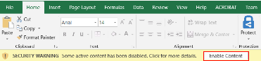
Select Continue
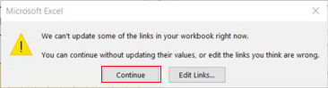
Click on a blue field to enter Data
Save File
Select File; Save as
Rename File to Last Name, First Name
Click Save
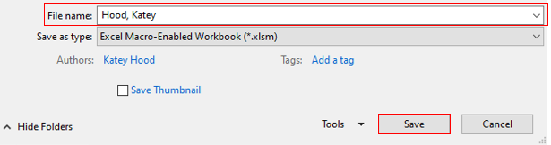
Email Timecard to an approver
Approver: Review, enter the budget code(s), and enter manager approval
Save the timecard
Email completed timecard to payroll.support@sanjuan.edu stating approval

