Emergency Safety Intervention
Parent Information

If an emergency safety intervention occurs, parents are strongly encouraged to schedule a meeting to: 1) discuss the incident and 2) discuss prevention of future use of emergency safety interventions. The district contact listed below is available to assist in scheduling this meeting. This meeting will be scheduled no later than ten (10) school days from when the parent makes the request unless the parent cannot meet within that time frame.

USD 305 Public Schools
Website access to ESI Information: https://www.usd305.com/departments/public_information/emergency_safety_intervention
District Contact for ESI: Jeff Hayes
(785) 309-5100
jeff.hayes@usd305.com

Documents Included in this Packet

District Emergency Safety Intervention Policy
Including dispute resolution process

Standards for the Use of Emergency Safety Interventions

A Family Guide to the Use of Emergency Safety Interventions and Parental Rights: Seclusion and Restraint in Kansas

Local Dispute Resolution Guide for Parents

State Board Administrative Review Process

State Administrative Review Guide for Parents

State and Community Resources

District Emergency Safety Intervention Policy
Including dispute resolution process

USD 305 District Policy GAAF:

GAAF Emergency Safety Intervention GAAF
(See JRB, JQ and KN)

The board is committed to limiting the use of Emergency Safety Intervention (ESI), such as seclusion and restraint, with all students. Seclusion and restraint shall be used only when a student’s conduct necessitates the use of an emergency safety intervention as defined below. The board encourages all employees to utilize other behavioral management tools, including prevention techniques, de-escalation techniques, and positive behavioral intervention strategies.

This policy shall be made available on the district website with links to the policy available on any individual school pages. In addition, this policy shall be included in at least one of the following: each school’s code of conduct, school safety plan, or student handbook. Notice of the online availability of this policy shall be provided to parents during enrollment each year.

Definitions
“Emergency Safety Intervention” is the use of seclusion or physical restraint, but does not 18 include physical escort or the use of time-out.

“Incident” means each occurrence of the use of an emergency safety intervention.

“Legitimate Law Enforcement Purpose” means a goal within the lawful authority of an officer that is to be achieved through methods or conduct condoned by the officer’s appointing authority.

“Law Enforcement Officer” and “Police Officer” means a full-time or part-time salaried officer or employee of the state, a county, or a city whose duties include the prevention or detection of crime and the enforcement of criminal or traffic law of this state or any Kansas municipality. This term includes a campus police officer.

“Campus Police Officer” means a school security officer designated by the board of education of any school district pursuant to K.S.A. 72-6146, and amendments thereto.

“School Resource Officer” means a law enforcement officer or police officer employed by a local law enforcement agency who is assigned to a district through an agreement between the local law enforcement agency and the district.

“School Security Officer” means a person who is employed by a board of education of any school district for the purpose of aiding and supplementing state and local law enforcement agencies in which the school district is located, but is not a law enforcement officer or police officer.

“Seclusion” means placement of a student in a location where all of the following conditions are met: (1) the student is placed in an enclosed area by school personnel; (2) the student is purposefully isolated from adults and peers; and (3) the student is prevented from leaving or reasonably believes that he/she will be prevented from leaving the enclosed area.

“Chemical Restraint” means the use of medication to control a student’s violent physical behavior or restrict a student’s freedom of movement.

“Mechanical Restraint” means any device or object used to limit a student’s movement.

“Physical Restraint” means bodily force used to substantially limit a student’s movement, except that consensual, solicited or unintentional contact and contact to provide comfort, assistance or instruction shall not be deemed to be physical restraint.

“Physical Escort” means the temporary touching or holding the hand, wrist, arm, shoulder, or back of a student who is acting out for the purpose of including the student to walk to a safe location.

“Parent” means (1) a natural parent; (2) an adoptive parent; (3) a person acting as a parent as defined in K.S.A. 72-3122(d)(2), and amendments thereto; (4) a legal guardian; (5) an education advocate for a student with an exceptionality; (6) a foster parent, unless the student is a child with an exceptionality; or (7) a student who has reached the age of majority or is an emancipated minor.

“Time-Out” means a behavioral intervention in which a student is temporarily removed from a learning activity without being secluded.

Prohibited Types of Restraint
All staff members are prohibited from engaging in the following actions with all students:
• Using face-down (prone) physical restraint;
• Using face-up (supine) physical restraint;
• Using physical restraint that obstructs the student’s airway;
• Using physical restraint that impacts a student’s primary mode of communication;
• Using chemical restraint, except as prescribed treatments for a student’s medical or psychiatric condition by a person appropriately licensed to issue such 81 treatments; and
• Use of mechanical restraint, except
o Protective or stabilizing devices required by law or used in accordance with an order from a person appropriately licensed to issue the order for the device;
o Any device used by a certified law enforcement officer to carry out law enforcement duties; or
o Seatbelts and other safety equipment when used to secure students during 89 transportation.

Use of Emergency Safety Intervention
ESI shall be used only when a student presents a reasonable and immediate danger of physical harm to such student or others with the present ability to effect such physical harm. Less restrictive alternatives to ESI, such as positive behavior interventions support, shall be deemed inappropriate or ineffective under the circumstances by the school employee witnessing the student’s behavior prior to the use of any ESI. The use of ESI shall cease as soon as the immediate danger of physical harm ceases to exist. Violent action that is destructive of property may necessitate the use of an ESI. Use of an ESI for purposes of discipline, punishment or for the convenience of a school employee shall not meet the standard of immediate danger of physical harm.

ESI Restrictions
A student shall not be subjected to ESI if the student is known to have a medical condition that could put the student in mental or physical danger as a result of ESI. The existence of such medical condition must be indicated in a written statement form the student’s licensed health care provider, a copy of which has been provided to the school and placed in the student’s file.

Such written statement shall include an explanation of the student’s diagnosis, a list of any reasons why ESI would put the student in mental or physical danger, and any suggested alternatives to ESI. Notwithstanding the provisions of this subsection, a student may be subjected to ESI if not subjecting the student to ESI would result in significant physical harm to the student or others.

Use of Seclusion
When a student is placed in seclusion, a school employee shall be able to see and hear the student at all times.

All seclusion rooms equipped with a locking door shall be designed to ensure that the lock automatically disengages when the school employee viewing the student walks away from the seclusion room or in case of emergency such as fire or severe weather.

A seclusion room shall be a safe place with proportional and similar characteristics as other rooms where students frequent. Such room shall be free of any condition that could be a danger to the student, well-ventilated, and sufficiently lighted.

Training
All staff members shall be trained regarding the use of positive behavioral intervention strategies, de-escalation techniques, and prevention techniques. Such training shall be consistent with nationally recognized training programs on ESI. The intensity of the training provided will depend upon the employee’s position. Administrators, licensed staff members, and other staff deemed most likely to need to restrain a student will be provided more intense training than classified staff who do not work directly with students in the classroom. District and building administration shall make the determination of the intensity of training required by each position.

Each school building shall maintain written or electronic documentation regarding the training that was provided and a list of participants which shall be made available for inspection by the state board of education upon request.

Notification and Documentation
The principal or designee shall notify the parent the same day as an incident. The same day notification requirement of this subsection shall be deemed satisfied if the school attempts at least two methods of contacting the parent. A parent may designate a preferred method of contact to receive the same-day notification. Also, a parent may agree, in writing, to receive only one same-day notification from the school for multiple incidents occurring on the same day.

Documentation of the ESI used shall be completed and provided to the student’s parents no later than the school day following the day of the incident. Such written documentation shall include: (1) the events leading up to the incident; (2) student behaviors that necessitated the ESI; (3) steps taken to transition the student back into the educational setting; (4) the date and time the incident occurred, the type of ESI used, the duration of the ESI, and the school personnel who used or supervised the ESI; (5) space or an additional form for parents to provide feedback or comments to the school regarding the incident; (6) a statement that invites and strongly encourages parents to schedule a meeting to discuss the incident and how to prevent future incidents; and (7) email and phone information for the parent to contact the school to schedule the ESI meeting. Schools may group incidents together when documenting the items in subparagraphs (1), (2) and (3) if the triggering issue necessitating the ESI is the same.

The parent shall be provided the following information after the first and each subsequent incident during each school year; (1) a copy of this policy which indicates when ESI can be used; (2) a flyer on the parent’s rights; (3) information on the parent’s right to file a complaint through the local dispute resolution process (which is set forth in this policy) and the complaint process of the state board of education; and (4) information that will assist the parent in navigating the complaint process, including contact information for Families Together and the Disability Rights Center of Kansas. Upon the first occurrence of an incident of ESI, the foregoing information shall be provided in printed form or, upon the parent’s written request, by email. Upon the occurrence of a second or subsequent incident, the parent shall be provided with a full and direct website address containing such information.

Law Enforcement, School Resource, and Campus Security Officers
Campus police officers and school resource officers shall be exempt from the requirements of this policy when engaged in an activity that has a legitimate law enforcement purpose. School security officers shall not be exempt from the requirements of this policy.

If a school is aware that a law enforcement officer or school resource officer has used seclusion, physical restraint, or mechanical restraint on a student, the school shall notify the parent the same day using the parent’s preferred method of contact. A school shall not be required to provide written documentation to a parent, as set forth above, regarding law enforcement use of an emergency safety intervention or report to the state department of education any law enforcement use of an emergency safety intervention. For purposes of this subsection, mechanical restraint includes, but is not limited to, the use of handcuffs.

Documentation of ESI Incidents
Except as specified above with regard to law enforcement or school resource officer use of emergency safety interventions, each building shall maintain documentation any time ESI is used with a student. Such documentation must include all of the following:
• Date and time of the ESI,
• Type of ESI,
• Length of time the ESI was used,
• School personnel who participated in or supervised the ESI,
• Whether the student had an individualized education program at the time of the incident,
• Whether the student had a Section 504 plan at the time of the incident, and
• Whether the student had a behavior intervention plan at the time of the incident.

All such documentation shall be provided to the building principal, who shall be responsible for providing copies of such documentation to the superintendent on at least a biannual basis. At least once per school year, each building principal or designee shall review the documentation of ESI incidents with appropriate staff members to consider the appropriateness of the use of ESI in those instances.

Reporting Data
District administration shall report ESI data to the state department of education as required.

Parent Right to Meeting on ESI Use
After each incident, a parent may request a meeting with the school to discuss and debrief the incident. A parent may request such meeting verbally, in writing, or by electronic means. A school shall hold a meeting requested under this subsection within 10 school days of the parent’s request. The focus of any such meeting shall be to discuss proactive ways to prevent the need for emergency safety interventions and to reduce incidents in the future.

For a student with an IEP or a Section 504 plan, such student’s IEP team or Section 504 plan team shall discuss the incident and consider the need to conduct a functional behavioral assessment, develop a behavior intervention plan or amend the behavior intervention plan if already in existence.

For a student with a Section 504 plan, such student’s Section 504 plan team shall discuss and consider the need for a special education evaluation. For students who have an individualized education program and are placed in a private school by a parent, a meeting called under this subsection shall include the parent and the private school, who shall consider whether the parent should request an individualized education program team meeting. If the parent requests an individualized education program team meeting, the private school shall help facilitate such meeting.

For a student without an IEP or Section 504 plan, the school staff and the parent shall discuss the incident and consider the appropriateness of a referral for a special education evaluation, the need for a functional behavioral assessment, or the need for a behavior intervention plan. Any such meeting shall include the student’s parent, a school administrator evaluation, the need for a functional behavioral assessment, or the need for a behavior intervention plan. Any such meeting shall include the student’s parent, a school administrator for the school the student attends, one of the student’s teachers, a school employee involved in the incident, and any other school employees designated by the school administrator as appropriate for such meeting.

The student who is the subject of such meetings shall be invited to attend the meeting at the discretion of the parent. The time for calling such a meeting may be extended beyond the ten day limit if the parent of the student is unable to attend within the time period. Nothing in this section shall be construed to prohibit the development and implementation of a functional behavior assessment or a behavior intervention plan for any student if such student would benefit from such measures.

Local Dispute Resolution Process
If a parent believes that an emergency safety intervention has been used on the parent’s child in violation of state law or board policy, the parent may file a complaint as specified below.

The board encourages parents to attempt to resolve issues relating to the use of ESI informally with the building principal and/or the superintendent before filing a formal complaint with the board. Once an informal complaint is received, the administrator handling such complaint shall investigate such matter, as deemed appropriate by the administrator. In the event that the complaint is resolved informally, the administrator must provide a written report of the informal resolution to the superintendent and the parents and retain a copy of the report at the school. The superintendent will share the informal resolution with the board and provide a copy to the state department of education.

If the issues are not resolved informally with the building principal and/or the superintendent, the parents may submit a formal written complaint to the board by providing a copy of the complaint to the clerk of the board and the superintendent within thirty days after the parent is informed of the incident.

Upon receipt of a formal written complaint, the board president shall assign an investigator to review the complaint and report findings to the board as a whole. Such investigator may be a board member, a school administrator selected by the board, or a board attorney. Such investigator shall be informed of the obligation to maintain confidentiality of student records and shall report the findings of fact and recommend corrective action, if any, to the board in executive session.

Any such investigation must be completed within thirty days of receipt of the formal written complaint by the board clerk and superintendent. On or before the 30th day after receipt of the written complaint, the board shall adopt a report containing written findings of fact and, if necessary, appropriate correction action. A copy of the report adopted by the board shall be provided to the parents, the school, and the state board of education and shall be mailed to the parents and the state department within 30 days of the board’s receipt of the formal complaint.

If desired, a parent may file a complaint under the state board of education administrative review process within thirty days from the date a final decision is issued pursuant to the local dispute resolution process.

Approved: October 8, 2013
Revised: November 10, 2015
Revised: November 8, 2016
Revised: October 9, 2018
Revised: February 26, 2019


Standards for the use of Emergency Safety Interventions

Emergency safety interventions law sets forth standards for the use of restraint and seclusion to ensure that all Kansas students and staff have a safe learning environment. The standards found in the emergency safety intervention regulations are required to be followed in all Kansas public school districts and accredited private schools.

An emergency safety intervention is the use of seclusion or physical restraint. The use of an emergency safety intervention shall cease as soon as the immediate danger of physical harm and violent action ceases to exist.

Before using an emergency safety intervention, a school employee witnessing the student’s behavior must have determined that less restrictive alternatives to emergency safety interventions, such as positive behavior interventions support, were inappropriate or ineffective under the circumstances.

An emergency safety intervention shall be used only when a student presents a reasonable and immediate danger of physical harm to such student or others with the present ability to effect such physical harm. Violent action that is destructive of property may necessitate the use of an emergency safety intervention if there is a reasonable and immediate danger of physical harm. An emergency safety intervention may not be used for purposes of discipline, punishment, or for the convenience of a school employee.

Physical restraint means bodily force used to substantially limit a student’s movement. Physical restraint is NOT:
- Consensual, solicited or unintentional contact and contact to provide comfort, assistance or instruction;
- physical escort;
- prescribed treatments for a student’s medical or psychiatric condition by a person appropriately licensed to issue these treatments;
- protective or stabilizing devices either ordered by an appropriately licensed professional or required by law;
- any device used by a law enforcement officer in carrying out law enforcement duties; and
- seatbelts and any other safety equipment when used to secure students during transportation.

Prohibited types of restraints:
- Prone, or face-down, physical restraint;
- supine, or face-up, physical restraint;
- any physical restraint that obstructs the airway of a student;
- any physical restraint that impacts a student’s primary mode of communication;
- chemical restraint (‘‘chemical restraint’’ means the use of medication to control a student’s violent physical behavior or restrict a student’s freedom of movement.); and
- mechanical restraint (‘‘mechanical restraint’’ means any device or object used to limit a student’s movement).

Seclusion means placement of a student in a location where:
- The student is placed in an enclosed area by school personnel;
- the student is purposefully isolated from adults and peers; and
- the student is prevented from leaving, or the student reasonably believes that such student will be prevented from leaving, the enclosed area.

An emergency safety intervention may not be used with a student if the student is known to have a medical condition that could put the student in mental or physical danger as a result of the use of an emergency safety intervention unless not using an emergency safety intervention would result in significant physical harm to the student or others. The medical condition must be indicated in a written statement from the student’s licensed health care provider, and a copy of which shall be provided to the school and placed in the student’s file.

When a student is placed in seclusion, a school employee shall be able to see and hear the student at all times.
If a seclusion room has a locking door it must be designed to ensure that the lock automatically disengages when the school employee viewing the student walks away from the seclusion room, or in cases of emergency, such as fire or severe weather.
A seclusion room must be a safe place. The room must have good ventilation and lighting, and be free of any condition that could be a danger to the student. The room must also be similar to other rooms where students frequent.

Seclusion is not time-out, which is a behavioral intervention in which a student is temporarily removed from a learning activity without being confined.

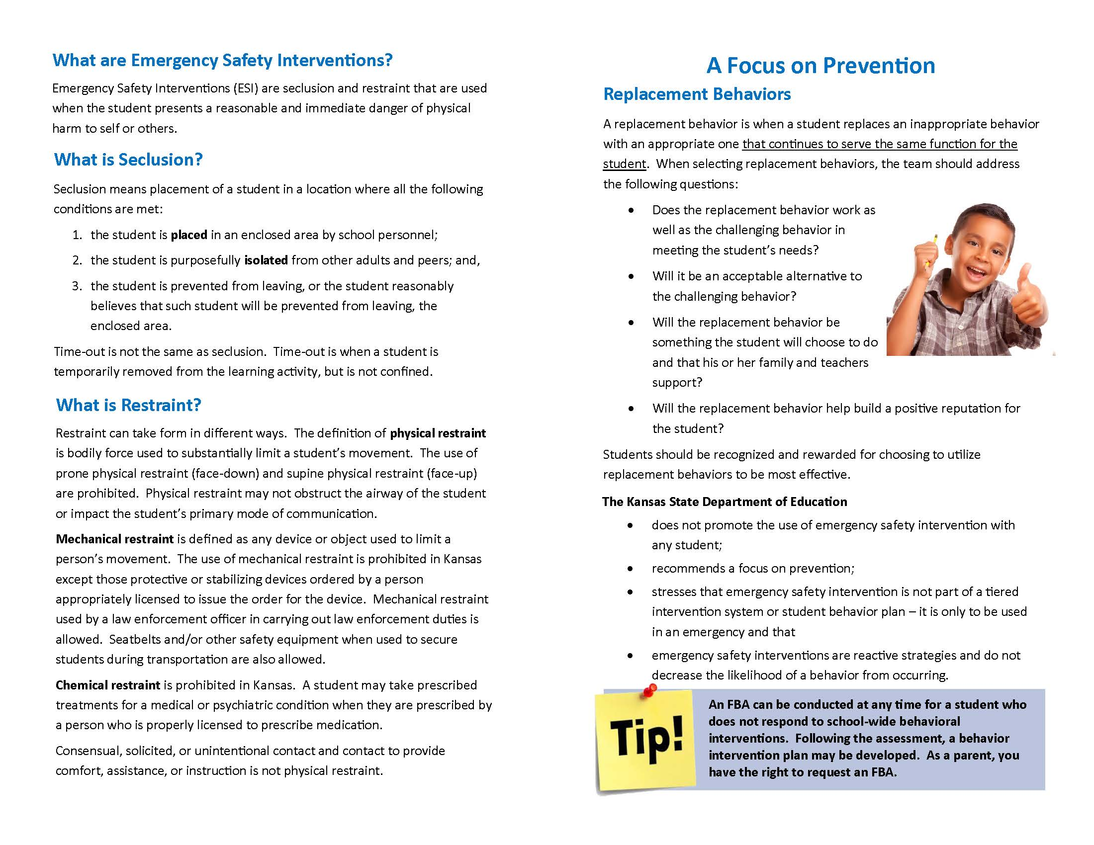
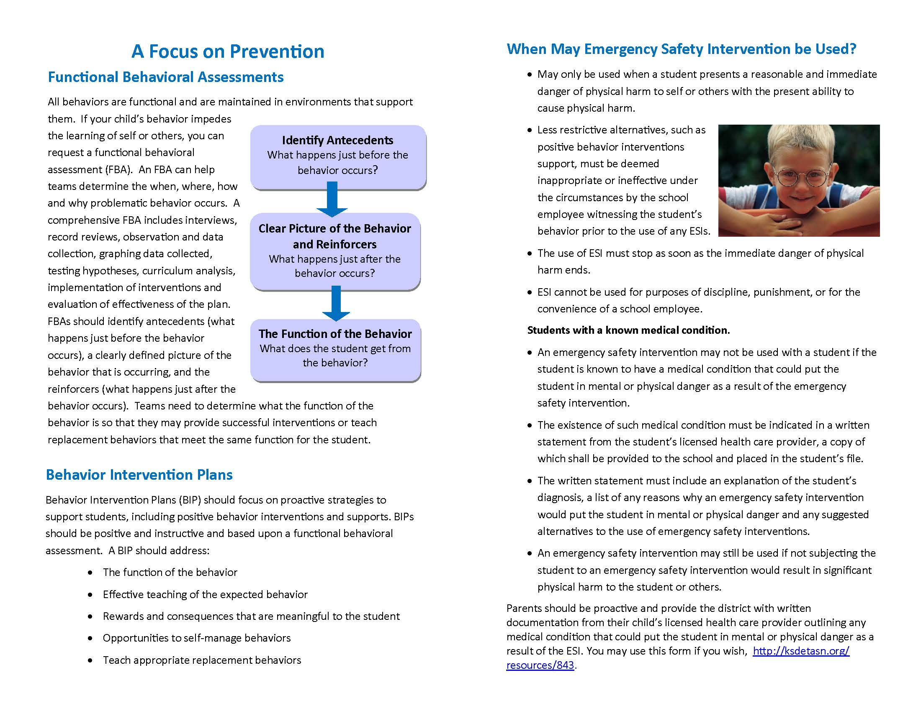
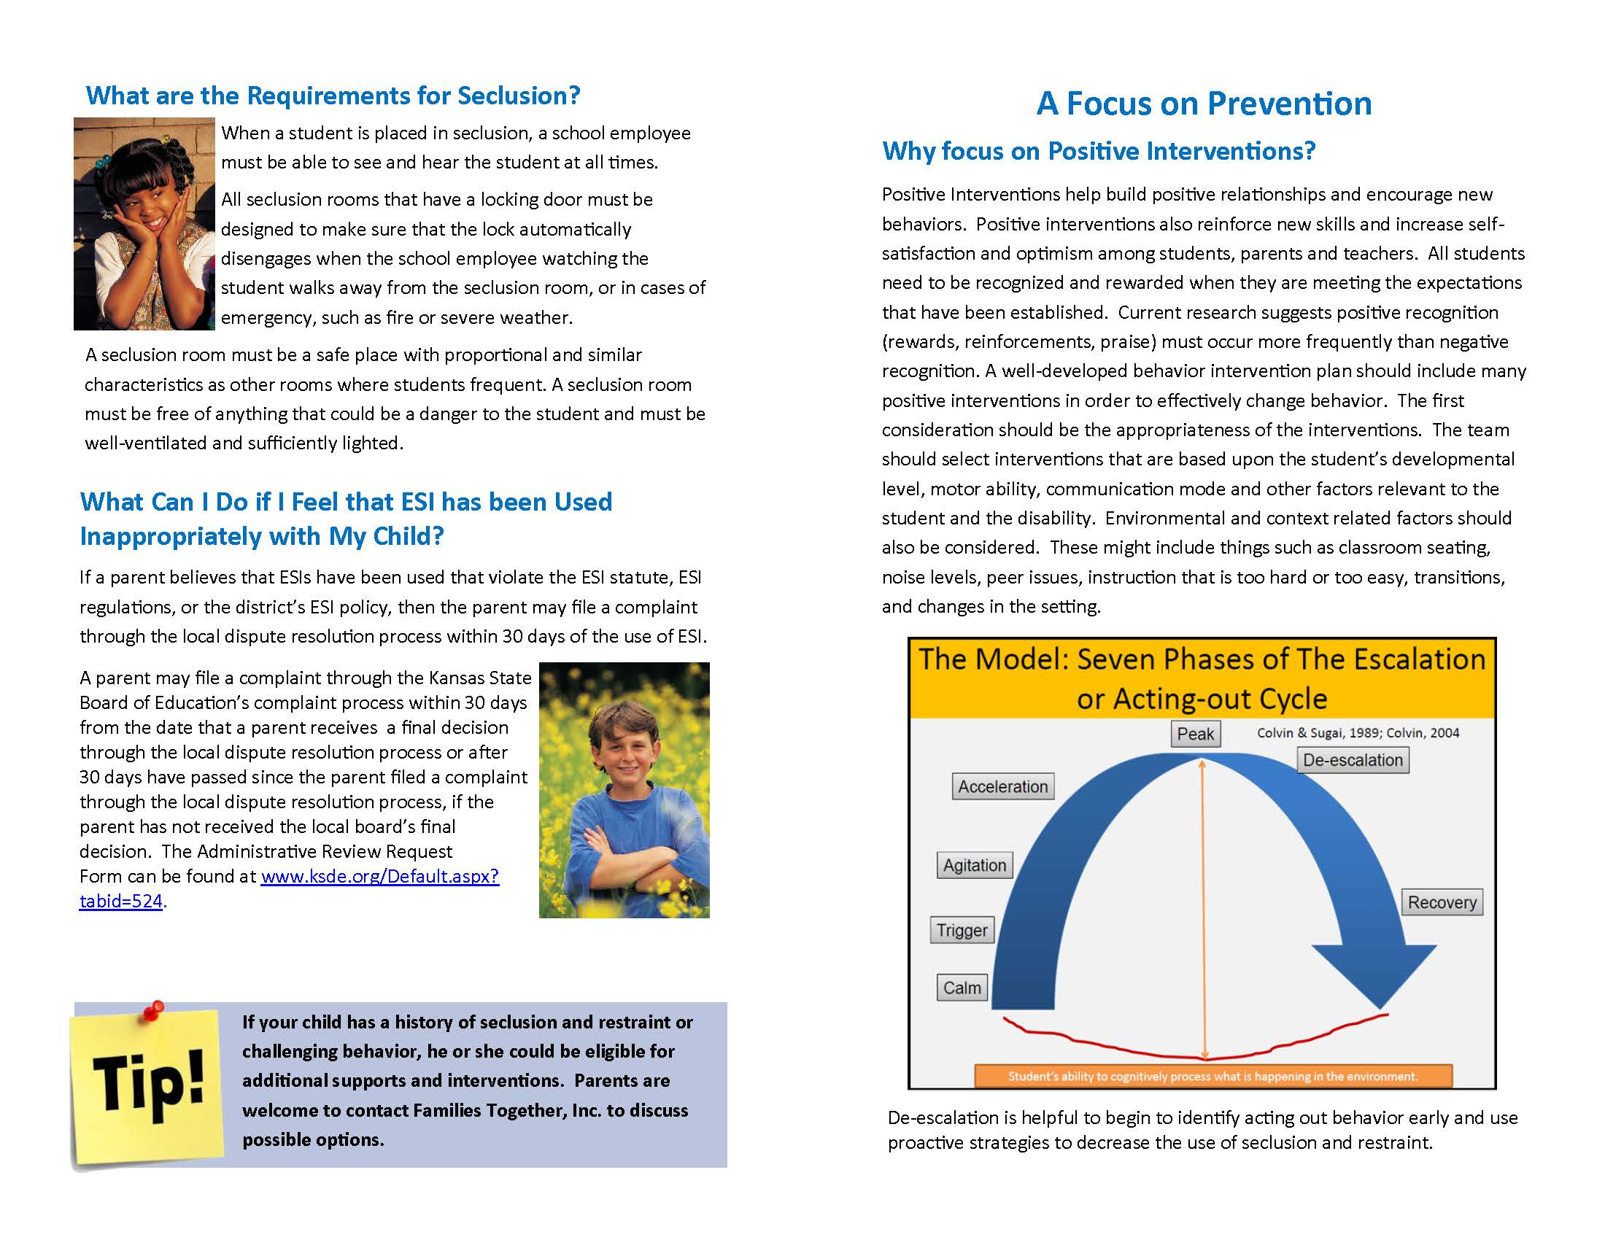
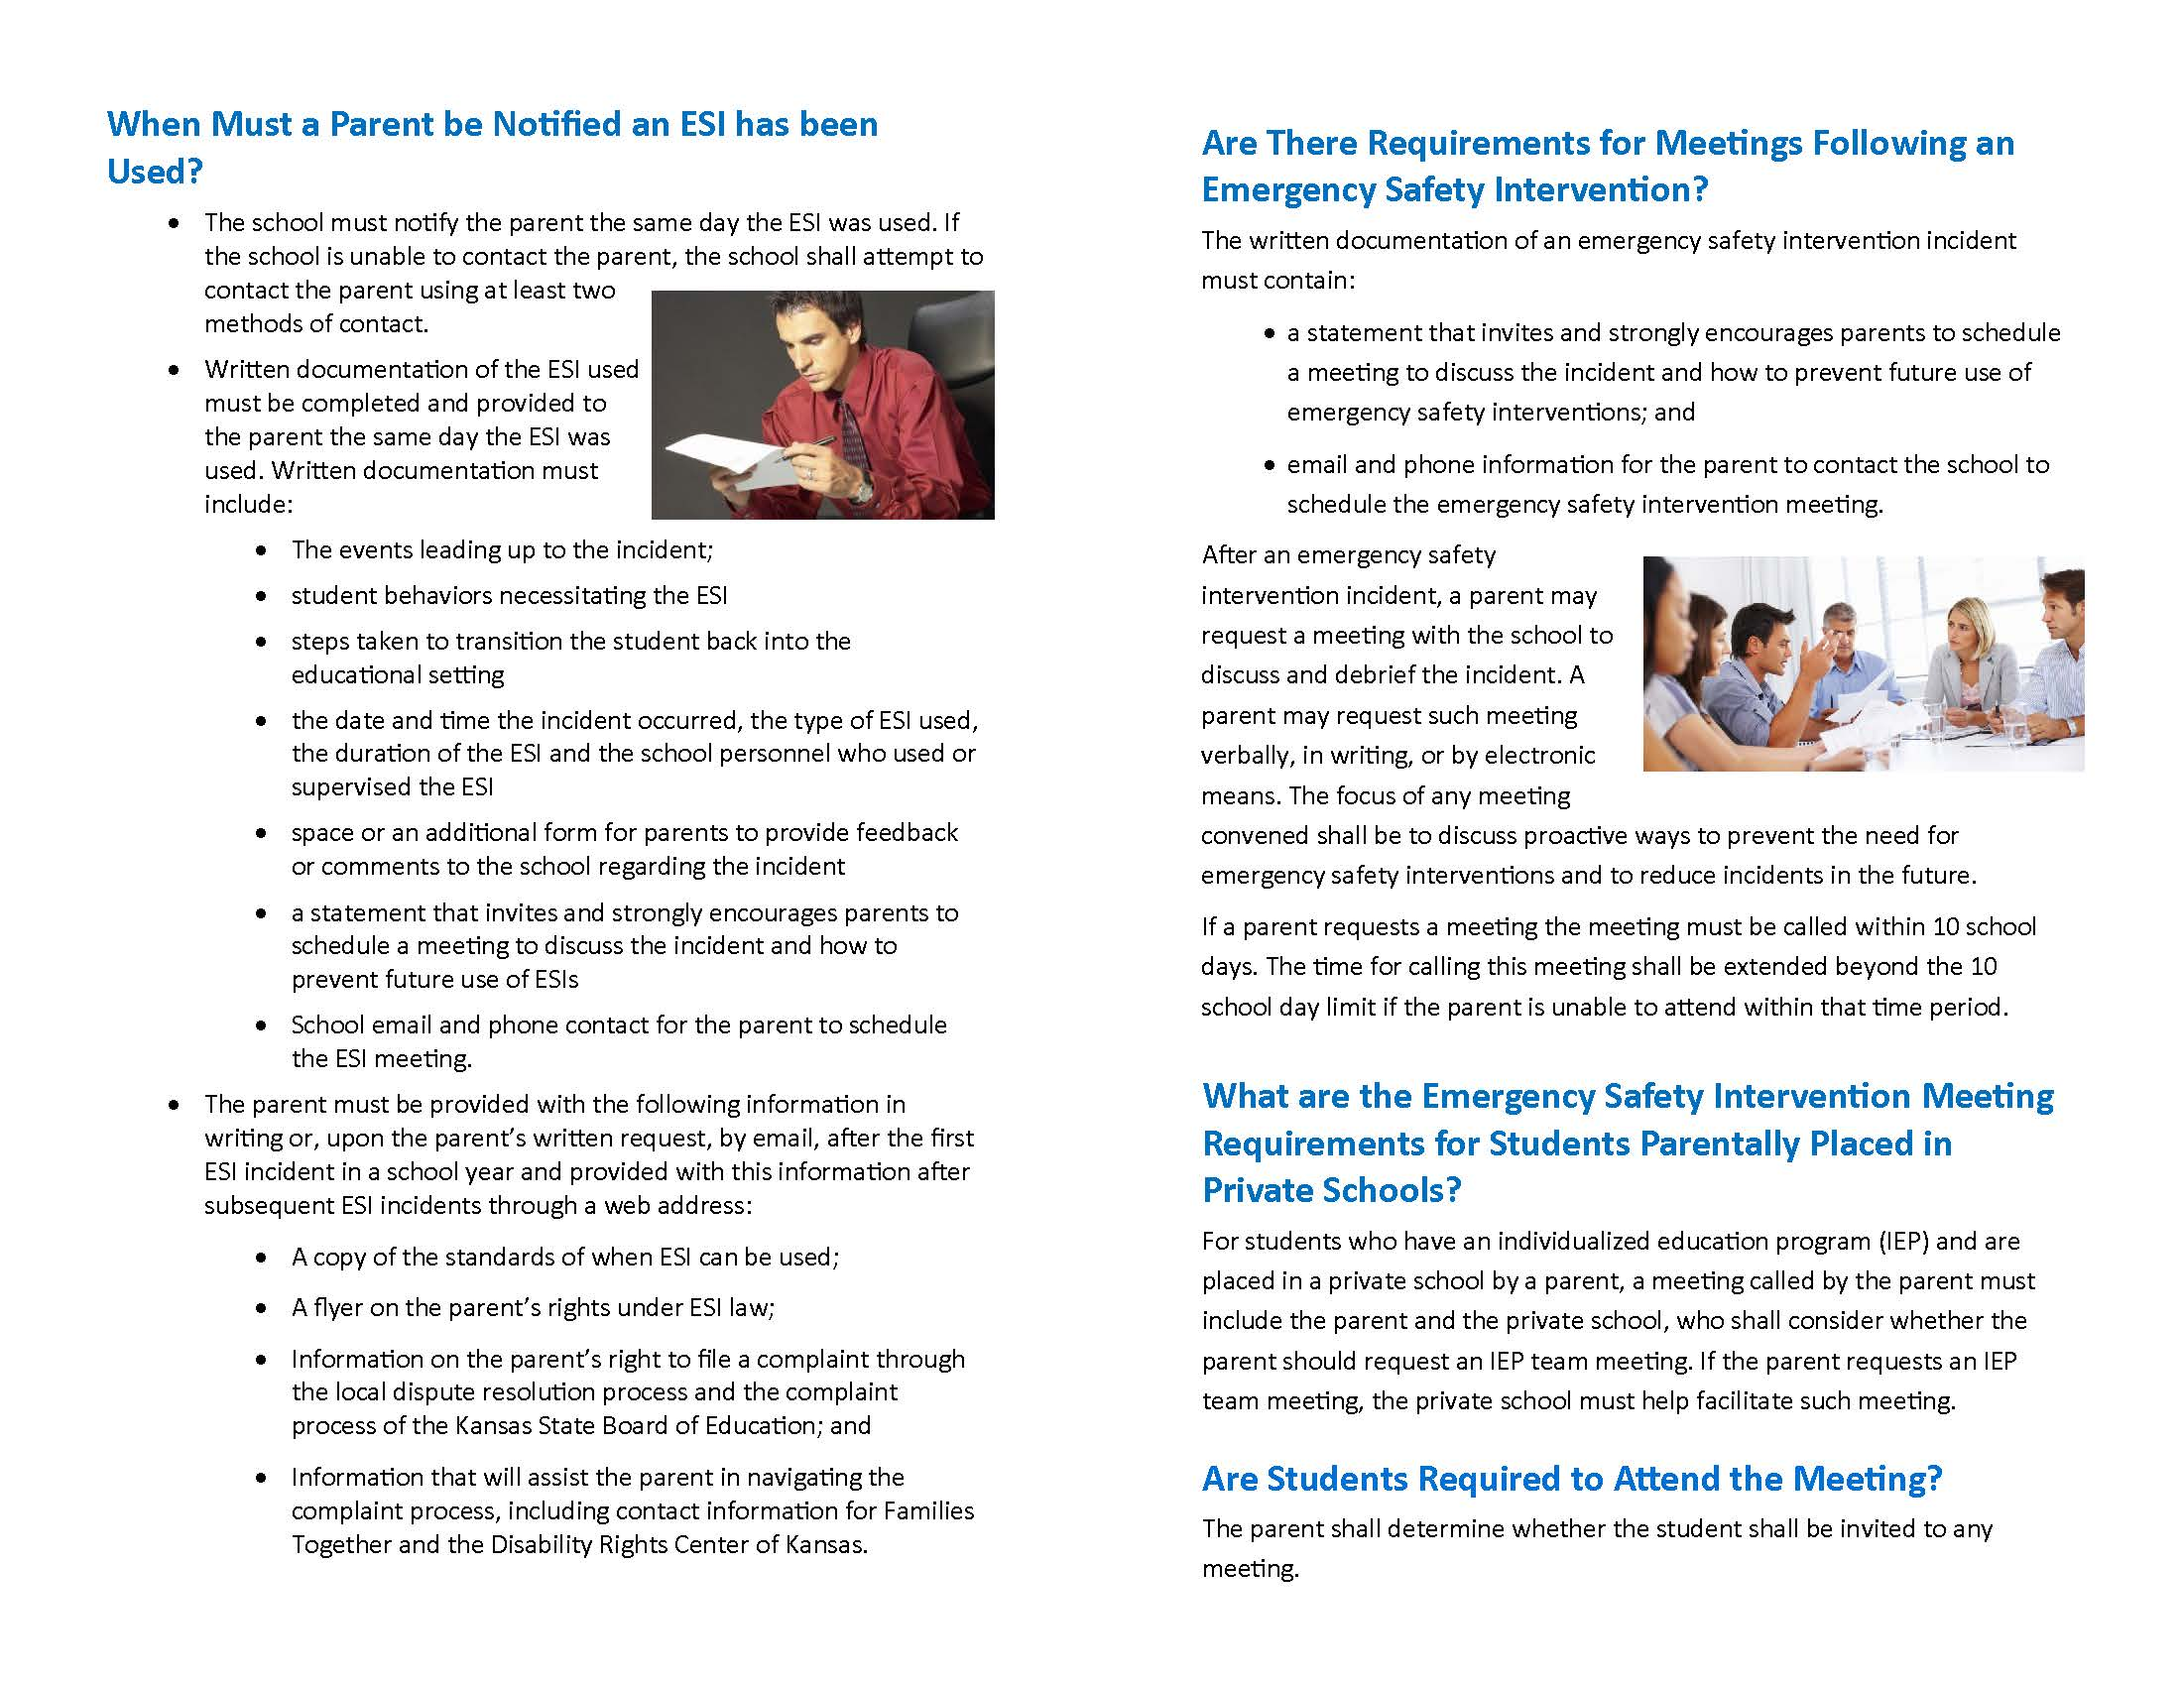

Local Dispute Resolution Guide for Parents

State Board Administrative Review Process

Refer to K.A.R. 91-42-5 for complete information. The following provides a summary of the regulations regarding an administrative review initiated with the Kansas State Board of Education (State Board).

- If a parent believes an emergency safety intervention was used in violation of K.A.R. 91-42-1 through -7 and the parent filed a written complaint with their local board of education, then this parent may request an administrative review of the local board’s decision from the State Board.
  - The request for administrative review must include the following information:
    - Name of the student and contact information;
    - Names and contact information for all involved parties (teachers, aides, administrators, and district staff), to the extent known;
    - A detailed statement of the reason for requesting an administrative review;
    - Any supporting facts and documentation; and
    - A copy of the complaint filed with the local board, the local board’s final decision (if issued).
    - The written request for administrative review must be typed or legibly written and signed by the parent.
    - Relevant documents must be attached or, if unavailable, the documents must be referenced in the request for administrative review.
    - Written consent to disclose any personally identifiable information from the student’s education records necessary to conduct an investigation

- The request for administrative review must be filed with the Commissioner of Education within 30 days of the local board issuing its final decision OR within 60 days from the date the parent filed a complaint with the local board, if the local board did not issue a final decision. You may mail this request to the Kansas State Department of Education, Landon State Office Building, 900 SW Jackson Street, Office of General Counsel, Room 102, Topeka, Kansas 66612. KSDE has provided a form for you to use, if you wish, and you can find it on the Emergency Safety Interventions page of the KSDE website, www.ksde.org/Default.aspx?tabid=524.

- A Hearing Officer will be designated by the State Board. The Hearing Officer must send a copy of the request for administrative review to the local board.

- The Hearing Officer will consider the local board’s final decision and may initiate an investigation that could include:
  - A discussion with the parent, during which additional information may be gathered;
  - Contact with the local board or other district staff to allow the local board to respond to the request with information supporting its final decision; and
  - An on-site investigation by Kansas State Department of Education staff.

- If new information is discovered that was not made available to both the parent and the local board during the dispute resolution process, the Hearing Officer may send the issue back to the local board.
  - If sent back to the local board, the Hearing Officer’s case will be closed and the local board has 30 days to issue a written amended final decision.
  - If the parent feels the local board’s amended final decision does not adequately address the issue, the parent may file a new request for administrative review with the commissioner by following the above process for requesting administrative review. This must be done within 30 days of the local board issuing its amended final decision. If the local board does not issue an amended final decision within 30 days, then the parent has 30 days from the date the Hearing Officer sent the issue back to the local board to file a request for administrative review with the commissioner.

- Within 60 days of receiving the request for administrative review, the Hearing Officer will, in writing, inform the parents, school administrator, district superintendent, local board clerk, and the state board of the results of the review. This time frame may be extended for good cause upon approval of the commissioner.

- The results of the administrative review will contain findings of fact, conclusions of law, and any suggested corrective actions. The Hearing Officer’s determination will include one of the following:
  - The local board appropriately resolved the complaint.
  - The local board should re-evaluate the complaint with suggested findings of fact.
  - The Hearing Officer’s suggested corrective active is necessary to ensure that local board policies meet legal requirements.

State Administrative Review Guide for Parents
Written request must include:
- Name and contact information of student that emergency safety intervention was used with
- Name and contact information for all people involved
- Statement describing the basis for the review with all supporting facts and documentation
- The local board’s final decision, if one was issued
- Type or legibly write the complaint and sign it
- Written consent to disclose any personally identifiable information
You may use the form on the KSDE website, www.ksde.org/Default.aspx?tabid=524.
Mail this request to the Emergency Safety Intervention Administrative Review Request, Kansas State Department of Education, Office of General Counsel, 900 SW Jackson Street, Room 102, Topeka, Kansas 66612
The Hearing Officer may initiate a separate investigation that may include:
- A discussion with the parent;
- Contacting the local board or other staff involved; and
- An on-site investigation.

If the Hearing Officer finds new information, they may send the issue back to the local board. If you are not satisfied with the local board’s amended decision the right to request administrative review begins again.
A request for an administrative review may include, but is not limited to, the following allegations:
- An emergency safety intervention was used with your child when your child did not present a reasonable and immediate danger of physical harm to themselves or others with the present ability to effect such physical harm.
- The district used a form of banned restraint including prone, supine, physical restraint that obstructs the airway of your child, physical restraint that impacts your child’s primary mode of communication, chemical or mechanical restraint that does not meet an exception.
- Less restrictive alternatives to emergency safety intervention were not deemed inappropriate or ineffective before emergency safety intervention was used.
- The use of emergency safety intervention with your child did not stop as soon as the immediate danger of physical harm stopped.
- emergency safety intervention was used with your child for discipline, punishment, or convenience.
- Emergency safety intervention was used with your child and you have provided school staff with documentation from your child’s licensed health care provider that seclusion could put your child in mental or physical danger.
- Seclusion was used with your child and school staff could not see and hear your child at all times.
- Your child was put in a seclusion room with a locking door that does not automatically disengage when school staff walk away or in an emergency.
- Your child was put in a seclusion room that was unsafe, not well-ventilated, or not sufficiently lighted.

State and Community Resources

General Emergency Safety Intervention Information:
www.ksdetasn.org
www.ksde.org/Default.aspx?tabid=524

Emergency Safety Intervention Questions:
Brian Dempsey
Kansas State Department of Education
785-296-6518
bdempsey@ksde.org

Parent Training and Information Center:
Families Together
http://familiestogetherinc.org/
888-815-6364

Protection and Advocacy System:
Disability Rights Center of Kansas
http://www.drckansas.org/
877-776-1541 or 785-273-9661

