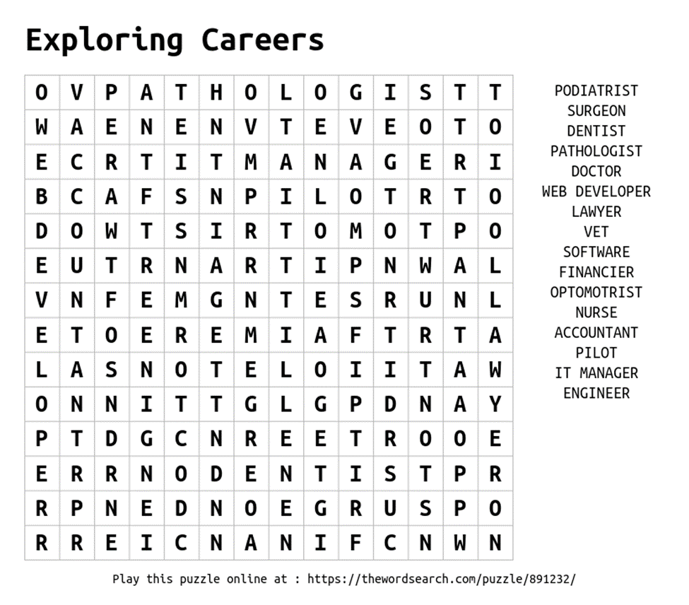

From the list of “Top Careers,” what skills do you need for these careers? List 3 below.
_________________________________________________________________________

Resources: See link below for a cumulative list of the top 100 jobs for 2024.
US News https://money.usnews.com/careers/best-jobs/rankings/the-100-best-jobs

Have Fun!- Mrs. Raptis

