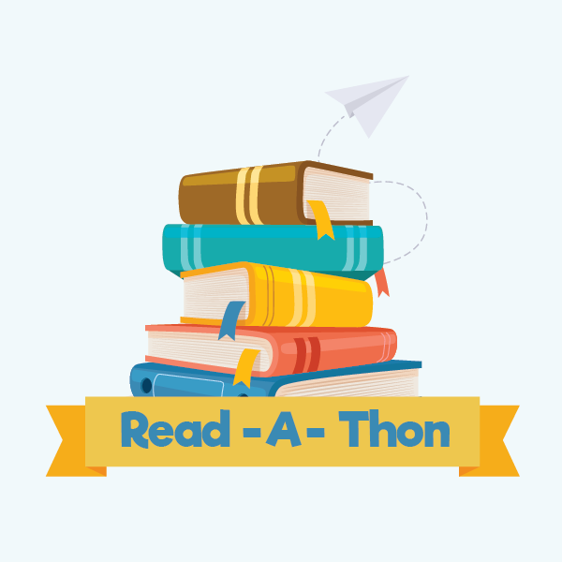
March 18-April 7 Read- A-Thon Fundraiser: How to Participate
- All Parkway and Glen Hills students will be sent home with a handout containing the log in instructions for each student’s personal Reaafun.com fundraiser page.
- Students can log in before the Read-A-Thon begins to check out their account and to go through the steps for parent authorization (so the student can request and accept sponsorships!).
- March 18th is Kickoff Day! Students should start logging their books/minutes read in their readafun.com account. Students can also email additional friends and family members to request sponsorships. All donated funds will go straight back to students in the form of PTO/Foundation activities and initiatives!
- Students will earn “Wisdom Coins” through Readafun.com to spend in the Online Owl Shop to accessorize their Owl Avatar. So fun!
- Individual prizes will be awarded to students who achieve certain minutes read milestones and the class in each grade with the most minutes read per student will earn a treat celebration!
- LET’S GET READING!!

