How to Register
If you have not registered for access to Infinite Campus please click HERE.
Already Registered

Open your web browser (Chrome, Explorer, Fire Fox), and type in InifiniteCampus.com

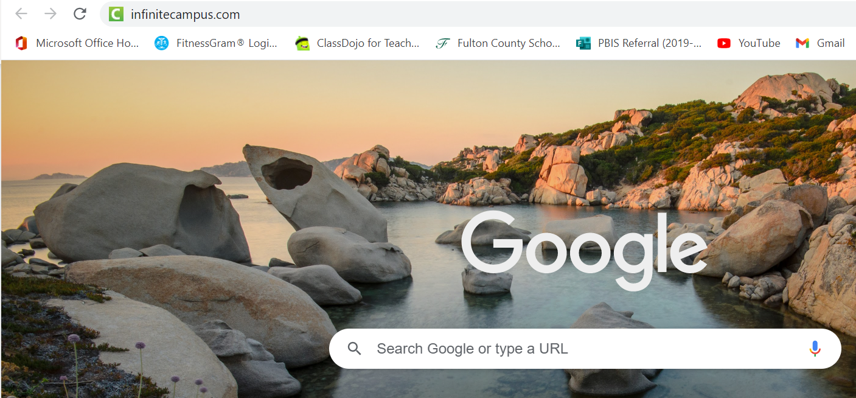
The below screen will open and then click Login

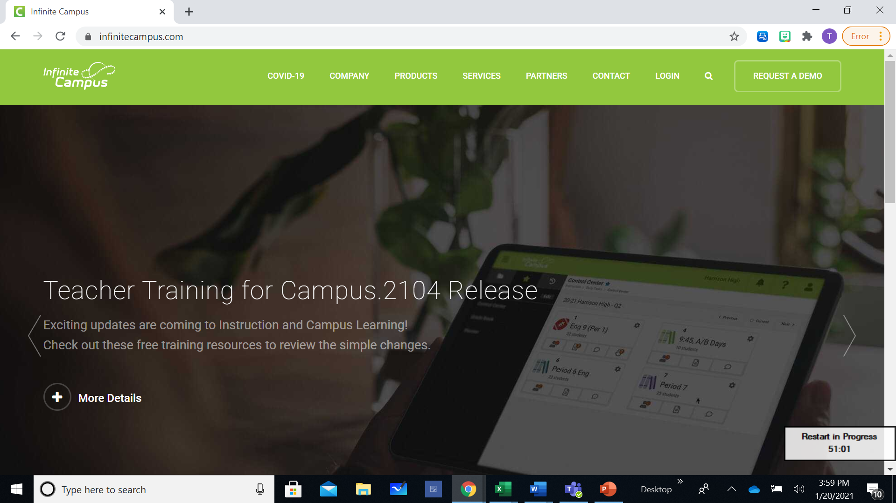
On the next page enter
“Fulton” and state “Georgia” click search.

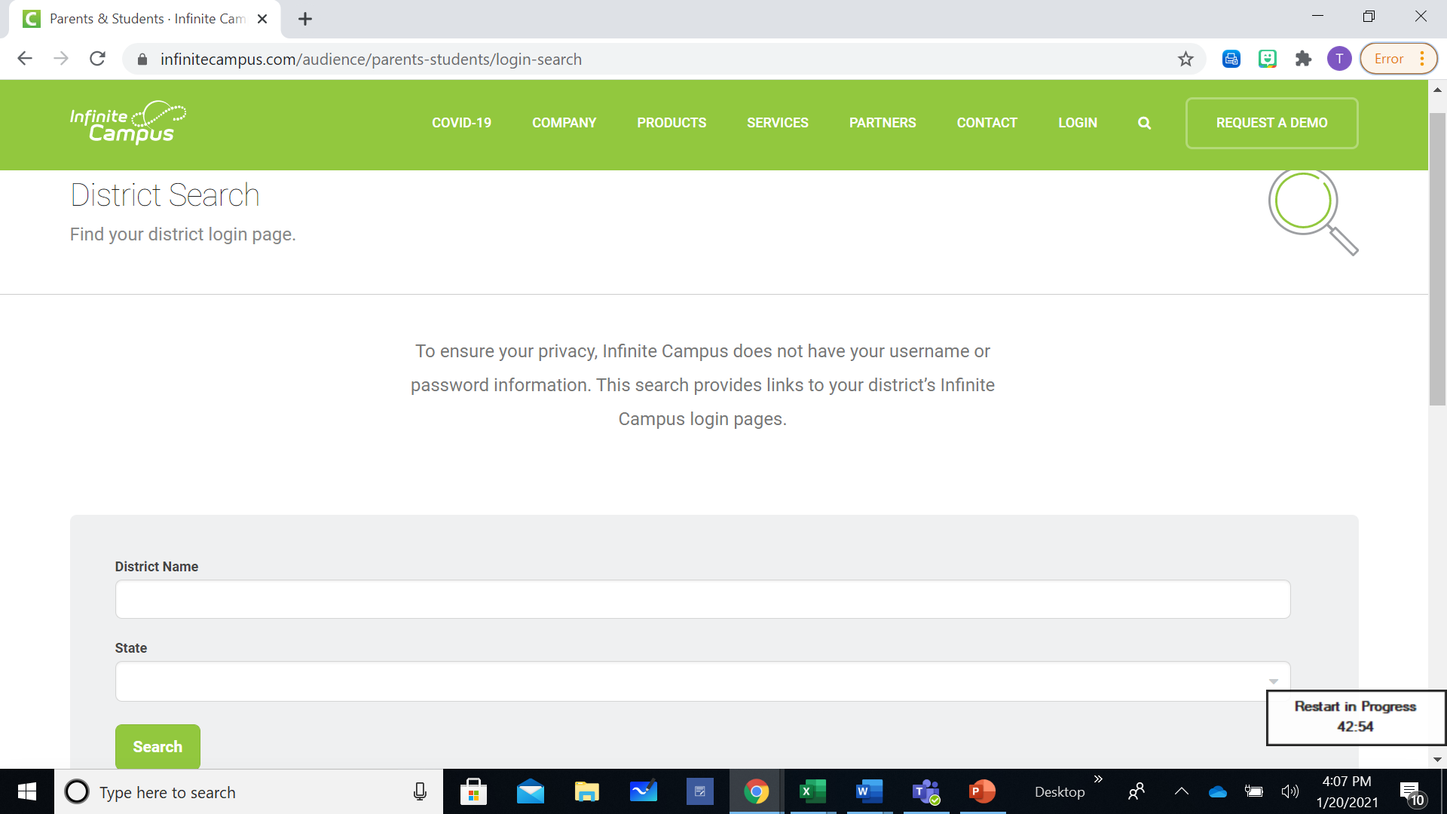

Two search options will appear. Click on Fulton County, GA., Parent/Student
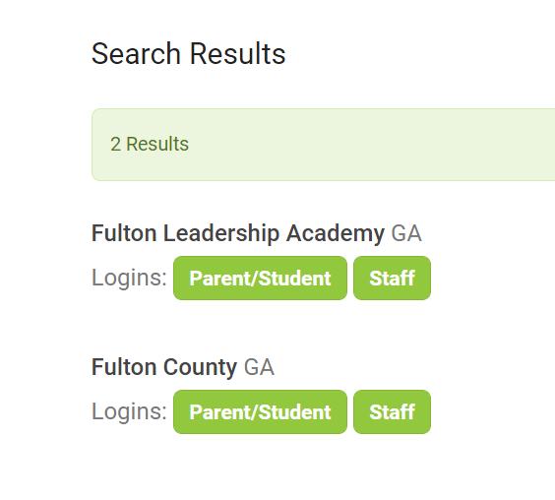

On the next screen click Campus Parent

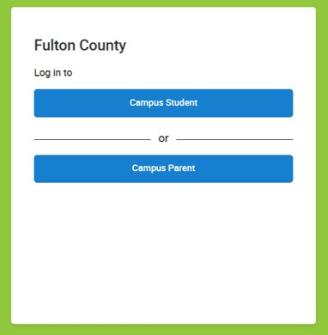
Put in your Parent Username and Password
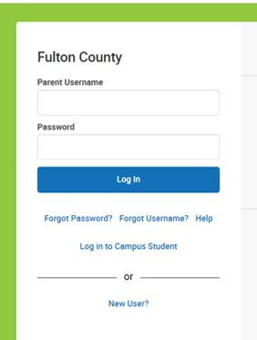

Your next page gives you all the different option to locate information about your child.

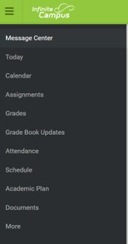
Message Center
The Message Center link gives you any district Announcements that Fulton County pushes out. If you open the Inbox you can see e-mails from your child’s teacher or school.



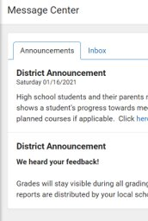
Today
The Today link gives you a snapshot of what you child has scheduled for the day.

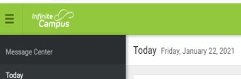
If you have more than one child in the Fulton County Schools system you can click in the upper right corner, where you see one child’s picture. Click on the arrow to the right to bring up your other children’s information.
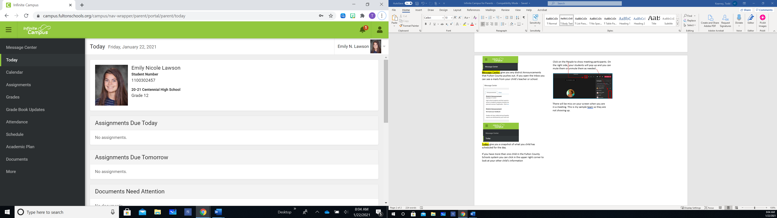
Jane Smith

Calendar
The Calendar link gives you know the following by clicking on the tabs:
Assignments – graded past and present assignments.
Schedule - what your child’s daily schedule looks like. Attendance – tracks your child’s attendance per day and per class.
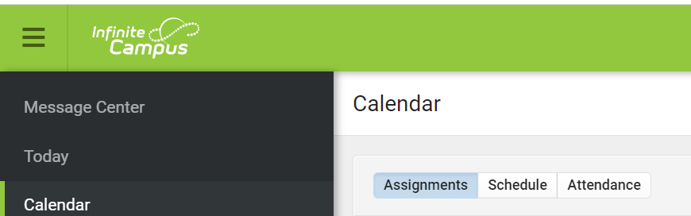

Assignments
The Assignments link gives all assignments that have been assigned. It has a link for Missing and Current Term assignments and graded papers or projects.

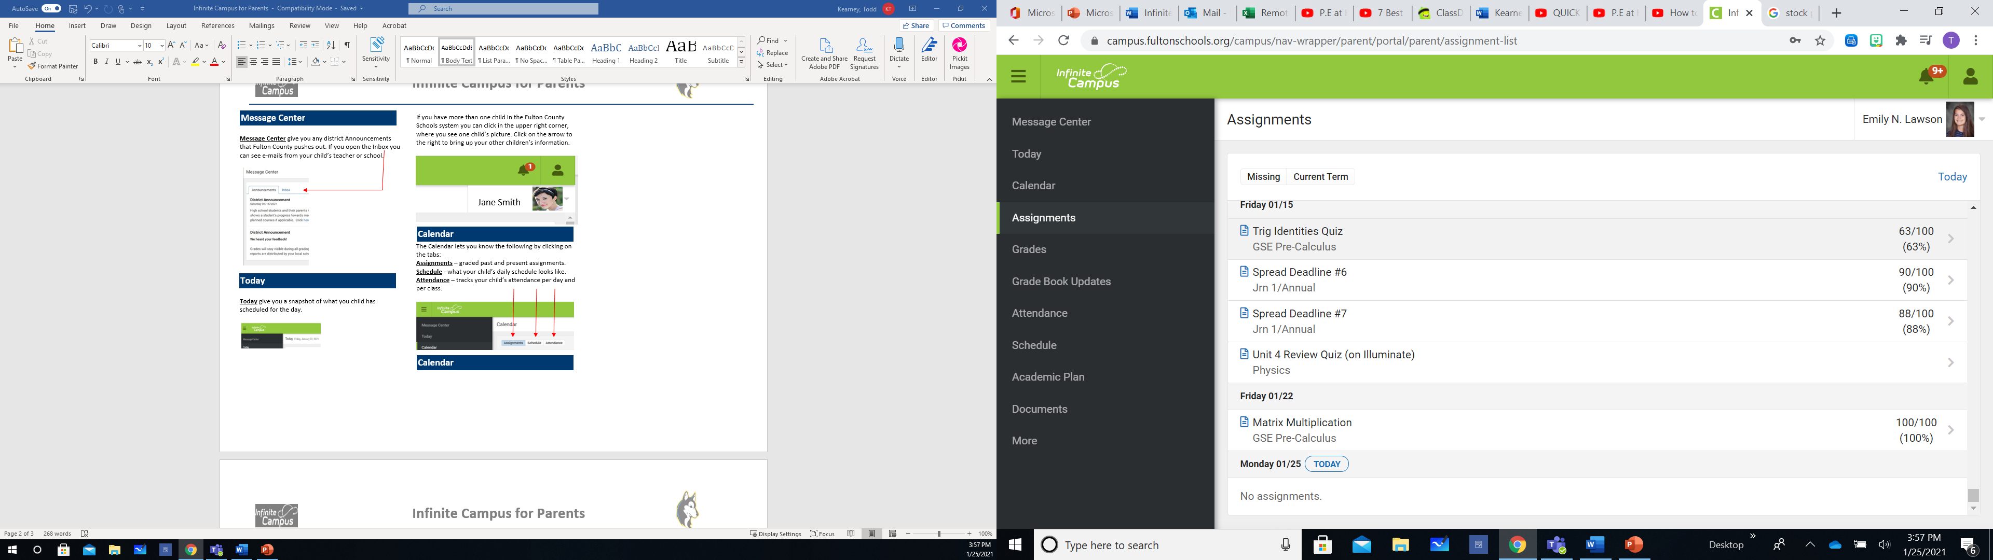
Grades

The Grades link gives you your child’s current GPA and present/past grades per class. You can click on the S1 (First Semester) to find out how your child performed in that semester. Or you can click on S2 (Second Semester) to find out how they are currently performing.

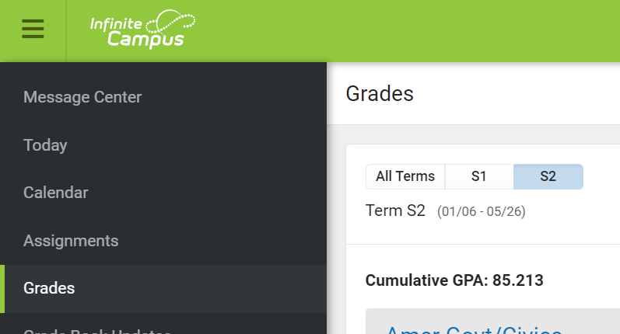

Grade Book Update
The Grade Book Update link gives you any updated grading by the teacher.
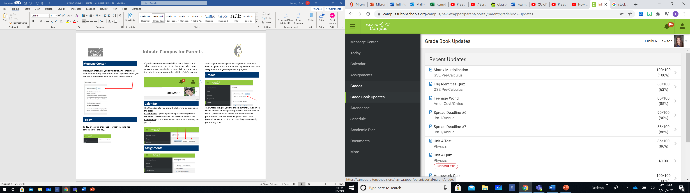
The Attendance link lets you know which classes your child has missed and how many times they have missed each individual class. When you click on the class the screen will pop up and let you know if it is an excused, not excused, or unknown absence.
Attendance

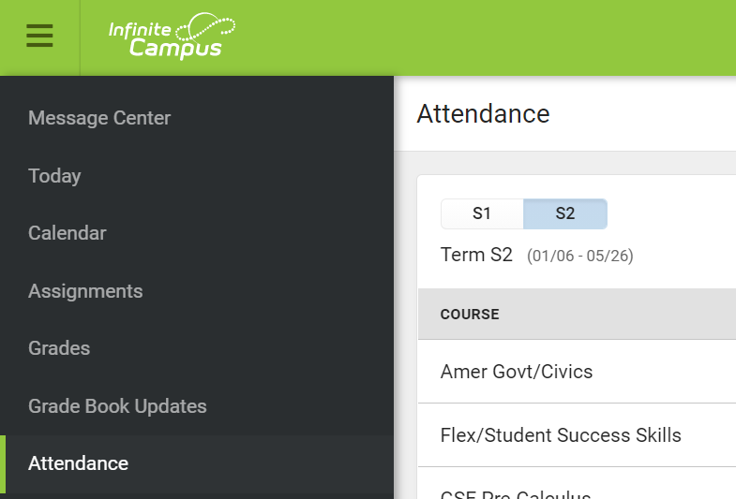

Documents
Schedule
The Schedule link gives you your child’s schedule for the day. If you click on a specific class a screen will pop up with the teachers name and e-mail address.
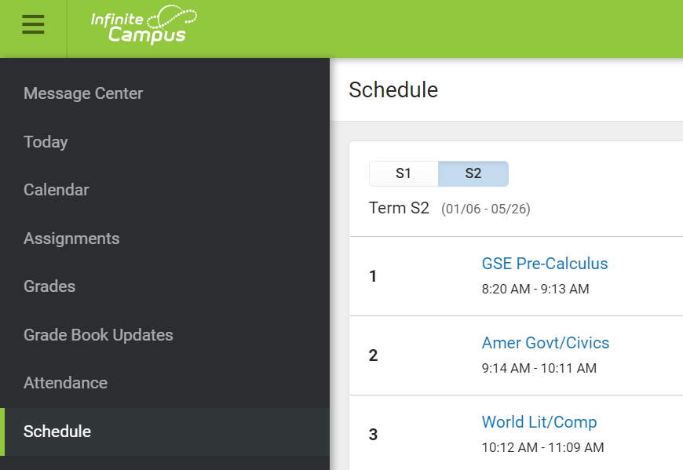
The Academic Plan link gives you a snapshot of all the classes your child has completed year to date. You will need to click on the drop-down menus in the screen and then click Proceed to see your results.
Academic Plan

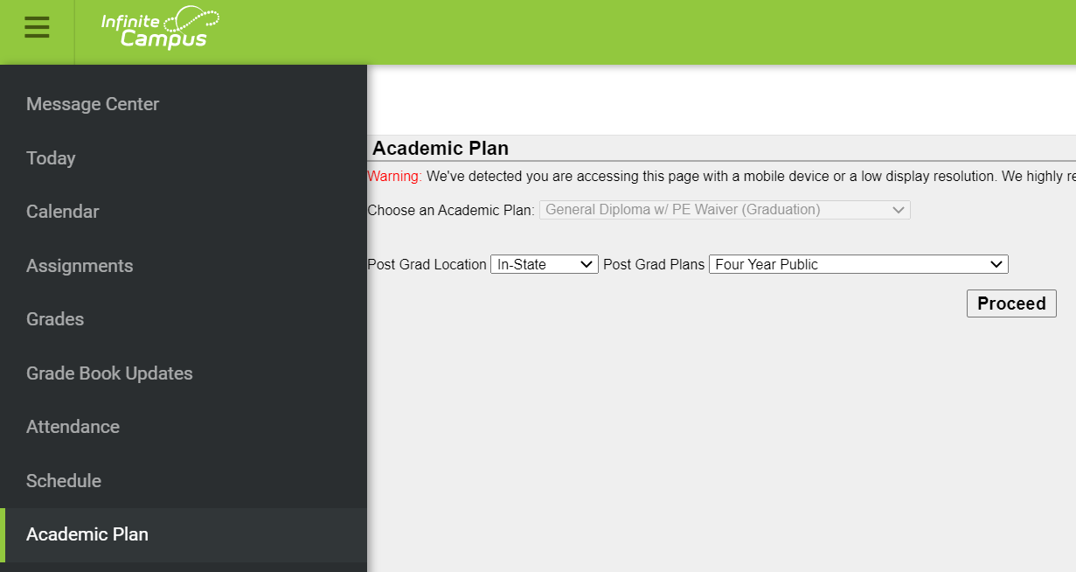

The Documents link is where you find Progress Reports, Report Card, and any other documentation you need regarding your child.

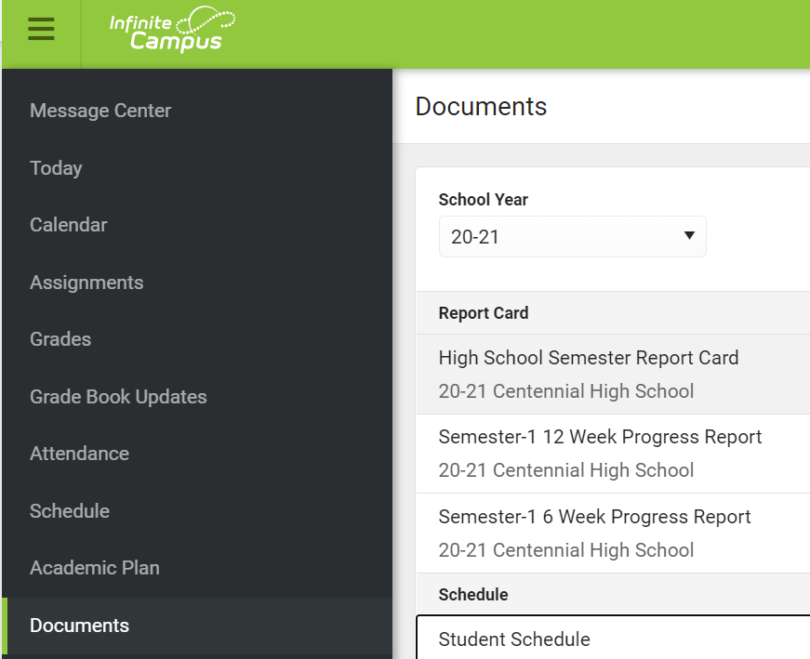

More

The More link is where you can find information about your child’s Assessments, like their PSAT and SAT results. End Of Grade Milestone test results in Language Arts, Math, Science, and Social Studies. Plus, quick links to each of your student’s home school web site.

