
Hudson City Schools

Financial Report
May 2017 Five-Year Forecast Update

Kathryn L. Sines
Treasurer/CFO
May 22, 2017
Board of Education Meeting

Executive Summary of the Five-Year Forecast
The May Update of the Five-Year Forecast for Hudson City School District for the period ending June 30, 2021, is respectfully submitted for your approval. This report outlines the status of the district’s finances for the future and conforms to the reporting requirements established by the Ohio Department of Education and the Ohio Auditor of State.
The Five-Year Forecast is intended to be a fluid and adaptable document. Changes over time are expected with fluctuations in the economy.
The forecast covers only the general fund and is a useful document, but only represents approximately 73% of the organization’s financial transactions.
The Five-Year Forecast financial projection is required by Section 5705.391 of the Ohio Revised Code to provide a method for Hudson City School District Board of Education, the Ohio Department of Education, and the Ohio Auditor of State to identify whether the school district may be facing financial difficulty over the next five years. The Auditor of State’s Office and the Department of Education have designed the format of this projection. Responsibility for the preparation of the projection and the accuracy of reasonableness of the assumptions on which these projections are based rests with the Hudson City School District Administration and the Board of Education.

Nature and Limitations of the Forecast
The financial forecast presents, to the best knowledge and belief of the Hudson City School District Board of Education, the expected revenues, expenditures, and operating balance of the general fund. Accordingly, the forecast reflects the Board’s judgment of the expected conditions and its expected course of action. The assumptions disclosed herein are those that management believes are significant to the forecast. Differences between the forecasted and actual results will usually arise because events and circumstances frequently do not occur as expected, and those differences may be material.
The financial numbers through April on the updated forecast are actual data, May and June are projected. Future year’s assumptions remain the same as October 2015.
Governor Kasich’s proposed budget in its present state will affect our five year forecast. The House Finance Committee proposed to cut our funding at its current level. The Senate Finance Committee is currently hearing testimony and has not submitted its recommendations to the full Senate. We will continue to advocate that state resources be held stable for high performing school districts such as Hudson City Schools.

Operating Revenue Update
The forecast of the general fund shows the cash position holding relatively unchanged from the projection earlier this year. The real estate numbers are actual figures as we have received our tax settlement for this current fiscal year.
The largest percent difference from our October projection is in the unrestricted grants-in-aid line 1.035, also known as our state foundation.
Total revenue has a variance of $70,750, a .12% increase over projected.

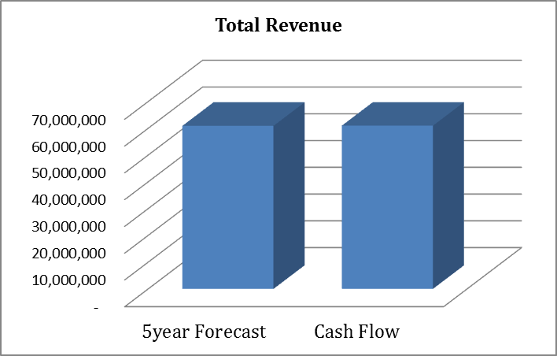
$60,894,400
$60,965,150

Operating Expenditure Update
Total operating expenditures are lower than October’s projected amounts. Salaries and benefits were projected higher than actual to date.
Total expenditures have a variance of $1,006,665, a 1.69% decrease under projected. We will continue to watch expenditures to maintain a high level of control.

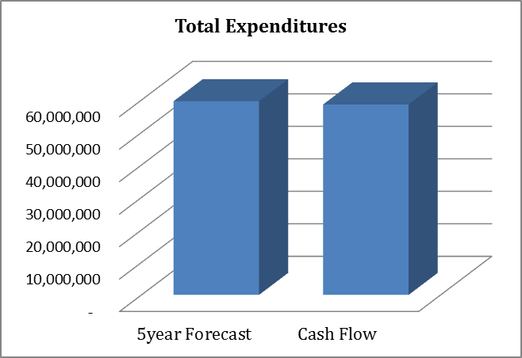
$59,639,423
$58,632,758
Cash Balance
May and June numbers are still projected; therefore the final numbers for the fiscal year will vary slightly. When looking over the forecast update, the results are as desired. Revenue came in just a little lower than projected and expenditures are lower than expected. The impact on our cash balance is a 3.59% variance.

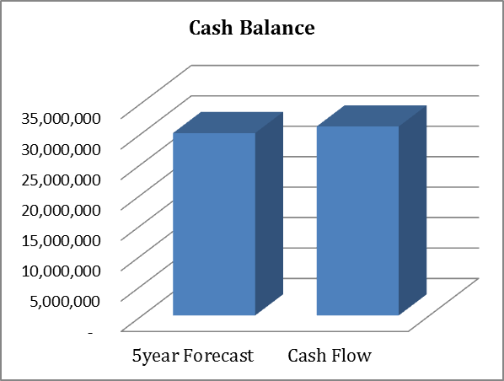
$29,982,948
$31,060,365
When looking at our cash balance we need to keep in mind, the volatility of the state foundation and the fact that we are on the guarantee. We need to advocate with our legislators to hold our funding at our current level. I will reflect any and all changes in funding on the October 2017 forecast.
We have worked hard to maintain our fiscal procedures and will continue to watch all expenditures and carefully watch revenue changes as they occur.

