
Hudson City Schools

Financial Report
May 2019 Five-Year Forecast Update

Kathryn L. Sines
Treasurer/CFO
May 16, 2019
Board of Education Meeting

Executive Summary of the Five-Year Forecast

The May Update of the Five-Year Forecast for Hudson City School District for the period ending June 30, 2023, is respectfully submitted for your approval. This report outlines the status of the district’s finances for the future and conforms to the reporting requirements established by the Ohio Department of Education and the Ohio Auditor of State.
The Five-Year Forecast is intended to be a fluid and adaptable document. Changes over time are expected with fluctuations in the economy.
The forecast covers only the general fund and is a useful document, but only represents approximately 51% of the organization’s financial transactions.
The Five-Year Forecast financial projection is required by Section 5705.391 of the Ohio Revised Code to provide a method for Hudson City School District Board of Education, the Ohio Department of Education, and the Ohio Auditor of State to identify whether the school district may be facing financial difficulty over the next five years. The Auditor of State’s Office and the Department of Education have designed the format of this projection. Responsibility for the preparation of the projection and the accuracy of reasonableness of the assumptions on which these projections are based rests with the Hudson City School District Administration and the Board of Education.

Nature and Limitations of the Forecast
The financial forecast presents, to the best knowledge and belief of the Hudson City School District Board of Education, the expected revenues, expenditures, and operating balance of the general fund. Accordingly, the forecast reflects the Board’s judgment of the expected conditions and its expected course of action. The assumptions disclosed herein are those that management believes are significant to the forecast. Differences between the forecasted and actual results will usually arise because events and circumstances frequently do not occur as expected, and those differences may be material.
The fiscal year 2019’s financial numbers through April on the updated forecast are actual data, May and June are projected. Fiscal year 2020, 2021, 2022 and 2023’s assumptions remain the same as October 2018.

Operating Revenue Update
The largest source of revenue is general property taxes and they are actual figures as we have received our tax settlement for this current fiscal year. We had an adjustment due to Costco’s TIF. Costco paid their taxes last year and this year the Summit County Fiscal Office returned that amount to the Boston Heights TIF distribution. On our fall settlement we had a deduction that affected our projection.
We still have two months of estimates in this projection and we are expecting several reimbursements that are not in this projection. Total revenue has a variance of .35% or $219,716. This is slightly higher than projected.

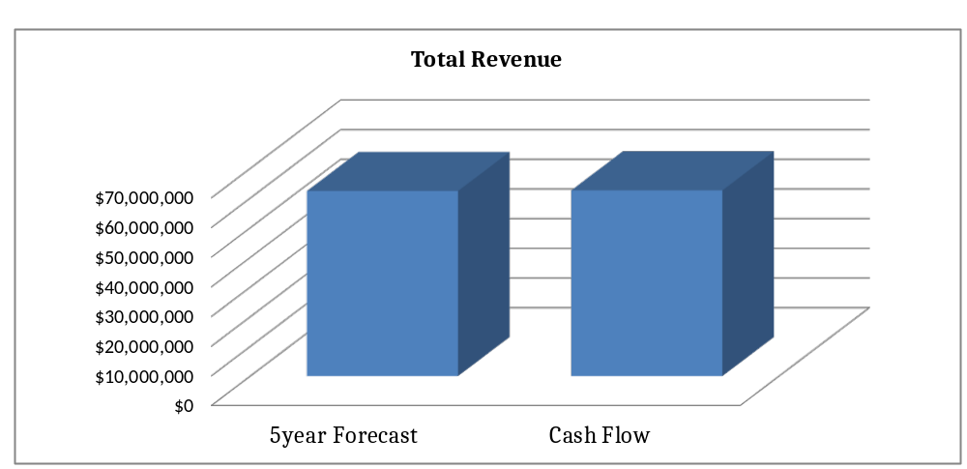
$62,597,706
$62,377,990

Operating Expenditure Update

Total operating expenditures are higher than October’s projected amounts. Salaries were projected higher than actual to date.
Retirement/Insurance benefits are higher than projected. We increased health insurance premiums in January 2019 by 9%. This increase affected the projection that was approved in October.
Purchase services are higher than projected because we started paying athletic officials from the general fund, an unanticipated expenditure. We also had higher legal fees than projected. We are waiting for a reimbursement from Hylant. We also had additional county fees due to the reimbursement to Costco.
Total expenditures have a variance of -.75% or -$ 476,729. These figures do not include the Apple purchases. We are very close to projected and will continue to watch expenditures to maintain a high level of control.

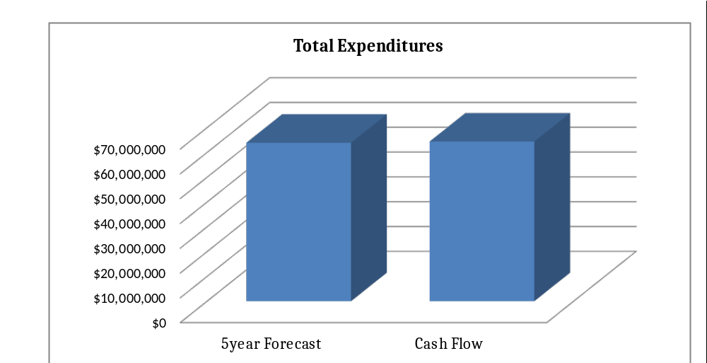
$64,387,381
$63,910,652

Cash Balance
May and June numbers are still projected; therefore, the final numbers for the fiscal year will vary slightly. When looking over the forecast update, the results are closer than in previous years. Our cash balance has a variance of -.77% or -257,013.

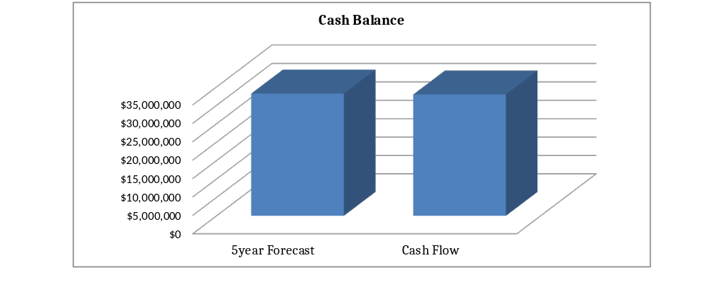
$32,941,782
$33,198,795

When looking at our cash balance, we need to keep in mind the volatility of the state foundation because we are on the guarantee. We need to advocate with our legislators to hold our funding at our current level. All changes in funding will be reflected on the October 2019 forecast.
Our district has worked hard to maintain our fiscal procedures and will continue to watch all expenditures and carefully watch and report revenue changes as they occur.

