

INFORMATION TECHNOLOGY

Resources for Women in Computer Technology
June 14, 2019 | Purdue University Global
https://www.purdueglobal.edu/blog/information-technology/resources-women-computer-technology/
Working women have had an interesting relationship with careers in computer science (CS) and information technology (IT) over the last 50 years. The field was dominated by men; then from the 1970s to the mid-1980s, there was a steady increase in women entering the field, then a leveling off, and then a decline. With computer and information technology occupations projected to grow faster than the average growth of all occupations through 2026, there are many opportunities for both men and women.*
This article reviews the history of women in computer science, current opportunities for women, and resources to help women explore and grow in computer science fields.

Quick Look Back: Women in Technology by the Numbers
1970 to the mid-1980s was an exciting time for anyone working with computers and technology, especially as more women began entering a field traditionally held by men. The number of women graduating with bachelor’s degrees in computer and information science was on a steady increase.
Between 1985 and 1986, the number of bachelor’s degrees in computer science awarded to women reached 36%—an all-time high, according to the National Center for Women & Information Technology (NCWIT). However, between 2015 and 2016, the number of women graduating with computer science degrees had returned to near-1970s levels at 19%.
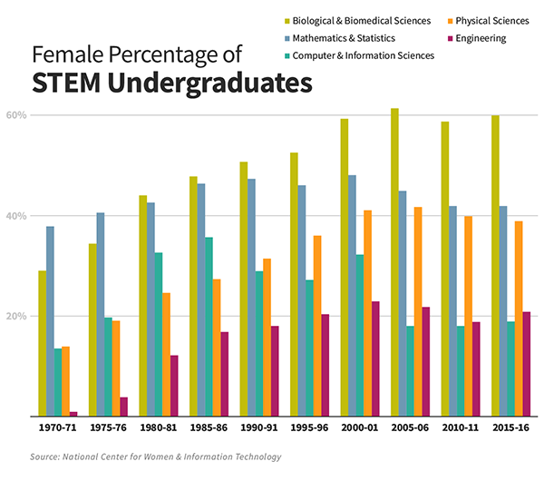
To put this into perspective, nationwide across all industries, women make up 47% of the workforce in the United States, according to the U.S. Department of Labor. Yet they comprise only 26% of the computer and information technology workforce, according to NCWIT.
From yet another perspective, degrees conferred to women in medical, law, and physical sciences have been on a steady increase since the 1970s, according to an NPR analysis from 2014:
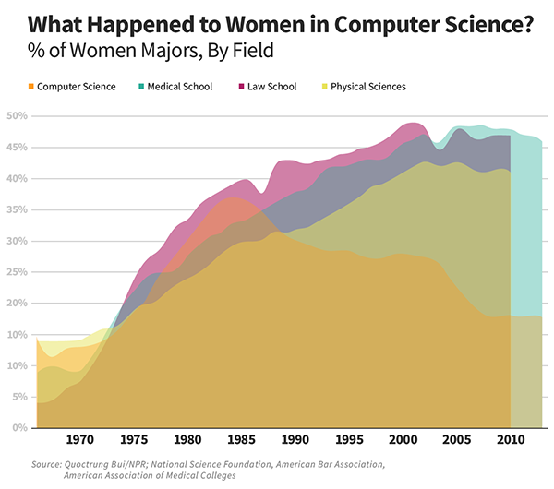

3 Reasons Why Women Should Seek IT Careers
1. Computer-related jobs are growing at a fast pace.
Demand for computer and information technology workers is projected to grow 13% through the year 2026, according to the Bureau of Labor Statistics. That’s faster than the average rate of growth for all jobs in the United States.
2. Although women comprise only about 20% of programmers, they’re earning nearly equal pay.
If opportunity isn’t enough reason, here’s another reason for women to get excited about careers in computer science and IT: The gender pay gap is nearly nonexistent between men and women in the U.S., according to research from the American Association of University Women.
- Across all occupations in the U.S., women earn about 80 cents for every dollar that men earn.
- In computer-related fields, it’s 94 cents for every dollar.
3. There aren’t enough skilled workers today to fill computer-related jobs through 2026.
If you are a woman who is thinking about a career in IT, or if you are already working in a computer-related field and are ready to get ahead, women in IT have a world of opportunity.
NCWIT predicts that 3.5 million new computer-related jobs will open by 2026, but there won’t be enough graduates with bachelor’s degrees to fill those positions if our universities continue at the current rate.
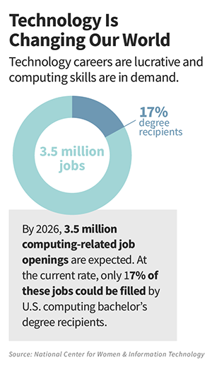

Next:
Resources for Girls and Women Seeking Careers in CS and IT

Computer Science and Information Technology Resources for Girls

- AAUW’s Tech Trek is a one-week summer camp in several locations throughout the U.S. where girls learn about STEM careers.
- Girls Who Code is a nonprofit founded in 2012 with a mission to “change the image of what a programmer looks like and does.” They sponsor clubs, campus-based programs, summer immersion, and other programs primarily for elementary, middle, and high school girls, but about 16% of the girls they serve are in college or older, according to their 2018 annual report.
- GirlsRiseNet is a partnership among several STEM-related organizations, museums, and science centers in the United States. The purpose is to build a network among these organizations, share resources, and encourage girls to explore opportunities in STEM subjects.
- “History of Women in IT: 6 Female Pioneers in Computer Science” is an article by Purdue University Global that profiles achievements in computer science and information technology by Ada Lovelace, Grace Hopper, and four other women.
- National Girls Collaborative Project is an “organization’s organization.” This charitable collaborative brings together organizations that encourage girls to pursue careers in STEM-related fields. Find a chapter near you.
- Project CS Girls is a nonprofit that encourages middle school girls to pursue computer science and technology careers. They hold an annual national competition, technology workshops throughout the country, and offer opportunities to start local chapters.
- Tech Girls is an initiative from the U.S. Department of State’s Bureau of Educational and Cultural Affairs. It’s a weeklong technology camp for girls in the U.S., Central Asia, Middle East, and North Africa to encourage them to pursue careers in science and technology.
- Technovation is an annual challenge that matches girls with mentors in STEM-related careers. They invite groups of girls to identify problems in their communities and innovate to solve them. It has resources to find local clubs all over the world, as well as resources to start a club of your own.

Computer Science and Information Technology Resources for Women

- AnitaB.org is a nonprofit organization named for Anita Borg, a pioneer for women in computer science. Anita founded the Institute for Women and Technology in 1994, which has since been renamed AnitaB.org. The website provides a wealth of information about events, meetups, awards, scholarships, and other resources for women in technology.
- ACM-W is the Association for Computer Machinery’s Council on Women in Computing. It includes professional and student chapters, scholarships, newsletters, and networking opportunities.
- American Association of University Women (AAUW) is a nonprofit organization that promotes equity in education for girls and women in all fields, not just STEM-related fields. They offer leadership training, research on gender equity issues, local and campus initiatives, and a wealth of information for women.
- Association for Women in Computing is a professional organization for women in computer science and technology. It’s been around since 1978 and offers professional networking, mentoring, and continuing education.
- Association for Women in Science (AWIS) describes itself as a global network for women in STEM. AWIS is a think tank, leadership development, and advocacy group. Their career network includes postings for several hundred STEM-related jobs.
- IEEE Computer Society offers online resources for women in computing, such as conferences, publications, a digital research library, and local chapters for networking.
- MentorNet is a nonprofit that matches mentors in STEM careers with student “mentees.” They’ve matched more than 33,000 pairs since 1997, and 81% of them are women or members of a minority group. They offer corporate programs, college and university programs, and professional programs.
- National Center for Women and Information Technology is a nonprofit that represents more than 1,100 universities, companies, nonprofits, and governmental organizations. They provide free resources for these organizations to raise awareness and reach out to critical populations of women and minorities.
- Society of Women Engineers (SWE) was founded in 1950. It’s a nonprofit membership organization with 300 collegiate and 100 professional member chapters. Members join a network of local and national engineers, attend national and regional conferences, and have access to SWE’s webinars, podcasts, website, and print materials.

Further Explore a Career in Information Technology
If you are thinking of pursuing or advancing a career in information technology, a college degree may help.† Purdue University Global offers several online degree programs in information technology. Explore our IT degree programs.
Women’s Advantage in Admission to STEM Programs from IVYSELECT.COM
Sources
- Female Percentage of STEM Undergraduates: National Center for Women in Technology, “NCWIT Scorecard: The Status of Women in Computing,” 2019 update
- What Happened to Women in Computer Science: NPR, “When Women Stopped Coding”
- Technology Is Changing Our World: National Center for Women in Technology, “Women and Information Technology by the Numbers”

