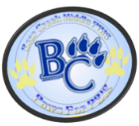
 | Classroom | Hallway | Cafeteria | Restroom | Bus Ramp
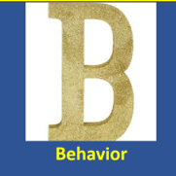 | - Follow instructions provided  - Raise your hand to speak  - Eliminate outside distractions  - Bring proper supplies | - Travel on the right side  - Walk  - 10/10- No travel within the first or last 10 minutes | - Enter in an orderly fashion  - Food should remain on the plate  - Conversations should be close proximity | - Keep hands and feet to yourself  - Limit of 3 scholars at a time  - Do NOT sit on sinks | - Keep hands and feet to yourself  - Remain seated  - Do NOT walk on the seats
 | - Food and Cellular devices are NOT allowed  - Remain On Task  - Organize Materials  - Be visible and present  - Actively Participate | - Food & Cellular devices are NOT allowed  - Engage with peers in an orderly fashion  - Move promptly | - Proceed directly to the line (No Lingering)  - Use moderate tone when speaking  - Line up when asked | - No restroom breaks first/last 10 minutes  - Use promptly | - Report to your bus on the correct load  - Adhere to bus driver instructions  - Ride your assigned bus
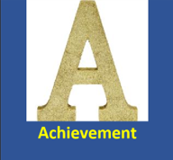 | - Report to class on time  - Devices should be charged  - Collaborate with peers about the school material  - Ask clarifying questions | - Pick up litter  - Remain on a low voice level  - Passes are required when traveling alone in the hallway | - Sit at assigned table  - Remain seated until dismissed  - Line up with your class | - Wash your hands  - Flush Toilet  - Put all trash in containers | - Enter/Dismiss in an orderly fashion  - Keep ALL limbs inside the bus window
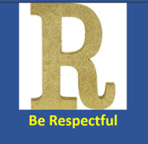 | - Use positive/appropriate language  - Respect other’s belongings  - Use proper chat etiquette | - Keep hands and feet to yourself  - Follow instructions by ANY BCMS staff member | - Adhere to ALL directions from BCMS Teachers  - Clean up your area before exiting  - Use positive language | - Clean up behind yourself  - Respect all school property | - Use positive language  - Clean up your area  - Do NOT throw any items outside of the bus

