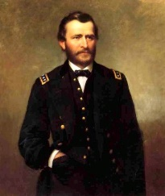
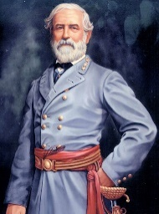
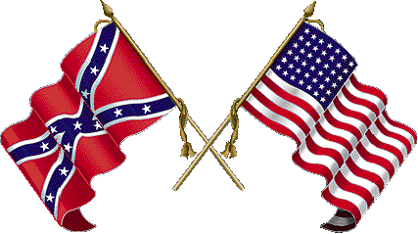
Worksheet American History Chapter 11 “The Civil War”

1. The first shots fired of the American Civil War were fired on fort _________, South Carolina.

2. What was the Southern goal of the Civil War?

3. What were Border States? List them.

4. What was Union general Winfield Scott’s Anaconda Plan? Why was it called the Anaconda Plan?

Define the following
a. Hardtack-
b. Conscription-
c. Copperheads-
d. Martial law-

5. Identify who said the following quotes AND tell me why they were said.
“The enemy is there and I intend to attack them there”

“If there is a worse place than Hell, I am in it”

“I can anticipate no greater calamity for the country than dissolution of the Union….I am willing to sacrifice everything but honour for its preservation”

“I beg to present you, as a Christmas gift, the city of Savanah”

6. What two things are Clara Barton famous for?

7. How did Confederate general Thomas Jackson get his name? What was his nickname?

8. What was “Cotton Diplomacy?” Why did it fail?
9. How did the following make the Civil War even deadlier?
a. Rifling-
b. Canister shot-
c. Bullet-shaped ammunition-
d. Observation balloons-

10. Tell me three things about the First Battle of Bull run.

11. Tell me three things about the Battle of Shiloh.

12. Union Admiral David Farragut captures the city of ______ __________, completing the Union ____________ of southern ports.

13. Tell me three things about the Second Battle of Bull run

14. ___________________Hebrew for “Place of peace”
15. ___________________Soldiers on horseback
16. ___________________Soldiers killed, missing, or captured in war
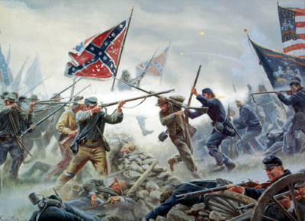
17. ___________________ Union all black regiment
18. ___________________ Confederate prison in Georgia

19. Tell me about the Battle of Bentonville (internet)

20. What did the Emancipation Proclamation do?

21. What was the Trent Affair?

22. Read and summarize document number 2 in your textbook.

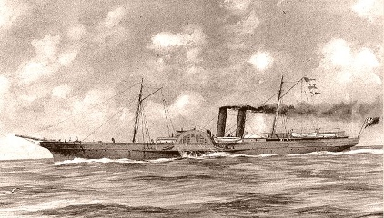
23. What were Blockade runners?

24. Why was Maryland such an important state for the Union to keep? Tell me one more thing about Maryland.

25. _________________________ Manassas Junction
26. _________________________ General of all the Union armies
27. _________________________ Gunboats with iron plates to protect them
28. _________________________ General of all the Confederate armies
29. _________________________ Forced service into the military

30. Tell me three things about the Battle of Antietam.

31. Tell me three things about the Battle of Gettysburg.

32. Answer the following about the Siege of Vicksburg
a. What is a siege?

b. What was the result of this siege?

c. What was the significance of this defeat?

33. How did the Union victory at the Battle of Atlanta help President Lincoln?

34. The ___ Amendment to the U.S. _____________ banning slavery was passed by the U.S. Congress because of the ____________ Party and ratified by __ of the states in 1865.

35. What Union general made his infamous “March to the Sea?” What happened on his “March to the Sea?”
36. Answer the following about the Battle of Chancellorsville.
a. What tactic did General Lee do that actually helped him obtain victory?

b. Tell me about “Pickett’s charge”

c. Lee’s “right arm” was killed-
d. This victory encouraged General Lee to do what?

37. What is inflation? What caused this inflation in the south?

38. What happened at the Battle of Pea Ridge?

39. Tell me about the Battle of Spotsylvania. (Internet)

40. At ______________ courthouse, Virginia, Confederate general __________________ surrenders to Union general ______________________ on ______________.

41. List four causes of the Civil War

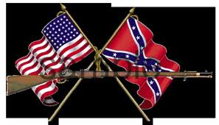
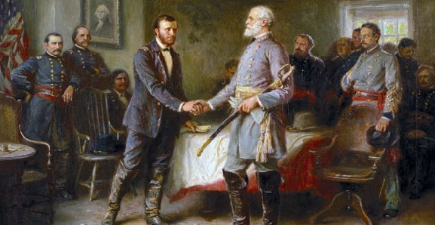
42. List three effects of the Civil War.

