
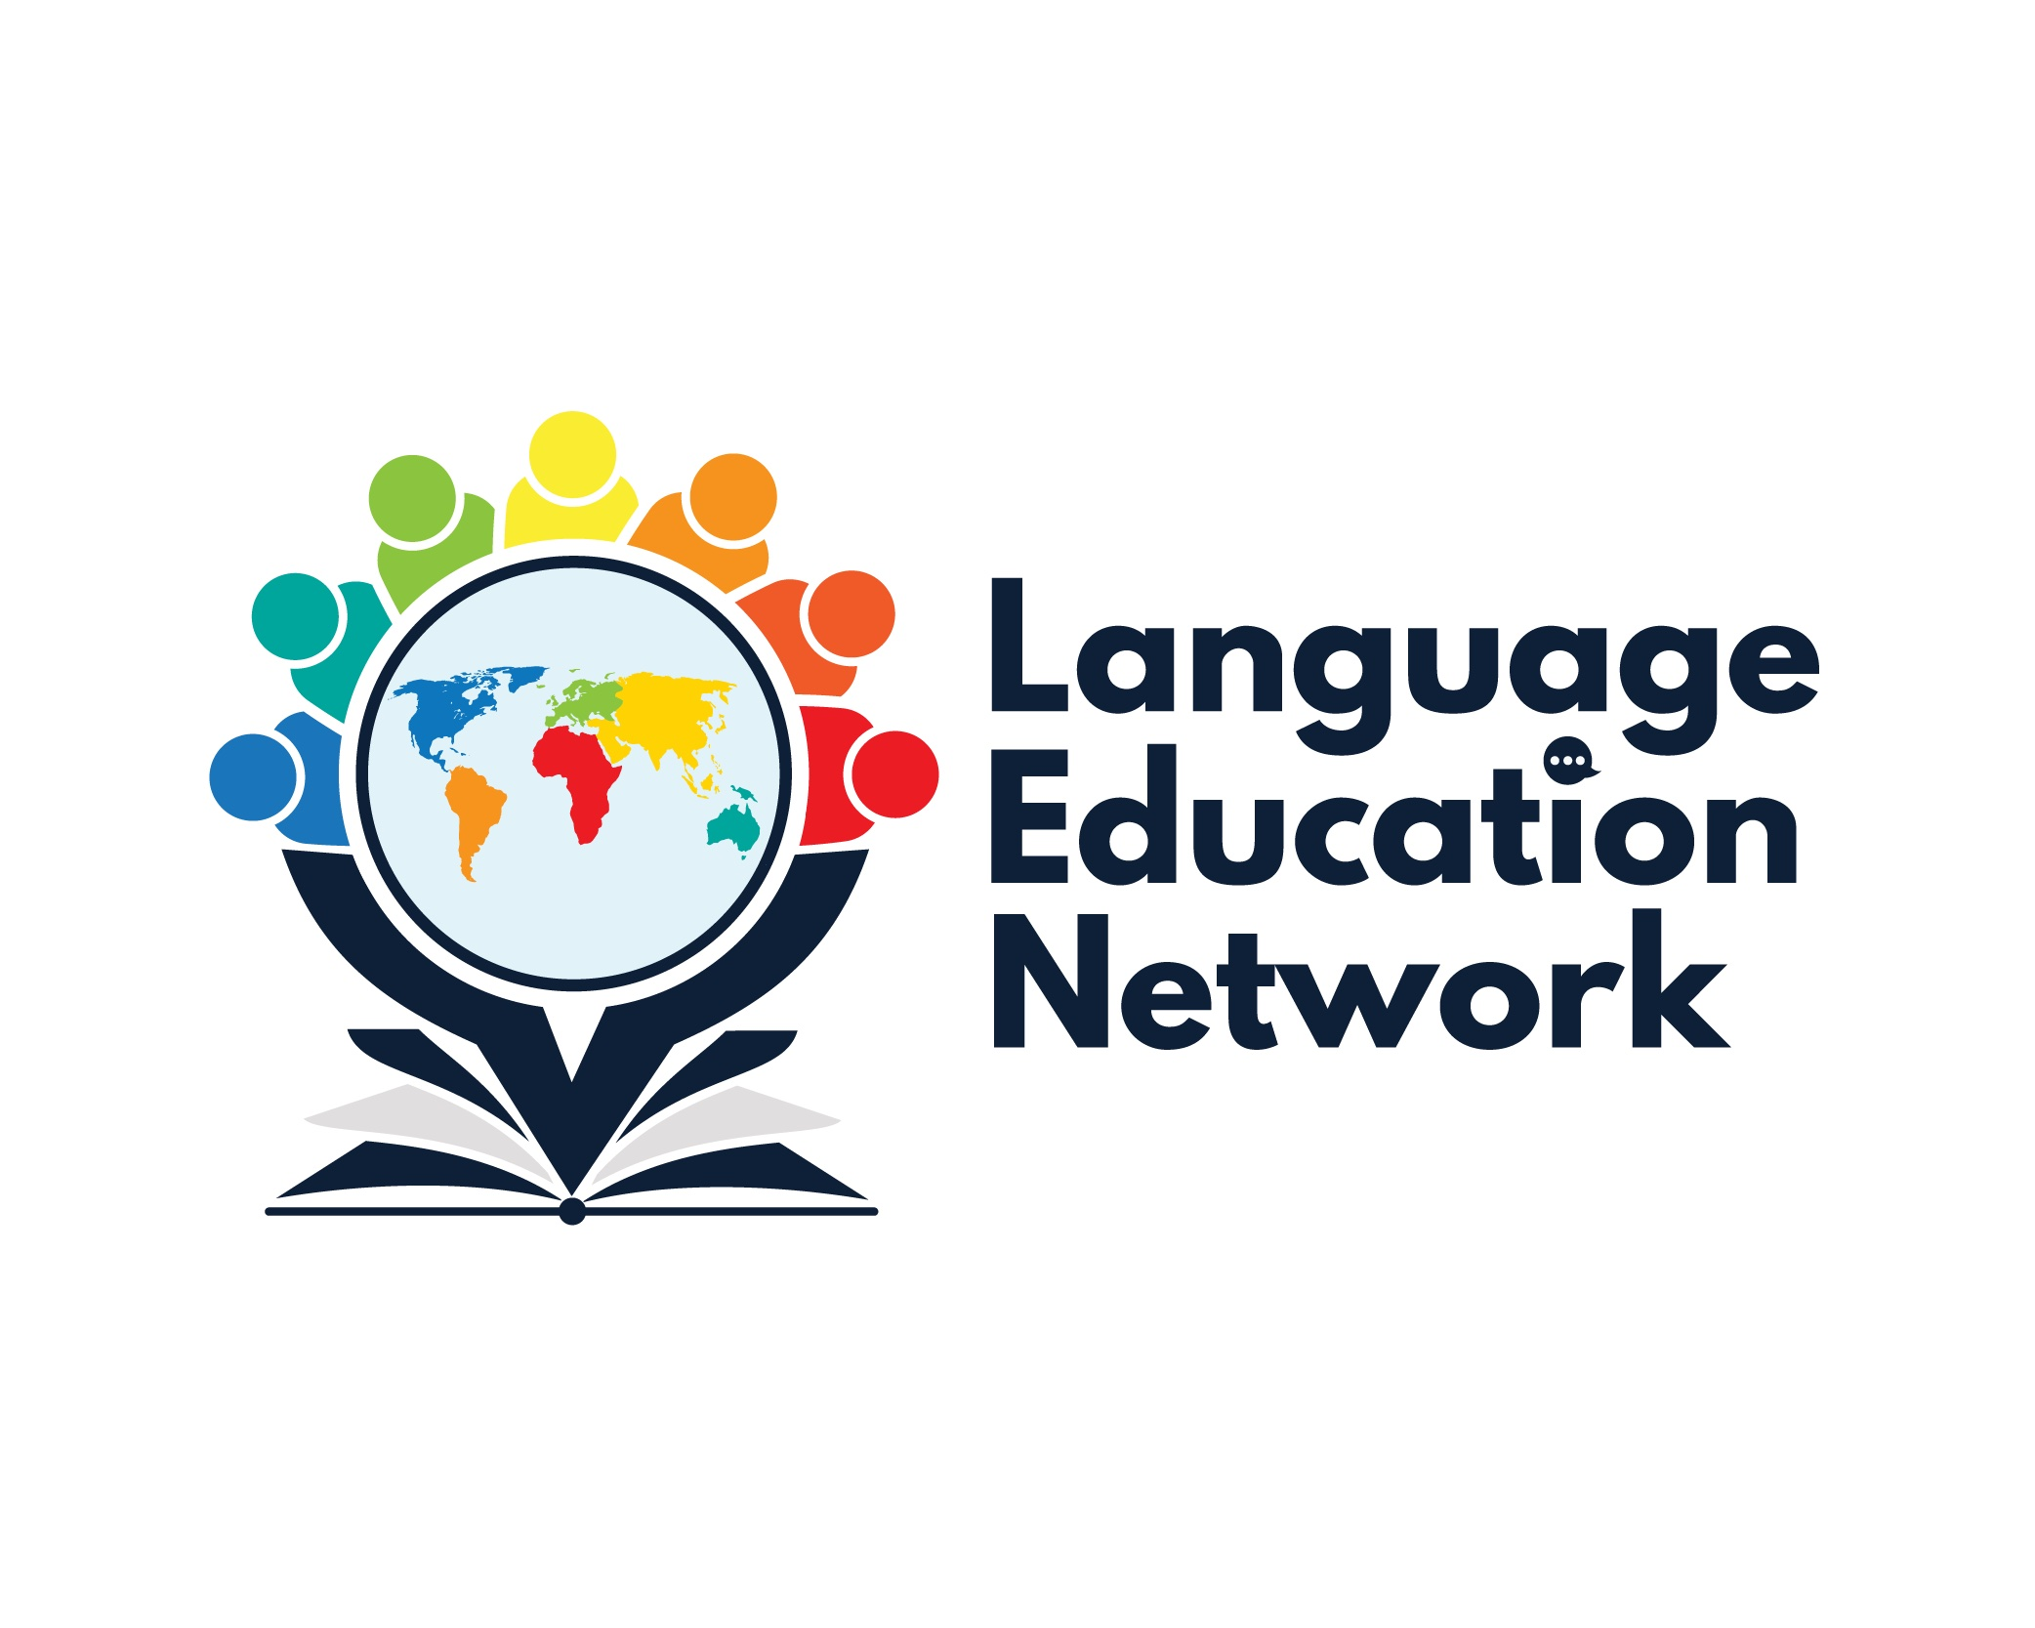
March 1, 2024
1:00 – 2:30 PM
AGENDA

Purpose: The purpose of our network is to come together to align current research and policy with the work that is required to prepare our English learners for college and career.
ZOOM LINK  Passcode: LEN | Facilitators:  Carlos Pagán: cpagan@sbceo.org  Melissa Garcia: mgarcia@sbceo.org

2023-2024 Meeting Dates
(1:00-2:30PM)
- September 8, 2023  - October 26, 2023 (World Languages Day, 8:30-3:30, in-person)  - December 15, 2023  - March 1, 2024  - May 17, 2024 | WELCOME!  ¡BIENVENIDOS!

TOPIC |  | NOTES/LINKS
PROFESSIONAL LEARNING OPPORTUNITIES (Spring-Summer 2024)
EWIG-EPiCC Zone C  - Integrated English Language Development (April)  - Literacy for Long-term English Learners (March)  - Spanish Literacy – Dr. Jiménez Jiménez (March)  - Spanish Reading and Writing – VIA Educational Consulting (March)  - World Languages Standards & Framework (April)  - Project GLAD – (June) | SBCEO Professional Learning Opportunities Webpage  EPiCC Professional Opportunities Statewide HUB
BILINGUAL COORDINATORS NETWORK (BCN) REPORTS & UPDATES
- Observation Protocol for Teachers of English Learners (OPTEL): Tool and User Guide  - ELPAC Updates (Melissa Garcia)  - BATALLA DE LOS LIBROS – May 21, 2024 |  | SBCEO Batalla de los libros webpage
UPDATES & ANNOUNCEMENTS
Bilingual Authorization Program  - Begins July 8, 2024  - Interest Form  - Next Virtual Information Session – March 4th, 4-5PM  Multilingual/Multilingual Curriculum Project (MMCP) Grant recipients:  - CONGRATULATIONS!: Patricia Villalobos – Righetti High School (Santa Maria Joint); Annabel Meza – Adelante Charter (Santa Barbara USD); Sonia Aguila Gonzalez – Canalino (Carpinteria USD); Herlinda Caro – Jiménez (Santa Maria-Bonita); Stephanie Hernandez-Jarvis – El Camino (Goleta Union) |  | SBCEO BAP WEBPAGE
INSTRUCTIONAL RESOURCES & PROFESSIONAL LEARNING OPPORTUNITIES

INSTRUCTIONAL RESOURCES:
- EL Toolkit of Strategies
- Designated & Integrated English Language Development Videos
- California ELD Standards
PROFESSIONAL LEARNING OPPORTUNITIES:
2024:
- ELPAC Initial – May 15, 2024

