Canvas Instructions
- Go to the Clark Creek homepage and select students:
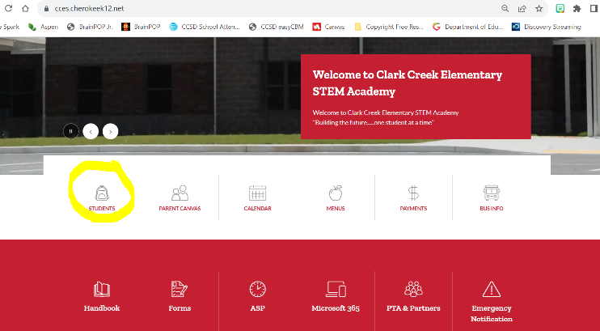
https://cces.cherokeek12.net/

- Choose the Canvas Icon:
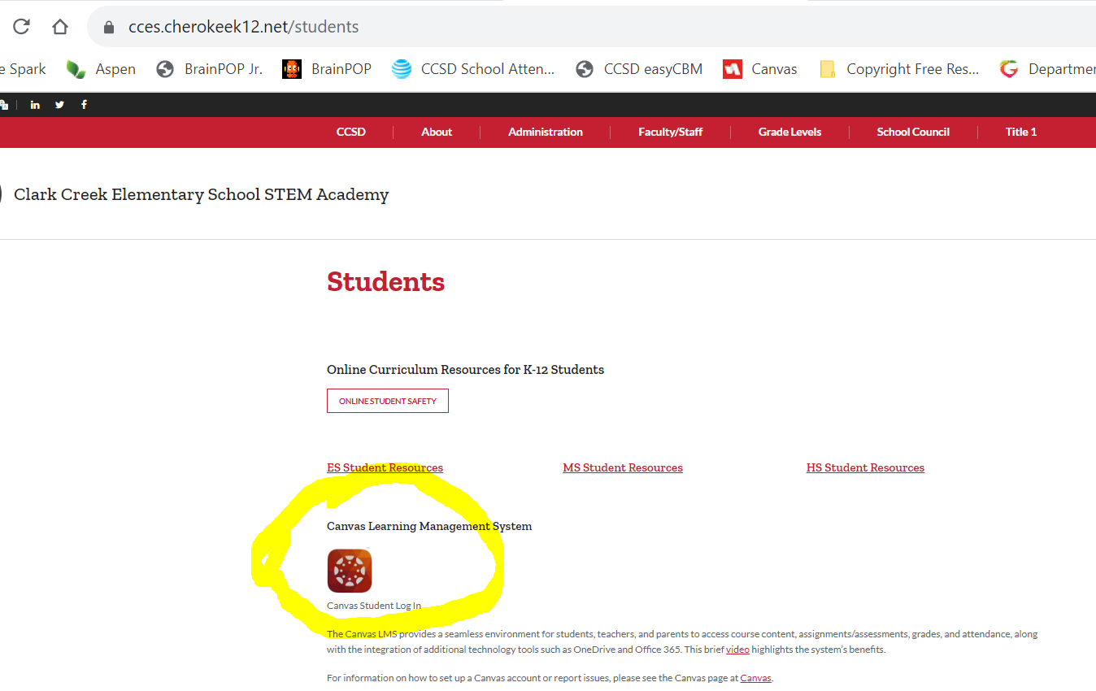

- Login using their everyday username (s + student #) or with the QR Code provided by the school. If you don’t have the QR Code you can click on “Try another method “ and add your password. If you need help with your password, please contact your teacher.
