Family Letter
5th Grade
Multiplication and Division of Fractions
Dear Family,

During the week of <date> we will begin a new math unit focused on multiplying and dividing fractions. The purpose of this letter is to provide some background information about our new unit.

Focus of the Unit
This unit builds on the understanding that fractions are equal parts of a whole. Students will continue to develop fluency with adding and subtracting fractions while also learning to multiply and divide fractions. They will learn how to multiply a fraction or whole number by a fraction. They will also learn how to model and interpret a fraction as the division of the numerator by the denominator and interpret a fraction as an equal sharing context.

Building off Past Mathematics
In previous grade levels, students explored the idea that fractions are also numbers, so they can be added, subtracted, multiplied, and divided. Students have also learned about comparing fractions using equivalence, benchmarks, doubling, and like denominators. In previous grades, students learned how to place fractions on a number line and explored the idea of mixed numbers and fractions larger than a whole.

Strategies that Students Will Learn
In this unit, students will extend their work with multiplying fractions to solve situations involving fractions times fractions and fractions times mixed numbers. When multiplying fractions, students often expect the product (the answer) to be larger, like multiplication with whole numbers. It is very important for students to show these situations with drawings and other models to visualize what is actually happening in the problem. This visualization helps students make sense of the process to build understanding of the math in the problem.
Fraction x Fraction | Mr. Dawson planted a garden. Three-fourths of his garden was planted with corn. Two-thirds of that three-fourths was harvested. How much of the garden was harvested?  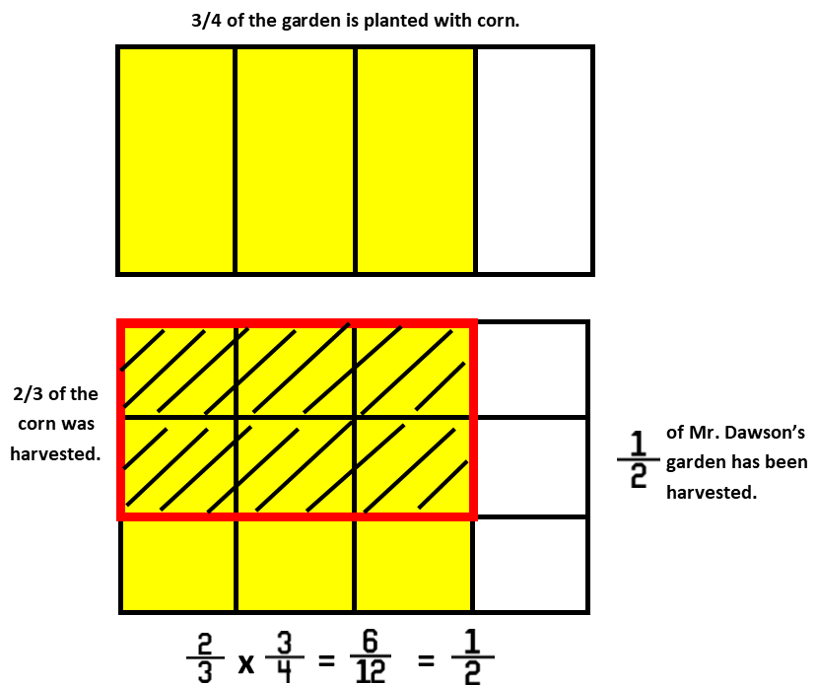
Fraction x Mixed Number | Mr. Dawson decided to build a flower box for his wife. He built it to be 2 ½ yards long and ½ yards wide. What is the area of his flower box?  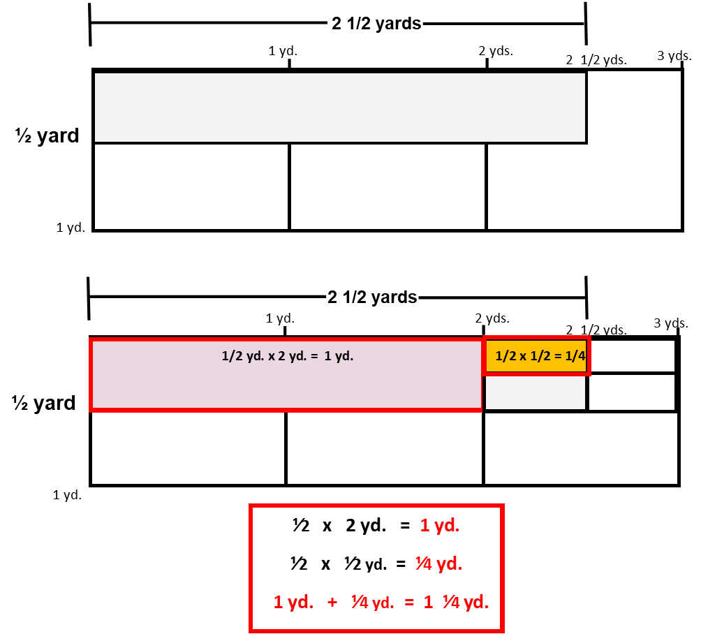

In this unit, students also extend their understanding of division of whole numbers by unit fractions and division of unit fractions by whole numbers. Unit fractions are fractions with 1 as a numerator (½, ⅓, ¼, etc.). It is important that students continue to use models and drawings to justify their thinking and make sense of what the problem is asking. These models and drawings are especially important because there are different types of situations for dividing fractions, as shown below:
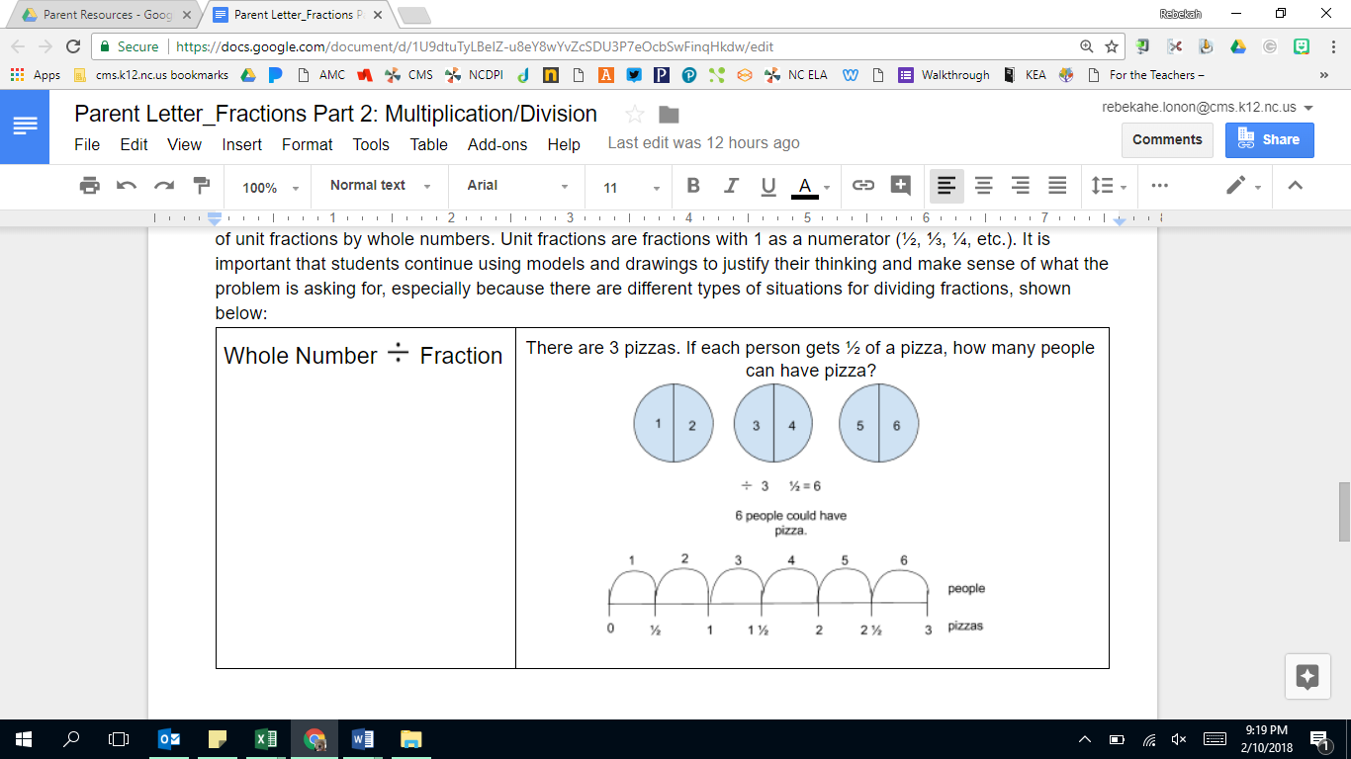
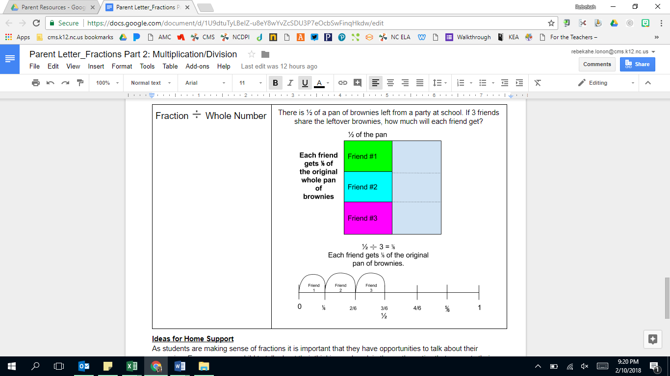

Ideas for Home Support
As students are making sense of fractions it is important that they have opportunities to talk about their reasoning. Encourage your child to talk about their thinking, explain the mathematics that supports their reasoning, and show their thinking with models and drawings. Thinking about fraction problems with real-life scenarios helps children visualize what is happening and understand what makes sense in relation to the problem.

The idea of “leftovers” from meals can be a great real-life example of fractional parts. Discuss how much is left of the whole and how much each person receives. Build on this work of division of fractions by discussing how much of the leftovers each person would have as well. Also, discuss predictions about the result of the problem:
-Will the size of the pieces be larger or smaller than the original pieces?
-If more people joined, will the pieces be larger or smaller?

When you see opportunities to use fractions in everyday life, have conversations about estimating how much is needed, whether or not you have enough, and how much more you might need.

Thank you for serving as partners in your child’s success as a mathematician!
<signature>

