Family Letter
5th Grade Multiplication and Division of Decimals

Dear Family,

During the week of <date> we will begin a new math unit focused on the multiplication and division of decimals. The purpose of this letter is to provide some background information about our new unit.

Focus of the Unit
This unit on multiplication and division of decimals builds on students’ learning in previous grade levels. Students will apply their prior knowledge of multiplication of whole numbers to make connections to multiplication decimals.

Building off Past Mathematics
In previous grade levels, students learned that multiplication is counting or combining equal sized groups. Situations involving multiplication have a number of groups and a number of objects in each group. In previous grade levels, students learned that a multiplication equation should be read in this way:

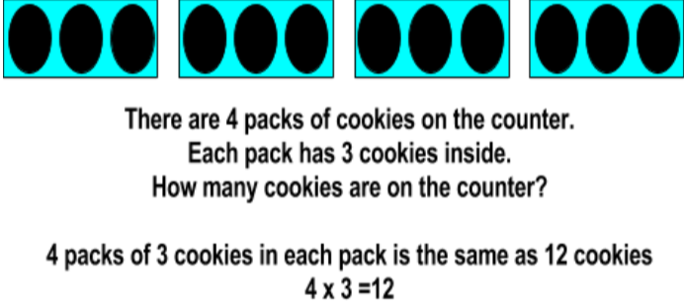

Students also learned that division is separating a number of objects into equal shares or groups. Situations involving division contain a total number of objects, the number of groups, and the number of objects in the groups.
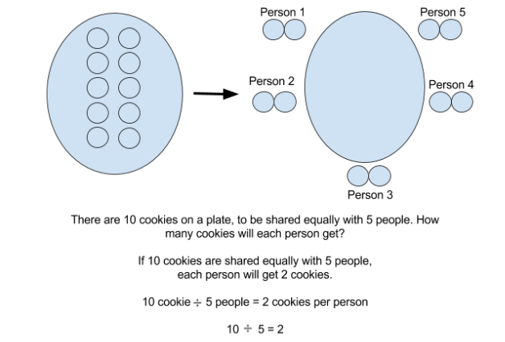
Students use their understanding of multiplication and division to solve story problems about real-life situations. These story problems involve situations where the number of groups, number of objects in a group, or total amount are missing. It is important that students “act out” story problem situations, so they can clearly see what information is given and what is still needed.
Strategies that Students Will Learn
In fifth grade, students use their previous understanding of multiplication and division strategies and apply them to decimals. Below are some specific strategies and representations that students use as they solve multiplication and division situations:
Multiplication
Number Line Model | 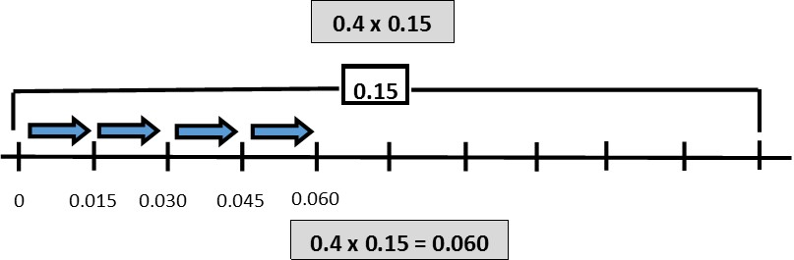
Use an area model to break apart unknown facts | 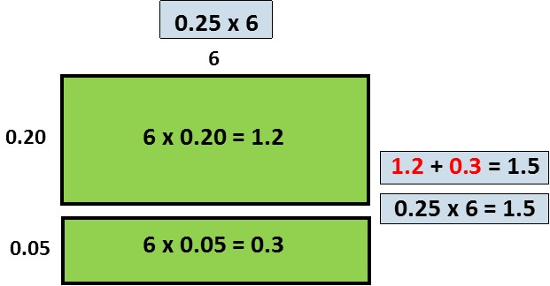
Break apart numbers by their place value | 0.4 x 0.15  0.4 x (0.10 + 0.05)  0.4 x 0.10 = 0.04 0.4 x 0.05 = 0.020  0.04 + 0.020 = 0.06

Division
Use an area model to show partitioning of a quantity | 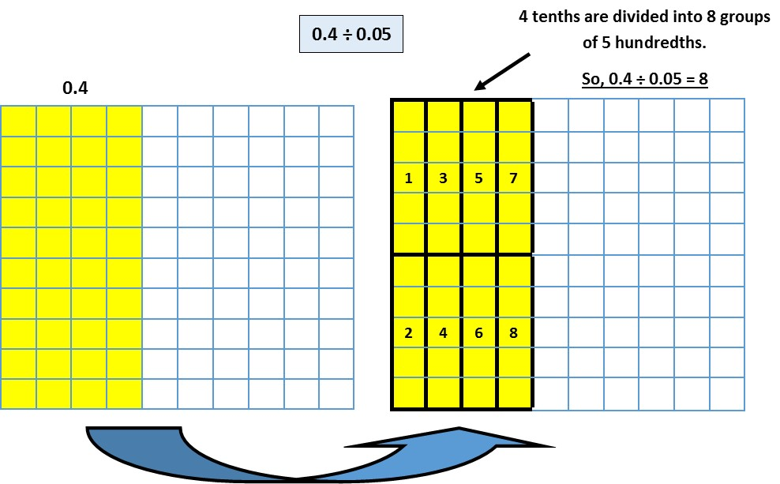
Use a fair sharing model to find the number in each group or share | 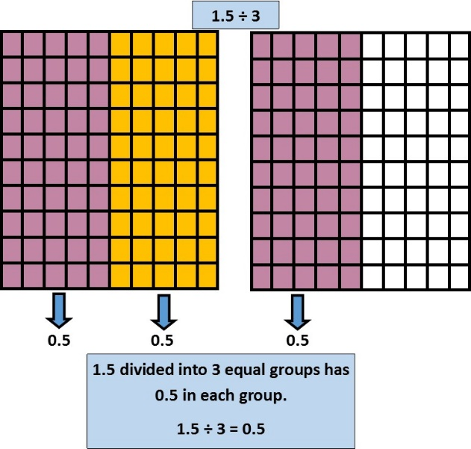

Ideas for Home Support
As a family, point out experiences when decimals are involved with your everyday life. These experiences might include totaling the grocery bill, doubling or halving a recipe, calculating the bill at a restaurant, determining mileage for a trip, buying gas for your vehicle, and many others. This helps children see and apply multiplication and division with decimals in a real-life context. Discuss mental strategies and estimations before solving to discover how your child is making sense of the mathematical context. When solving, prompt your child to show their thinking with models, as shown above, to remind him/her of the value of each number in the situation and the relationships between the numbers.

Thank you for serving as partners in your child’s success as a mathematician!
<signature>

